365-Day “Olymp-i-a Challenge” for HEALTH- Year 2
Author: Lesa R. Walker, MD, MPH**

**Author’s comments: In this document I present my daily positive ideas and actions for health, generated (and posted in Facebook) in the Year 2012. This journal is a journey of positive discovery. I hope it provides you with inspiration for your own positive ideas and actions for health. Many of the ideas and actions are timeless and are relevant now and in the future. Some, however, are specific to a particular event in 2012. Nevertheless, the journal entries provide you with tangible examples of positive steps taken on a daily basis. The journal entries frequently include and reference websites and their content. Due to the fluid and changing landscape of the Internet, some links may not work over time. If a link does not work or a website no longer exists, you can enter key words from the subject matter of the journal entry in “Google” or other search engine to locate current relevant websites and launch your own exploration. As you will see, the journal entries reflect my personal interests, passion, and culture. They serve merely as prompts to motivate and encourage you to create your own, personal and unique journey.
After reading an idea or action, write down your own positive idea or action for that day along with the date and re-save this file so you record your positive idea or action. Do this as often as you can over time. Ideally, do this for 21-30 consecutive days to help engrain the habit. The more you practice, the stronger you become! You will create a living journal of your positive ideas and actions.

365 Daily Positive Ideas and Actions for Health:

Day 1: OLYMP-I-A for HEALTH (Year 2)- Action: Sharing a positive greeting from “Special Olympics Texas”:
Special Olympics Texas
Happy New Year to all our athletes, coaches and volunteers! May 2012 be filled with happiness, joy and good health!

Day 2: OLYMP-I-A for HEALTH (Year 2)- Action: Sharing an informative article posted in Facebook by "Family Voices of Ohio":
Decision sharing tied to lower cost for kids' care
www.reuters.com
NEW YORK (Reuters Health) - Parents who report having an increased involvement in making decisions about their children's medical treatment are more likely to see lower risks of their kids going to the

Day 3: OLYMP-I-A for HEALTH (Year 2)- Action: Did stretching, floor exercises, and kicking. This day is the kick-off of "very serious" daily training regimen before February Kung Fu testing! Gotta be fearless :)).

Day 4: OLYMP-I-A for HEALTH (Year 2)- Action: Pedaled a mini stationary bike while sitting at the computer at work. Helps to reduce the health problems from long periods of sitting. Felt great!

Day 5: OLYMP-I-A for HEALTH (Year 2)- Action: Played ball outside with children in after school childcare... a beautiful day. Also, more stretching and Kung Fu training.

Day 6: OLYMP-I-A for HEALTH (Year 2)- Action: Took two long walks, one in my neighborhood and one along the trail at the lake. Such a wonderful, warm, sunny day... beautiful and refreshing to be outside!

Day 7: OLYMP-I-A for HEALTH (Year 2)- Action: Went to Kung Fu class this morning with much kata review and practice both during and after class... getting my stamina up.

Day 8: OLYMP-I-A for HEALTH (Year 2)- Action: I read a great article about an inspirational teenager with Down Syndrome and his swim team, coach, friends, and family. I like the quote from the coach in the article: "The whole team supports him," Moncman said. "They don't let his disability define him. I yell at him just like the other kids." http://www.lehighvalleylive.com/sports/index.ssf/2012/01/teenager_with_down_syndrome_co.html
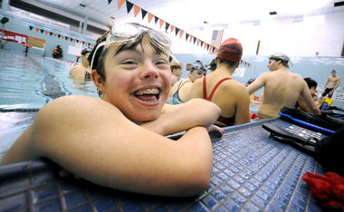
Teenager with Down syndrome competes with Saucon Valley High School swim team
www.lehighvalleylive.com
According to his mother, Nick Williams has been 'one with the water' his whole life.

Day 9: OLYMP-I-A for HEALTH (Year 2)- Action: Explored a website that showcases products, books, events, practices, etc. that support quality of life for persons with developmental disabilities. Found a great book highlighted on the site, "America According to Connor Gifford," written by a young man with Down Syndrome. http://www.qualitymall.org/services/about.asp
Quality Mall - About this Site
www.qualitymall.org
QualityMall.org, a showcase of promising practices and innovations that promote quality of life for persons with developmental disabilities, was developed by the Research and Training Center on Community Living at the University of

Day 10: OLYMP-I-A for HEALTH (Year 2)- Action: Had some fun exercise outdoors, kicking a ball on the playground with children in after-school childcare.

Day 11: OLYMP-I-A for HEALTH (Year 2)- Action: Took my dog on a walk in the neighborhood... enjoying a beautiful and unseasonably warm day.

Day 12: OLYMP-I-A for HEALTH (Year 2)- Action: Going to Kung Fu class for some awesome exercise :))... a great way to warm up in the winter!

Day 13: OLYMP-I-A for HEALTH (Year 2)- Action: Explored a website that encourages a healthy perspective on life: http://www.disabilityisnatural.com/
Your #1 Source for People First Language and New Ways of Thinking
www.disabilityisnatural.com
The #1 source for new ways of thinking about developmental disability, inclusive education, and Kathie Snow's People First Language.

Day 14: OLYMP-I-A for HEALTH (Year 2)- Action: Went on a peaceful afternoon walk with my dog around the neighborhood. Greeted a few neighbors along the way and enjoyed the beautiful day. Refreshing and relaxing!

Day 15: OLYMP-I-A for HEALTH (Year 2)- Action/Idea: Had an intense workout at Kung Fu, practicing katas and stretching. If I moved my legs and arms as often and as much as I do my fingers while typing on FB, I'd be in awesome shape :)).

Day 16: OLYMP-I-A for HEALTH (Year 2)- Action: Taking a relaxing, rejuvenating day. Nothing major planned. Enjoying the spontaneity of the moment.

Day 17: OLYMP-I-A for HEALTH (Year 2)- Action: Practiced Kung-Fu and Tai Chi. Great 2-hr exercise!

Day 18: OLYMP-I-A for HEALTH (Year 2)- Action: Doing some gentle stretching after yesterday's strenuous exercise.

Day 19: OLYMP-I-A for HEALTH (Year 2)- Action: I had seen a promotional ad on T.V. about a new "Healthy at H-E-B" initiative. I looked it up online and learned more about it. H-E-B grocery stores are offering recipes for healthy meals and reduced food prices to encourage healthy eating. http://www.heb.com/page/healthy-at-heb
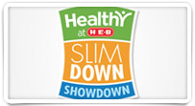
Healthy at H-E-B Food, Body, Life - HEB
www.heb.com
The Healthy at H-E-B program is designed to help you eat better, move more and live well. Here you’ll find more than 150 healthy recipes, information on free health screenings and more.

Day 20: OLYMP-I-A for HEALTH (Year 2)- Action: I read an article about healthy food choices written by Jonny Bowden, author of "The 150 Healthiest Foods on Earth": http://www.forbes.com/2009/07/07/healthiest-foods-nutrition-lifestyle-health-healthiest-foods.html

The Healthiest Foods On Earth - Forbes.com
www.forbes.com
The most important consideration in constructing a healthy diet: Eat whole food with minimal processing. These 12 foods do the trick.

Day 21: OLYMP-I-A for HEALTH (Year 2)- Action: I read about the "Big 12" campaign to promote a healthy perspective and end the "R-word." Starting this weekend and concluding on Feb. 4, the Big 12 Conference will join the Special Olympics in its efforts to stamp out use of the "R" word. "The campaign, called Spread The Word To End The Word, will be emphasized at Big 12 games starting this weekend. Fans will be urged to go online to R-WORD.ORG and digitally pledge to eliminate the use of the R-Word."
http://www.big12sports.com/ViewArticle.dbml?ATCLID=205364129&DB_OEM_ID=10410 Big 12 and ending the R Word
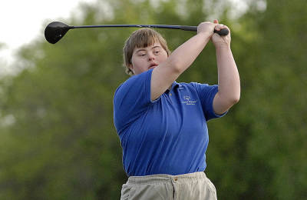
Big 12, Special Olympics Join Forces
www.big12sports.com
The Big 12 Conference and its long-time partner Special Olympics working to end use of the word

Day 22: OLYMP-I-A for HEALTH (Year 2)- Action: I saw an announcement on T.V. about Common Sense Media online resources that help teach children about cyberbullying and ways to stop it. I explored the nonprofit's website (http://www.commonsensemedia.org/) and found out more about the organization's mission and programs for educators.
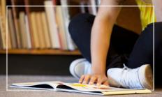

Reviews and Ratings for Family Movies, TV Shows, Websites, Video Games, Books and Music
www.commonsensemedia.org
Common Sense Media is dedicated to improving the lives of kids and families by providing the trustworthy information,

Day 23: OLYMP-I-A for HEALTH (Year 2)- Action: Had a "Vegetable Kingdom" smoothie (spinach, beets, spirulina, mango, lemon...) with added "emergen-C" (lots of Vitamin C !). Delicious and healthy!!

Day 24: OLYMP-I-A for HEALTH (Year 2)- Action: I watched an interesting video on the health benefits of Tai Chi: http://www.youtube.com/watch?v=_cTlHy7D4uw&feature=share. Personally, I know these benefits to be true. Also, it is something people can practice at all ages.
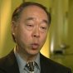
Health Benefits of Tai Chi (MSNBC)
www.youtube.com
Current research on tai chi as presented on MSNBC's program "The Mind-Body Connection." The video can also be found on the MSNBC website at the following lin...

Day 25: OLYMP-I-A for HEALTH (Year 2)- Action: I tried a "Lifeway Kefir" drink (a probiotic milk drink). It was delicious! I looked up "Lifeway Kefir" on Facebook and found out about their "12 Days to a Better 2012." "Lifeway Kefir" is encouraging people to try a Kefir drink each day for 12 days and during that time they’ll be posting tips, recipes and ideas for other ways to feel better this year – from meal ideas to tips for getting kids interested in healthy living. http://lifeway.net/Community/Blog/tabid/266/entryid/265/12-Days-to-a-Better-2012.aspx
12 Days to a Better 2012
lifeway.net

Day 26: OLYMP-I-A for HEALTH (Year 2)- Action: Nurtured a pain or two acquired in Kung Fu class. Exerting mind over matter. Also, glucosamine and chondroitin are becoming my close friends :)) Prepping for the test!

Day 27: OLYMP-I-A for HEALTH (Year 2)- Action: Watched a powerful and moving video. Change can happen. We just need to find the passion, commit and take the first step. Then, others follow. http://www.youtube.com/watch?feature=player_embedded&v=Ja9BFx5Mhqo
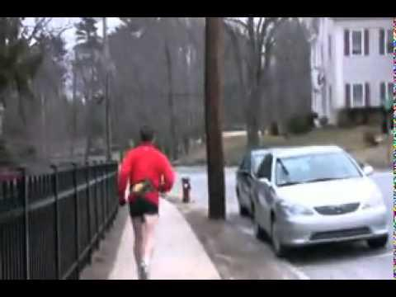
The most inspiring video you will ever watch!
www.youtube.com
*This is a repost of a video that a friend of mine made. He posted it to a car website to inspire the members there. I wanted others to see the video so that...

Day 28: OLYMP-I-A for HEALTH (Year 2)- Action: Did lots of Kung Fu practice of open-hand forms. Needing work on details...

Day 29: OLYMP-I-A for HEALTH (Year 2)- Action: Walked at the lake with a friend on a brilliant sunny and cool afternoon. So many people were out enjoying the beautiful weather. So refreshing!

Day 30: OLYMP-I-A for HEALTH (Year 2)- Action: I read an article (shared by a friend) about a good habit to start: “Meatless Mondays.”
‘Meatless Mondays’ might lead to healthier diets all week long | www.ecocenter.org
www.ecocenter.org
“Planned vegetarian diets, including total vegetarian or vegan diets, are healthful, nutritionally adequate and may provide

Day 31: OLYMP-I-A for HEALTH (Year 2)- Action: I found out about a book focused on the importance and power of our habits, "The Power of Habit: Why We Do What We Do in Life and Business" (http://www.stonehearthnewsletters.com/why-habits-exist-and-how-they-can-be-changed/human-behavior/). Running the "OLYMP-I-A" helps create the habit of generating positive ideas and actions and promotes positive and powerful change in our lives.
Why habits exist and how they can be changed | Health, Medical, and Science Updates
www.stonehearthnewsletters.com
A young woman walks into a laboratory. Over the past two years, she has transformed almost every aspect of her life. She has quit smoking, run a

Day 32: OLYMP-I-A for HEALTH (Year 2)- Action: Went on a relaxing walk in late afternoon with my dog around the neighborhood. The weather has been so warm that some flowers are starting to bloom. Felt like a Spring day in February!

Day 33: OLYMP-I-A for HEALTH (Year 2)- Action: Sharing a link describing a diet plan that helps people incorporate more vegetables into their meals
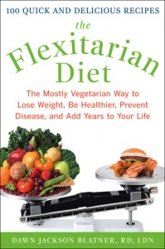
The Flexitarian Diet | Dawn Jackson Blatner, RD
dawnjacksonblatner.com
Flexitarianism is a hot new diet plan that gradually guides you to eat more veggies while still enjoying your favorite meats. It’s a great way to introduce the benefits of vegetarianism into every family’s lifestyle.

Day 34: OLYMP-I-A for HEALTH (Year 2)- Action: I read an article about a way to calculate how much water to drink. I also found interesting related videos re: water consumption on the site. http://nutrition.about.com/library/blwatercalculator.htm
Water Calculator - How Much Water To Drink a Day
nutrition.about.com
Your body needs water and fluids. About.com Nutritionist Shereen Jegtvig helps you determine how much water you need to drink each day.

Day 35: OLYMP-I-A for HEALTH (Year 2)- Action: I watched a 20/20 special, "Giving Life: A Risky Proposition." In some countries the chances of dying in childbirth is 1 in 10. "Every 90 seconds a woman needlessly loses her life in pregnancy or childbirth. But 80% of these are preventable." (http://abc.go.com/watch/2020/SH559026/VD55158749/2020-1216-giving-life-a-risky-proposition). The Million Mom Challenge (http://www.millionmomschallenge.org/) is helping to do something about it. Funding helps provide basic medicines and training that save lives.
20/20 12/16: Giving Life: A Risky Proposition Full Episode - 20/20 - ABC
abc.go.com
Watch full episodes of 20/20 online at ABC. Stream 20/20 12/16: Giving Life: A Risky Proposition instantly.

Day 36: OLYMP-I-A for HEALTH (Year 2)- Action: Got some restful sleep last night and this morning. Sleep is an important ingredient for health and healing.

Day 37: OLYMP-I-A for HEALTH (Year 2)- Idea: Trying hard to pump up my positive mental energy to take a positive attitude and approach to a physical set-back in my martial arts training. I know positive energy is much better for health than negative. Sometimes, it takes mental work to overcome the negative. Focusing on positive helps.

Day 38: OLYMP-I-A for HEALTH (Year 2)- Action: Took action to learn and practice some specific exercises that I hope will help me overcome an injury and keep up my stamina.

Day 39: OLYMP-I-A for HEALTH (Year 2)- Action: Added stationary biking to my floor exercises as part of a full-scale physical therapy program to help get my knee stronger. Hoping it works.

Day 40: OLYMP-I-A for HEALTH (Year 2)- Action: I read about a health worker hero who is making a difference for moms and babies in Indonesia. The info is posted as part of the "Save the Children" campaign: http://www.goodgoes.org/local-health-workers/story/one-midwife-two-rooms-hope-for-moms-and-babies-in-indonesia. I am always so amazed by the impact that one person can make.

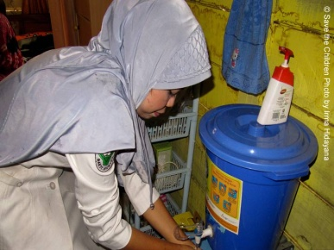
One midwife + two rooms = Hope for moms and babies in Indonesia
www.goodgoes.org
For a village that previously had no health clinic, you would think that a new midwife and a two-room home turned health post would be a welcome addition. Desita, an Indonesian midwife for more

Day 41: OLYMP-I-A for HEALTH (Year 2)- Action: I learned about a wonderful, health-promoting collaboration between NASA and Special Olympics.
Special Olympics Texas
Our friends from NASA set up displays at Athletes Village to show Special Olympics Texas athletes and coaches how to train like an Astronaut. The interactive displays taught the importance of a healthy lifestyle.
Athletes learned about crew strength training to develop strong muscles and bones--something that's reall...y important in space! They also learned that athletes--and astronauts--need to drink lots of water. Eating the right foods when you're in training also is key to success as an athlete.
Dr. Mike Barratt, a NASA astronaut who lived on the International Space Station for 199 days, was popular with visitors. He posed for photos with the athletes and gave them autographs. Dr. Barratt will be visiting other venues during the day Saturday.

Days 42-45: OLYMP-I-A for HEALTH (Year 2)- Actions: Exercised daily (stationary biking, floor exercises, kata walk-throughs).

Day 46: OLYMP-I-A for HEALTH (Year 2)- Action: I saw the American Cancer Society's "Relay for Life" Luminaria TV commercial (http://www.youtube.com/watch?v=TW3MY9lLfFc&feature=youtu.be) and looked up more info about "Relay for Life" online. I found the dates for the Relay for Life events in my community at http://www.relayforlife.org/. "Relay For Life represents the hope that those lost to cancer will never be forgotten, that those who face cancer will be supported, and that one day cancer will be eliminated."
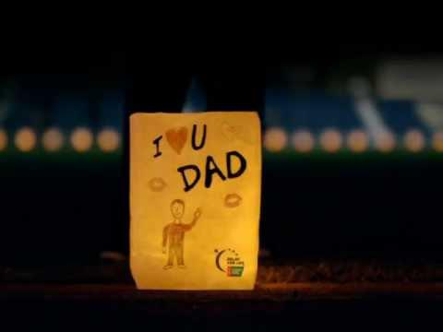
Relay For Life Luminaria TV Commercial
www.youtube.com
When we walk together, we're bigger than cancer. Join the world's biggest fight for less cancer and more birthdays, the American Cancer Society Relay For Lif...

Day 47: OLYMP-I-A for HEALTH (Year 2)- Action: I read an article about the 8 most nutrient-dense foods- some more surprising to me than others. Good info! http://www.stumbleupon.com/su/1aNCkS/www.organicauthority.com/health/most-nutrient-dense-healthy-foods-on-earth.html
The 8 Most Nutrient Dense Foods on Earth | Energetic Health
www.organicauthority.com
What are the most nutrient dense foods on the planet? And more importantly, do they taste good?

Day 48: OLYMP-I-A for HEALTH (Year 2)- Action: Kata and tournament demo practice and a workout at the gym :))!

Day 49: OLYMP-I-A for HEALTH (Year 2)- Action: I read an informative article about foods that can keep you from getting a good night's sleep: http://ht.ly/962KZ
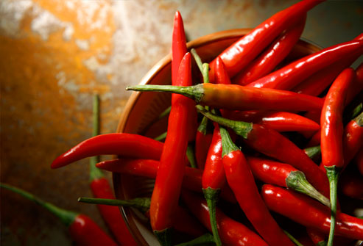
The Green Life Pages | Healthy Recipes
www.greenlifepages.com
For those of us who love to snack before bed. Beware of these 5 foods.

Day 50: OLYMP-I-A for HEALTH (Year 2): I read an article on "mindful eating" shared with me by a friend. It is not only what we eat, but how we eat that matters. http://www.nytimes.com/2012/02/08/dining/mindful-eating-as-food-for-thought.html?_r=3&pagewanted=all%3Fsrc%3Dtp&smid=fb-share

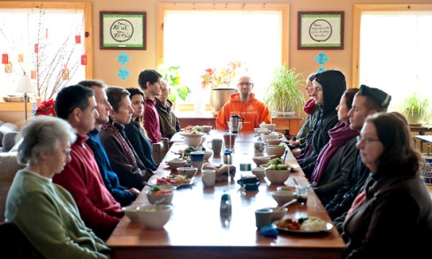

Day 51: OLYMP-I-A for HEALTH (Year 2): I read an informative article on the power of touch and the science that shows its impact on health and well-being: http://www.dailygood.org/view.php?sid=9. "This research is suggesting that touch is truly fundamental to human communication, bonding, and health.....Proper uses of touch truly have the potential to transform the practice of medicine—and they’re cost effective..."

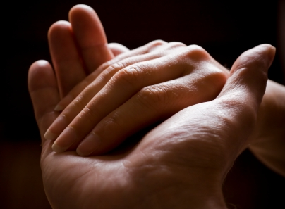
DailyGood: Hands On Research: The Science of Touch, by Dacher Keltner
www.dailygood.org
A pat on the back, a caress of the arm--these are everyday, incidental gestures that we usually take for granted. But after years spent immersed in the science of touch, University of

Day 52: OLYMP-I-A for HEALTH (Year 2): I read an inspirational article about a Special Olympian, Tim Lupton-Stegall. "I've always been a positive person," he said. "I see people and I just want to make sure they are happy at work or at races. I think why I survived all of these things is because of my positive attitude and my will to live."
Attitude is life-changing! A great message! http://www.eastvalleytribune.com/local/the_valley/ahwatukee/article_1fd383f5-ddad-5220-a543-4b484b653737.html
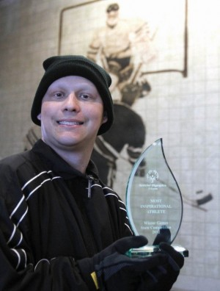
Lupton-Stegall uses Special Olympics as outlet for life's struggles
www.eastvalleytribune.com
Tim Lupton-Stegall probably had no business being in the middle of all his friends, skating effortless as if he never

Day 53: OLYMP-I-A for HEALTH (Year 2)- Action/Idea: I am awakening to the day, so amazed at life and the adventures it brings us along the way. Physical and mental challenges work to make us stronger, often in ways we don't even recognize. I am working to focus today.... Kung Fu test here I come :)). When we push our perceived limitations, we enter the world of discovery.

Day 54: OLYMP-I-A for HEALTH (Year 2)- Idea: Health is found in pursuing balance in life. There is a fine line between peak performance and exhaustion. The body and mind call us to balance. It is important to listen.

Day 55: OLYMP-I-A for HEALTH (Year 2)- Action: Attended an impressive Shaolin Do Kung Fu tournament, got to see some highly skilled martial artist forms, sparring, and demos, and participated in the women's demo. Great times with great friends!

Day 56: OLYMP-I-A for HEALTH (Year 2)- Action: Participated in a wonderful seminar given by Shaolin Do Kung Fu Grand Master Sin The and learned two new, powerful katas. Fun and challenging to mind and body!

Day 57: OLYMP-I-A for HEALTH (Year 2)- Action: Had an organic veggie and fruit smoothie with added Vitamin C for supper! Power-packed nutrition!

Day 58: OLYMP-I-A for HEALTH (Year 2)- Action: Did some stationary biking, floor exercises, and stretching, focusing on strengthening my knees. Great workout in under an hour. Then, later, went to Kung Fu class ... "tiger" workout!

Day 59: OLYMP-I-A for HEALTH (Year 2)- Action: Watched a video of an inspiring young swimmer. Limitless potential!! http://video.msnbc.msn.com/nbc-news/46338524#46338524
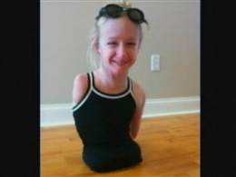
Lack of limbs doesn't stop 10-year-old swimmer
video.msnbc.msn.com
Video on msnbc.com: "I feel free in the water," says 10-year-old Breanna Sprenger, who, despite having only one arm and no legs, is a competitive swimmer. WKYC-TV's Jennifer Lindgren reports.

Day 60: OLYMP-I-A for HEALTH (Year 2)- Action: Worked out for an hour at the gym- cycling and stretching.

Day 61: OLYMP-I-A for HEALTH (Year 2)- Action: Walked my dog in the neighborhood on a beautiful, sunny afternoon!

Day 62: OLYMP-I-A for HEALTH (Year 2)- Action: Kung Fu workout in the morning and started learning a new kata!

Day 63: OLYMP-I-A for HEALTH (Year 2)- Action: Took a beautiful walk around the lake in the morning, Kung Fu conditioning class at noon, then another long walk in the gorgeous March Spring weather. A beautiful weekend!

Day 64: OLYMP-I-A for HEALTH (Year 2)- Action: Worked out at the gym- cycling and floor exercises.

Day 65: OLYMP-I-A for HEALTH (Year 2)- Action: Had a great workout at Kung Fu class- tiger forms and more :)).

Day 66: OLYMP-I-A for HEALTH (Year 2)- Action: Worked out at the gym and also did some strengthening physical therapy for my knee.

Day 67: OLYMP-I-A for HEALTH (Year 2)- Action: Talked with children and read them stories about how animals can help people (e.g. service dogs) and how we can help animals stay healthy.

Day 68: OLYMP-I-A for HEALTH (Year 2)- Action: Bought organic produce- veggies, fruits.

Day 69: OLYMP-I-A for HEALTH (Year 2)- Action: Ate a delicious macrobiotic vegan lunch... kale and rice mixed with quinoa. So good :)).

Day 70: OLYMP-I-A for HEALTH (Year 2)- Action: Lots of exercise... Kung Fu conditioning class, walking at the lake... a gorgeous day!

Day 71: OLYMP-I-A for HEALTH (Year 2)- Action: Watched an inspiring video, showing how creativity and belief in an idea can transform playing soccer into provision of a healthy power source: http://www.youtube.com/watch?v=AqOZLfr-JTY. This is so awesome!!
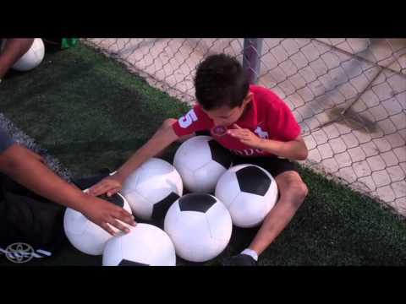
Mothers of Invention: "Turning Play to Power"
www.youtube.com
Through pure innovation, two Harvard undergrads created an energy-harvesting soccer ball that quite literally empowers

Day 72: OLYMP-I-A for HEALTH (Year 2)- Action: Found out about a new shopping cart, designed especially for children with special needs. It can also accommodate adults with special needs. The cart is called "Caroline's Cart" and is inspired and designed by a parent of a youth with special needs. http://www.lsu.edu/departments/gold/2012/03/cart.shtml
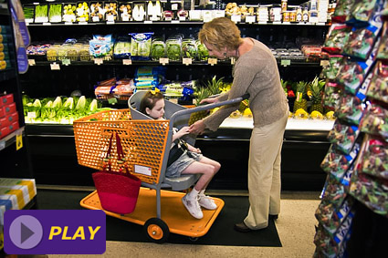
A Mother's Love Inspired LSU Alumna Drew Long to Design Shopping Cart for Special Needs Children
www.lsu.edu
These are just some of the challenges facing the parents of special needs children who have outgrown traditional supermarket shopping carts.

Day 73: OLYMP-I-A for HEALTH (Year 2)- Action: Did some stationary biking along with exercises to strengthen my knee and topped it off with relaxing stretching :)).

Day 74: OLYMP-I-A for HEALTH (Year 2)- Action: Taking "Sambucus Immune Syrup" (elderberry syrup with zinc & echinacea) for my cold. I'm a believer in its ability to boost immunity and help lessen the length and severity of colds. I've used it many times and rely on its preventive effects on trips.
Natures Way Sambucus Immune Syrup 8 oz (240 ml)
www.google.com
Google does not charge for inclusion in its search results and all advertisements are clearly marked. Tax and shipping costs are estimates.

Day 75: OLYMP-I-A for HEALTH (Year 2)- Action: Sharing an informative link.
Bright Paint or Bright Kids?
www.nationofchange.org
When I was repainting the exterior of my house in Oakland, I showed the painter a photo of a house painted with bright blue trim. “That’s the color I want,” I said to the painter, who shook

Day 76: OLYMP-I-A for HEALTH (Year 2)- Action: Took a walk downtown and by the river and enjoyed some music at SXSW. A great way to start the day!

Day 77: OLYMP-I-A for HEALTH (Year 2)- Action: Enjoying a relaxing morning after getting some much needed sleep... taking a few moments to pause, appreciate life, and follow the true intent of the weekend (rest).

Day 78: OLYMP-I-A for HEALTH (Year 2)- Action: Had my last physical therapy session for my knee and "graduated," only to be handed an exercise regimen to continue at least 3X/week :))

Day 79: OLYMP-I-A for HEALTH (Year 2)- Action: Walked my dog and went to Kung Fu class.

Day 80: OLYMP-I-A for HEALTH (Year 2)- Action: Worked out at the gym and took a walk with my neighbor.

Day 81: OLYMP-I-A for HEALTH (Year 2)- Action: Sharing an innovation for the kitchen to assist people in obtaining filtered water.
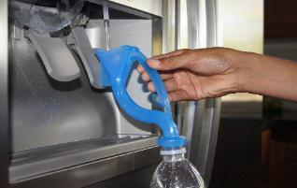
Check Out This Eco-Friendly Kickstarter Project!
www.kickstarter.com
Dr. Fill's Water Tunnel is used to refill standard and wide-mouth water bottles with filtered water from all refrigerator dispensers, without spills.

Day 82: OLYMP-I-A for HEALTH (Year 2)- Action: I am enjoying a probiotic drink which contains acerola. I read up more about acerola, the Vitamin C super-fruit. http://www.webmd.com/vitamins-supplements/ingredientmono-608-ACEROLA.aspx?activeIngredientId=608&activeIngredientName=ACEROLA

ACEROLA: Uses, Side Effects, Interactions and Warnings - WebMD
www.webmd.com
Find patient medical information for ACEROLA on WebMD including its uses, effectiveness, side effects and safety, interactions, user ratings and products that have it.

Day 83: OLYMP-I-A for HEALTH (Year 2)- Action: Feeling better after getting some good rest. Sleep... the body's own miracle cure :))

Day 84: OLYMP-I-A for HEALTH (Year 2)- Action: Took a long walk along trails through fields of wildflowers. A beautiful way to get good exercise.

Day 85: OLYMP-I-A for HEALTH (Year 2)- Action: I read about World Autism Awareness Day, coming up on April 2nd, and "Light It Up Blue": http://www.lightitupblue.org/Markslist/home.do. I also found info on Facebook at: https://www.facebook.com/pages/Light-It-Up-Blue/199407840080896
Light it Up Blue | Autism Speaks
lightitupblue.org
Join Autism Speaks in celebrating World Autism Awareness Day on April 2 and Light It Up Blue to help shine a light on autism. Whether it's your front porch or your local city hall, an

Day 86: OLYMP-I-A for HEALTH (Year 2)- Action: Passing along great info on veggie protein sources!
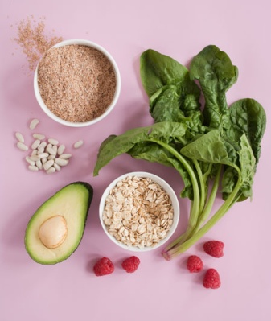
vegetarian protein sources | 9 Super-Healthy, Vegetarian Protein Sources | Rodale News
www.rodale.com
You don't need a 20-ounce porterhouse to meet your daily protein requirement. There are much cheaper and healthier

Day 87: OLYMP-I-A for HEALTH (Year 2)- Action: I was at the gym today and saw a great example of true strength. An older woman (with a deceptive appearance of frailty) was there in a motorized scooter and her right side was paralyzed. She was using the exercise machines to help work her muscles on both her right and left side. All by herself she managed, slowly to situate herself near the exercise machines and work them. She managed quite well, showing patience, concentration, and perseverance. Never stopping. Never giving up because it was hard. I was inspired to do my best by watching her. She was a role model of strength and tenacity. What a cool person!!

Day 88: OLYMP-I-A for HEALTH (Year 2)- Action: Sharing an interesting article regarding lessons learned from Tai Chi and the health of balance. Thanks to Mike S. for sharing.
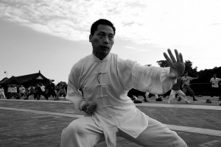
Waking Times. Where revolution and evolution collide, bringing ideas that make the world a better pl
wakingtimes.com
Waking Times brings you human news and conscious ideas about the things in our changing world that beg us to evolve or revolt. If you are awake, you are part of the solution.

Day 89: OLYMP-I-A for HEALTH (Year 2)- Action: Had a great work-out at the gym- bicycling and floor exercises.

Day 90: OLYMP-I-A for HEALTH (Year 2)- Action: Practiced spear katas outside in Kung Fu class on a beautiful Spring morning.

Day 91: OLYMP-I-A for HEALTH (Year 2)- Action: Held my great-nephew and felt the heartbeat of a new generation. How we live impacts the future. Our health will influence his health. A powerful message and motivation for healthy living!

Day 92: OLYMP-I-A for HEALTH (Year 2)- Action: Sharing an article about a social innovation project of "Design for America," a nationwide college nonprofit organization. Very cool!
http://www.good.is/post/child-s-play-a-teddy-bear-to-help-diabetic-kids-master-their-care/
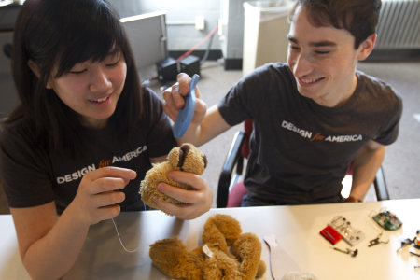
Child's Play: A Teddy Bear to Help Diabetic Kids Master Their Care - Lifestyle - GOOD
www.good.is
He's cute, cuddly, and looking for a shot of insulin. Jerry the Bear is not your average stuffed animal.

Day 93: OLYMP-I-A for HEALTH (Year 2)- Action: Talked with 5 and 6 yr. olds about the benefits of organic foods and the importance of looking beyond the advertising and packaging. We had a taste test of 3 different brands of strawberry yogurt with different packaging. Most of them knew the word "organic" but they had a hard time explaining what it was. We had a good discussion. As you might predict, they liked the yogurt that tasted the sweetest which was also the one that had the most fun-looking and brightly-colored container.

Day 94: OLYMP-I-A for HEALTH (Year 2)- Action: Sharing news about a wonderful "Comfort the Children Intl" (CTC) health project with the Maasai in Kenya. http://www.ctcinternational.org/blog/2012/04/03/ctc-trains-grandmothers-home-based-care

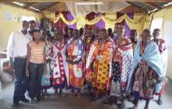
CTC Trains Grandmothers in Home-Based Care | CTC International
www.ctcinternational.org
It was an exciting week as the Health program was finalizing on home based care training in Oleimwa in Maasai land.

Day 95: OLYMP-I-A for HEALTH (Year 2)- Action: Learning new Kung Fu katas! Awesome! Stretching my body and my brain :)).

Day 96: OLYMP-I-A for HEALTH (Year 2)- Action: Sharing a great video message: http://www.youtube.com/watch?v=RlEWEO4cEAo
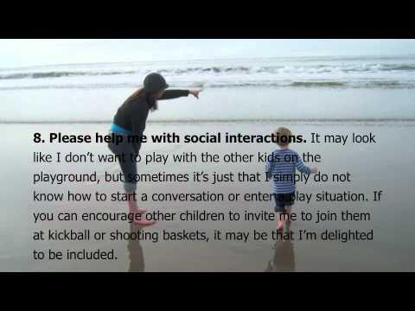

10 Things Every Child With Autism Wants You to Know - Go Brody!
www.youtube.com
Ten Things Every Child with Autism Wishes You Knew from the book by Ellen Notbohm © 2005, 2011 Reproduced with permission of author www.ellennotbohm.com Brod

Day 97: OLYMP-I-A for HEALTH (Year 2)- Action: Worked outside in the yard, pulling up some weeds, trimming plants, and sweeping the walkway. Good exercise and a good way to enjoy a beautiful, sunny afternoon!

Day 98: OLYMP-I-A for HEALTH (Year 2)- Action: Spending the day with family and friends, relaxing, celebrating, experiencing the uplifting rhythms of life. A healthy boost for the soul :)).

Day 99: OLYMP-I-A for HEALTH (Year 2)- Action: Good workout today with stationary bicycling and floor exercises. Added some upper body workout.

Day 100: OLYMP-I-A for HEALTH (Year 2)- Action: Took my dog on a walk in the beautiful Spring afternoon sunshine.

Day 101: OLYMP-I-A for HEALTH (Year 2)- Action: I watched a beautiful video demonstrating the enlivening and restorative power of music. iPods + music + good memories bring a measure of happiness, love, and health. A wonderful connection between the old and the new. http://www.youtube.com/watch?feature=player_embedded&v=NKDXuCE7LeQ
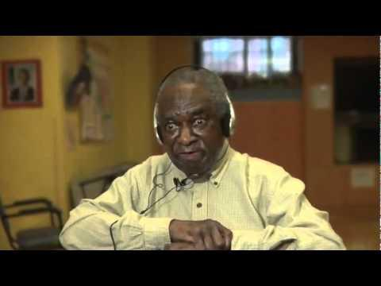
Old Man In Nursing Home Reacts To Hearing Music From His Era
www.youtube.com
Old Man In Nursing Home Reacts To Hearing Music From His Era

Day 102: OLYMP-I-A for HEALTH (Year 2)- Action: Sharing an informative article on autism, emphasizing the importance of paying attention to what foods we eat and to the environment in which our food is grown and prepared. Our health and the health of our children depend on it. http://www.commondreams.org/headline/2012/04/11-6.
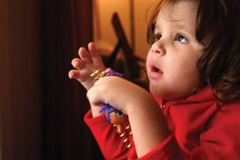
Study: Autism Linked to Industrial Food, Environment
www.commondreams.org
A new study by Clinical Epigenetics has found that the rise in autism in the United States could be linked to industrial food and the American diet. The study, published yesterday online, explores how mineral deficiencies could impact how the

103: OLYMP-I-A for HEALTH (Year 2)- Action: Took a long walk with my neighbor and our dogs. The weather was cool and breezy. It was a lovely evening to be outside.

104: OLYMP-I-A for HEALTH (Year 2)- Action: Had a great Kung Fu class. Invigorating way to start the morning :)).

Day 105: OLYMP-I-A for HEALTH (Year 2)- Action: Sharing data about safeguarding our children's health, posted by the Children's Defense Fund: "Arm yourself with the facts by checking out the 'Myths about Guns' section in our recent gun report. Myth #3: Guns don't kill people, people kill people." http://www.childrensdefense.org/child-research-data-publications/data/protect-children-not-guns-2012.html
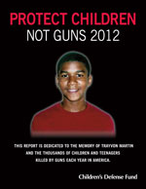
Protect Children, Not Guns 2012
www.childrensdefense.org
CDF's Protect Children, Not Guns 2012 is a compilation of the most recent and reliable national and state data on gun violence in America.

Day 106: OLYMP-I-A for HEALTH (Year 2)- Action: Sharing a video posted by a friend. Children learn meditation and move in a healthy direction. http://www.karmatube.org/videos.php?id=46.
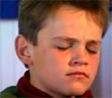
KarmaTube: Children Finding The Compass
www.karmatube.org
Children learn Vipassana meditation, or insight meditation, in over 40 centers around the world. This technique is used as a compass to help calm the mind and give the children a sense of peace and direction.

Day 107: OLYMP-I-A for HEALTH (Year 2)- Idea: I keep being reminded that health is found in balance. When I over-do, my body rebels a little (or a lot) and makes me slow down and regain balance. I always learn something in the slowing down. For some reason, these reminders seem to come more frequently as I age.... hmmmm :)). Perhaps the wisdom of aging is that we get lots of practice learning about balance.

Day 108: OLYMP-I-A for HEALTH (Year 2)- Action: Practicing Tai Chi today and enjoying learning a new form and method of focus.

Day 109: OLYMP-I-A for HEALTH (Year 2)- Action: Drinking some "Zola" organic Acai juice- delicious and healthy, lot of antioxidants and omega fatty acids 3, 6, & 9: https://www.facebook.com/drinkzola
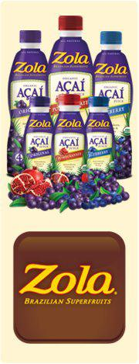
Zola Acai
Our mission is simple. Zola is fanatical about traveling the world to find the best ingredients for our great tasting beverages.

Day 110: OLYMP-I-A for HEALTH (Year 2)- Action: I watched the TV newscast that won the 2012 Barbara Jordan Media Award in the TV Feature-Extended category.. “The Baty Bot” story. The "story highlights high school freshman Lyndon Baty from Knox City, Texas. Baty has infantile polycystic kidney disease and uses a robot along with his love of sports to overcome isolation." What a creative and inspiring young man!
http://www.nbcdfw.com/on-air/about-us/NBC-5-Sports-Wins-Barbara-Jordan-Media-Award-142393345.html
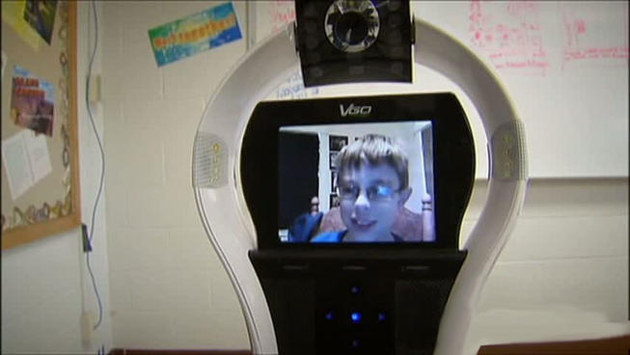
NBC 5 Sports Wins Barbara Jordan Media Award
www.nbcdfw.com
NBC 5 sports's Matt Barrie, Noah Bullard, and photographer, Peter Hull, win the 2012 Barbara Jordan Media Award.

Day 111: OLYMP-I-A for HEALTH (Year 2)- Action/Idea: I attended a pediatrics conference meeting discussing the quality of health care of children with disabilities. Progress and change in health care is often frustratingly slow, but persistence is the key. The challenges will never be met if people give up seeking collaborative solutions.

Day 112: OLYMP-I-A for HEALTH (Year 2)- Action: Did a brisk 3 mile walk around the lake, trailing a spry group of my Kung Fu buddies who were jogging and left me in a cloud of dust :)). Wonderful, cool Spring morning and the lake was sparkling. So refreshing! Good health, good friends, good times!

Day 113: OLYMP-I-A for HEALTH (Year 2)- Action: While working at the computer, I did some pedaling on a small stationary exercise bike that fits under my desk. A great way to keep moving while sitting for long periods of time at a desk.

Day 114: OLYMP-I-A for HEALTH (Year 2)- Action: I read a wonderful article about the impact of dogs on our health and emotional well-being, affirming what dog-lovers, like me, know to be true :)) http://www.huffingtonpost.com/andrew-weil-md/health-benefit-pets_b_1447033.html
The Healing Power Of Dogs
www.huffingtonpost.com
In 1982, a longtime friend gave me a Rhodesian Ridgeback puppy as a birthday present. I told her, gently, that it was utterly inappropriate; my life was far too unsettled. She thrust

Day 115: OLYMP-I-A for HEALTH (Year 2)- Action: I attended an informative lecture on school safety and the prevention of school violence and learned about helpful resources for schools. https://www.facebook.com/txssc
Texas School Safety Center
The Texas School Safety Center (TxSSC) is a central location for safety and security information pertaining to all independent school districts and junior college districts in the state of Texas. Services provided include training, research, and technical assistance related to successful safety and...

Day 116: OLYMP-I-A for HEALTH (Year 2)- Action: I read about "Meals on Wheels and More" and learned about the variety of programs they offer, primarily delivering meals and groceries for the elderly, however, also offering some home repairs and help with pets. The organization helps sustain the health and well-being of those served. People can volunteer or give monetary contributions to help. I'm "in" :)) http://www.mealsonwheelsandmore.org/programs/
Meals on Wheels and More - Programs
www.mealsonwheelsandmore.org
Meals on Wheels and More seeks to nourish and enrich the lives of the homebound and other people in need through programs that promote dignity and independent living.

Day 117: OLYMP-I-A for HEALTH (Year 2)- Action: Sharing a post by "Special Olympics Texas":
"The kids at Clack Middle School are raising the bar for the Meet in the Middle program. Kristi Newton shares some of the great ways her school is being inclusive and bringing students of all abilities together." http://www.sotx.org/news-events/blog/2012-blogs/at-clack-we-meet-in-the.html
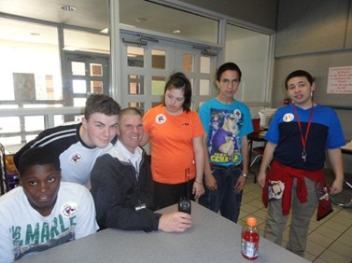

At Clack, We Meet in the Middle
www.sotx.org
The Meet in the Middle program at Clack Middle School has more than 80 students participating in an inclusion based program called Lunch and Sports. The campus-wide initiative

Day 118: OLYMP-I-A for HEALTH (Year 2)- Action: Went on a walk with my dog and saw a beautifully illuminated cloud formation at sunset. Brilliant!

Day 119: OLYMP-I-A for HEALTH (Year 2)- Action: Sharing an article about a way to improve health and inner peace, and more... Very cool! Thanks to John Scott for posting. http://www.nytimes.com/2012/04/29/technology/google-course-asks-employees-to-take-a-deep-breath.html?_r=1
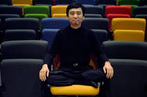
Google Course Asks Employees to Take a Deep Breath
www.nytimes.com
At a company known for a hard-driving culture, a seven-week course in mindfulness techniques is giving employees a better way to cope.

Day 120: OLYMP-I-A for HEALTH (Year 2)- Action: I worked out at the gym- bicycling and strengthening exercises for my knees.

Day 121: OLYMP-I-A for HEALTH (Year 2)- Action: I played kickball and basketball with some elementary school children. What fun! Keeping me young at heart!

Day 122: OLYMP-I-A for HEALTH (Year 2)- Action: I attended a lecture about the importance of reducing non-medically-indicated, elective deliveries of babies before 39 wks. gestational age. The speaker mentioned "The Leapfrog Group." I read more about "The Leapfrog Group" online and their efforts to improve hospital quality in this area. Key info to share with family members and friends about the importance of giving babies a full 39 weeks of gestation before delivery if at all possible. http://www.leapfroggroup.org/news/leapfrog_news/4827337

Hospitals Make Progress in Eliminating Early Elective Deliveries: Good News, but More Work Needs to.
www.leapfroggroup.org
News & Events > Hospitals Make Progress in Eliminating Early Elective Deliveries: Good News, but More Work Needs to be Done

Day 123: OLYMP-I-A for HEALTH (Year 2)- Action: Sharing info from the International Rescue Committee and promoting a pledge to spread the word about critical obstacles to health and well-being facing women and girls around the world.
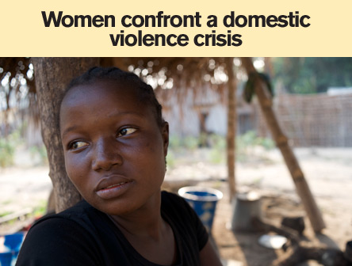
Help For Women & Girls | Wake Up & Take Action | IRC | International Rescue Committee (IRC)
www.rescue.org
Millions of women and girls confront daily threats to their health, their livelihoods and their dignity. Stand with women!

Day 124: OLYMP-I-A for HEALTH (Year 2)- Action: I walked up stairs instead of taking the elevator. A step (or should I say several steps :)) in the right direction.

Day 125: OLYMP-I-A for HEALTH (Year 2)- Action: Had a great Kung Fu class! Practiced many old katas as well as the new ones I'm learning. Always a good workout for my body and my memory.

Day 126: OLYMP-I-A for HEALTH (Year 2)- Action: I found out about the program "Spirit Reins." Spirit Reins is a 501c3 non-profit whose mission is to improve the emotional and behavioral health of children with the help of horses. Spirit Reins serves children who have experienced abuse and/or neglect or other traumatic events. Spirit Reins’ program, Reins of Hope, is based on the Natural Lifemanship model of Equine Assisted Psychotherapy (EAP). https://www.facebook.com/pages/Spirit-Reins/119092691696
Spirit Reins
Spirit Reins improves the lives of children and families through trauma-informed therapy services, training, and research. We offer a variety of innovative professional counseling services and specialize in serving children who have experienced abuse, neglect, or other traumatic events by incorporat...

Day 127: OLYMP-I-A for HEALTH (Year 2)- Action: I watched a wonderful video demonstrating the powerful and positive impact of friendship on health.
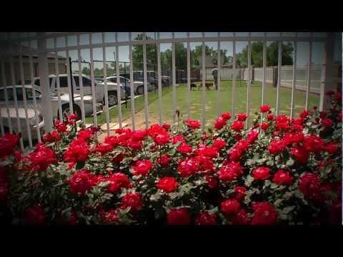

Original Tanner and Blair Best Friends KTUL news story by Andrejs Dabars and Burt Mummolo.mp4
www.youtube.com
The little dog story that did! The dogs are a blast to work with...we are so glad we

Day 128: OLYMP-I-A for HEALTH (Year 2)- Action: I had fun and laughter playing "Uno" and "Bingo" games with children today. A great way to boost health!

Day 129: OLYMP-I-A for HEALTH (Year 2)- Action: Planning to share some of the local, organic produce I got from the "Farm to Work" program with family and friends. Got an "abundance" of produce and will be fun to "share the health" and maybe find out some new recipes :))

Day 130: OLYMP-I-A for HEALTH (Year 2)- Action: Played "keep-away" with children in an after-school program. I had a good workout, mainly because they were definitely the experts at keeping the ball away from me :)). I found myself in the "middle" most of the time, trying to intercept their passes. Lots of fun had by all!

Day 131: OLYMP-I-A for HEALTH (Year 2)- Action: Saw the movie "Bully." Very moving and powerful. Critical viewing for all who support the mental and physical health of children. It is important to encourage children and adults to see this film: http://action.thebullyproject.com/million

The Bully Project
action.thebullyproject.com
This year 13 MILLION American kids will be bullied. 3 MILLION students will be absent because they feel unsafe at school. Take a stand against bullying today.

Day 132: OLYMP-I-A for HEALTH (Year 2)- Action: I watched this video and had to share it! Please watch it too! So inspiring!!! http://www.youtube.com/watch?feature=player_embedded&v=qX9FSZJu448
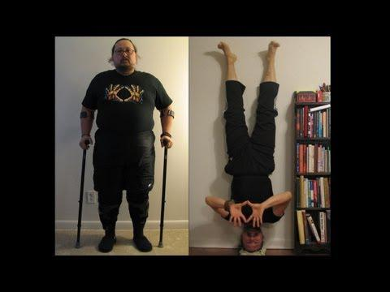

Never, Ever Give Up. Arthur's Inspirational Transformation!
www.youtube.com
If this story can inspire someone you know, please share it with them! Arthur Boorman was a disabled veteran of the Gulf War for

Day 133: OLYMP-I-A for HEALTH (Year 2)- Action: I spent a wonderful afternoon with my son and my husband... the heartbeats of my soul!

Day 134: OLYMP-I-A for HEALTH (Year 2)- Action: I enjoyed being inspired by a photo-blog highlighting an incredible woman... still doing yoga at 93! So amazing!!
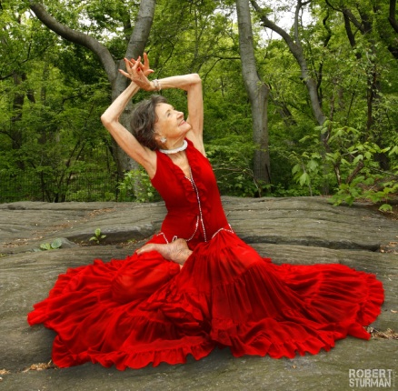

A Meeting In Central Park With The Oldest Living Yoga Teacher In The World. ~ Photographed by Robert
www.elephantjournal.com
Master Tao, a 93 year old yoga master, showed us the moves in Central Park.

Day 135: OLYMP-I-A for HEALTH (Year 2)- Action: I took a much-needed nap. When you stop and think about it, it is quite miraculous how the body refreshes and restores itself with sleep. Sleep is the all-natural, cost-effective, organic, miracle stress-reducer :))

Day 136: OLYMP-I-A for HEALTH (Year 2)- Action: Went on two walks today- one by the lake and one around the neighborhood... a beautiful and refreshing afternoon to be outside.

Day 137: OLYMP-I-A for HEALTH (Year 2)- Action: I took a short break from the computer at work and did "office" exercises. Helped with my focus and energy level.

Day 138: OLYMP-I-A for HEALTH (Year 2)- Action: I listened to some inspiring speeches about science and its contributions to our health and understanding of life and the world. The speeches were part of the opening ceremony of the Science Olympiad National Tournament. http://www.scienceolympiad2012.com/
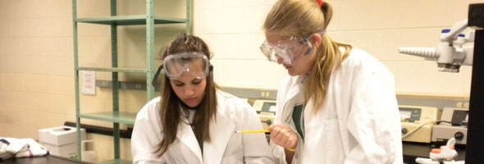
Science Olympiad National Tournament
www.scienceolympiad2012.com

Day 139: OLYMP-I-A for HEALTH (Year 2)- Action: I helped at a fun Shaolin-Do Kung Fu tournament with the children and teen competitors. Kung Fu is such a wonderful discipline for mind and body. Great to see the talent and good sportsmanship of the young people involved!

Day 140: OLYMP-I-A for HEALTH (Year 2)- Idea/Action: I thought about the wonderful life and legacy of Katie Beckett. She impacted the health and well-being of so many!! I visited the FB page "In Memory of Katie Beckett" and was inspired by all the posts there honoring Katie. Such a beautiful person! https://www.facebook.com/InMemoryOfKatieBeckett
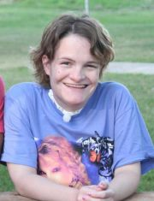

Day 141: OLYMP-I-A for HEALTH (Year 2)- Action: I shared a possible grant-funding opportunity (http://www.humana.com/resources/about/corporate/hcb/) with some friends who are directors of non-profit organizations. I encourage others to pass along this info. The grant supports organizations that support childhood health and education, health literacy and services, and intergenerational health.
Humana Communities Benefit - Charitable Giving
www.humana.com
Humana's charitable giving program in support of mind, body and spirit, as an outgrowth of Humana's commitment as a corporate citizen.

Day 142: OLYMP-I-A for HEALTH (Year 2)- Action: I watched some videos now available for viewing on the new National Center for Medical Home Implementation (NCMHI) YouTube channel (www.youtube.com/aapmedicalhome). The videos provide important info for parents and health care providers. The videos feature thought leaders and medical home advocates and their thoughts on the medical home concept of care and how to implement it in medical practice. Framed around the six building blocks of the Building Your Medical Home toolkit (www.pediatricmedhome.org), the interview videos are designed to provide an in depth view of the essential components that make up the medical home. All children deserve a medical home!
AAPMedicalHome's channel
www.youtube.com
The National Center for Medical Home Implementation (NCMHI) is a cooperative agreement between the Maternal and Child Health Bureau (MCHB) and the American Academy of

Day 143: OLYMP-I-A for HEALTH (Year 2)- Action: Went to Tai Chi class and learned some powerful applications of the Tai Chi kata moves. Stretching body and mind :))

Day 144: OLYMP-I-A for HEALTH (Year 2)- Action: I finished participating in a two-day training with staff for a city-wide summer childcare program. I provided information and training on the "OLYMP-I-A" challenge. I learned how important summer activities can be for the educational growth and development of children. We hope to try out the "OLYMP-I-A" challenge with the children during the summer and engage them in positive habits for health, green-living, and peace and recognize them for their positive lifestyle choices.

Day 145: OLYMP-I-A for HEALTH (Year 2)- Action: I saw a truck with the name "Farmhouse Delivery" painted on its side. I looked up Farmhouse Delivery online: https://www.farmhousedelivery.com/about.html. The Farmhouse Delivery trucks bring organic produce from local farms to peoples' homes and offices. "Farmhouse Delivery members are given not only recipes and cooking tips, but also storage advice - what can be frozen, what should be placed in a crisper drawer - to ensure that the food is enjoyed and nothing goes to waste." Wonderful!!
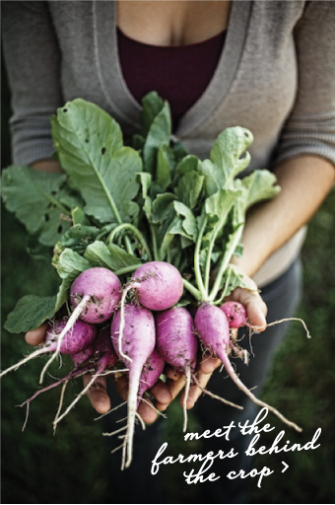
Farmhouse
www.farmhousedelivery.com
Description #4

Day 146: OLYMP-I-A for HEALTH (Year 2)- Action: I read an article about the benefits of drinking water and staying hydrated. New research with students says drinking water can help boost thinking power: http://www.everydayhealth.com/healthy-living/0419/drink-water-it-makes-you-smart.aspx?xid=fb_EH_sf

Drink Water, It Makes You Smarter - Healthy Living - Everyday Health
www.everydayhealth.com
In a new study, students who brought water into exams scored higher than those who didn't. The researchers believe staying hydrated lowered anxiety and improved thinking

Day 147: OLYMP-I-A for HEALTH (Year 2)- Idea/Action: I want to bicycle more, so I took my old, non-functional bike to a bike repair shop to compare the cost of repair to that of purchasing a working bike. Still in the process of deciding. If I decide to purchase a working bike, I plan to recycle my old one, either to the Yellow Bike Project (https://www.facebook.com/pages/Austins-Yellow-Bike-Project/194137973930427) or the Green Team Re-cycling Project.
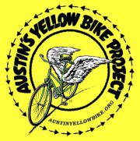
Austin's Yellow Bike Project
The Austin Yellow Bike Project (YBP) 501c(3) is an all-volunteer initiative to put bicycles on the streets of Austin and Central Texas by operating community bike shops, teaching bike mechanics and maintenance, and acting as a local bike advocacy group.

Day 148: OLYMP-I-A for HEALTH (Year 2)- Action: Took the plunge and got a working bike (& recycled the old, non-working one). Now no excuses for not biking :))

Day 149 (changed # from 148): OLYMP-I-A for HEALTH (Year 2)- Action: Though I was tired at the end of a long day, I still decided to go to Kung Fu class. I can always count on feeling better when I go.

Day 150 (changed # from 149): OLYMP-I-A for HEALTH (Year 2)- Action: I did a long bike ride and stopped along the way for a cool drink. I tried a new kind of GTs Synergy Kombucha drink with chia seeds. Very tasty and perfect for a hot day. https://www.facebook.com/GTsSynergyKombucha
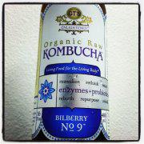
GTs Synergy Kombucha
In 1995, Millennium Products founder GT Dave was inspired by how Kombucha had helped his mom overcome breast cancer that he began making it from the kitchen of his house. Fast forward over 10 years. GT's Kombucha has grown to a full-fledged company that makes over a dozen different varieties of Ko...

Day 151 (changed # from 150): OLYMP-I-A for HEALTH (Year 2)- Action: I watched the movie "First Position," an amazing documentary about the training and incredible talent of young ballet dancers who are competing at a world-class level. It was beautiful to see their skill, dreams, hard work, and dedication. The movie provides insight into their lives, setbacks, and triumphs. I was transported to a time in my youth when I practiced many hours and, though I was far from "world-class," I was swept away by the soaring joy and passion of the dance.

Day 152 (changed # from 151): OLYMP-I-A for HEALTH (Year 2)- Action: I biked around the neighborhood in the late afternoon. When riding on a bike instead of traveling in a car, I feel closer to the world and the life around me... all the sights, sounds, smells are more present. Great exercise for the body and the senses :))

Day 153 (changed # from 152): OLYMP-I-A for HEALTH (Year 2)- Action: I got in some good stretching after Kung Fu class. I'm starting to work on my back too... trying some slow-stretch back-bends. Haven't done that in far too long :)). We'll see how it goes!

Day 154: OLYMP-I-A for HEALTH (Year 2)- Action: Had fun at Kung Fu practice. Lots of exercise and good times with friends. Learned a new kata from start to finish! Now the hard part... exercising my brain and remembering it :)).

Day 155: OLYMP-I-A for HEALTH (Year 2)- Action: I read an article that provides great, practical tips about how to fit exercise into our daily lives. http://blogs.hbr.org/cs/2012/05/find_exercise_in_lifes_margins.html
Find Exercise in Life's Margins (Harvard Business Review)
blogs.hbr.org
You consider yourself a fit, active person. But, like most busy professionals, you want to exercise more. You want to hit the gym more frequently, you want to finally start taking that yoga class or make that 7 am boot camp in the local park. And then

Day 156: OLYMP-I-A for HEALTH (Year 2)- Action: I read an informative article about foods that help relieve seasonal allergy symptoms. Yeah! http://vegnews.com/articles/page.do;jsessionid=7845D9617887260A551D28C5B4CFD8E0?pageId=4566&catId=7
5 Allergy-Soothing Superfoods
vegnews.com
Keep seasonal allergies at bay by incorporating these tasty treatments into your diet.

Day 157: OLYMP-I-A for HEALTH (Year 2)- Action: I read an article with good tips for combating chronic inflammation and staying healthy: http://articles.mercola.com/sites/articles/archive/2012/06/06/eft-on-chronic-inflammation.aspx.
Body Hacks to Help You Minimize Chronic Inflammation
articles.mercola.com
These simple body hacks can help you avoid chronic inflammation, which is a risk factor of many dangerous diseases.

Day 158: OLYMP-I-A for HEALTH (Year 2)- Action: I read about safe, healthy ways to reuse food packaging. There are important tips on reuse of plastic and other containers. http://earth911.com/news/2012/06/06/reuse-it-safely-food-packaging/.
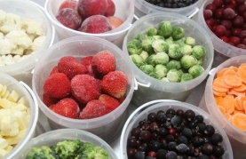
Wall Photos
Want to reuse your food packaging? Here's how to do it safely http://bit.ly/KOjdOv
By: Earth911

Day 159: OLYMP-I-A for HEALTH (Year 2)- Action: I prepared some OLYMP-I-A instructions and materials for summer childcare and education programs. I'm excited about the possibilities of reaching lots of children!

Day 160: OLYMP-I-A for HEALTH (Year 2)- Action: Went for a walk at dusk while visiting with relatives. A wonderful and cooler time a day for a stroll. Refreshing and relaxing!

Day 161: OLYMP-I-A for HEALTH (Year 2)- Action: I heard a radio public service announcement about the National Heart, Lung, and Blood Institute's "We Can" program and learned more about it online: http://www.nhlbi.nih.gov/health/public/heart/obesity/wecan/about-wecan/index.htm. This "national education program provides parents and caregivers with tools, fun activities, and more to help them encourage healthy eating, increased physical activity, and reduced time sitting in front of the screen (TV or computer) in their entire family."
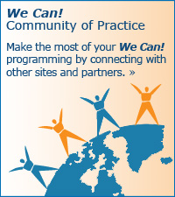
We Can! Ways to Enhance Children's Activity & Nutrition - Overview
www.nhlbi.nih.gov
We Can! (Ways to Enhance Children's Activity & Nutrition) is a national program designed as a one-stop resource for parents

Day 162: OLYMP-I-A for HEALTH (Year 2)- Action: Sharing a Facebook post from a friend. Well said! Hugs are uplifting and are supercharges for health! “Hugs are important things. They can have so many meanings: welcome home; hey we’re both here, let’s do this thing; missed you; thank you; you make me happy; you are special; can we have more of these; you touch my heart; love you; bye, gotta go; what else? They are all important…”

Day 163: OLYMP-I-A for HEALTH (Year 2)- Action: Went on an early morning walk with my dog before it got too hot. I love walking in the morning. The earth, the birds, the squirrels... all seem refreshed after a good night's sleep.

Day 164: OLYMP-I-A for HEALTH (Year 2)- Action: Sharing a Facebook post by Natural Grocers and Mama Chia: "Mmmm! A pudding recipe that's Gluten-Free, Dairy-Free, Paleo and Vegan. Guess what's for dessert tonight! The author says it's also a great pre-workout fuel-up. Think you might add it to your pre-workout routine?
Or would you prefer it as a dessert only?"

Quite an impressive recipe to meet all those criteria. What a fun, creative, and DELICIOUS way to enjoy healthy eating!!!
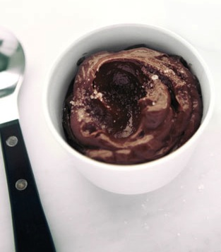

Raw Vegan Dessert Recipes: Chocolate Chia Pudding
blog.hailmerry.com

Day 165: OLYMP-I-A for HEALTH (Year 2)- Action: I talked with children about how they can each be champions in working to stay healthy. It just takes practice. They all had great ideas and will be practicing this summer with the OLYMP-I-A "Power" Game.

Day 166: OLYMP-I-A for HEALTH (Year 2)- Action: Sharing a post from the Association for Maternal and Child Health Programs (AMCHP): "Fathers play a very important role in healthy child development - from preconception and throughout life! Connecticut's Fatherhood Initiative is an example of a broad-based, multi-agency, statewide program that aims to change systems that can improve fathers’ ability to be fully and positively involved in the lives of their children. http://1.usa.gov/L80ygZ" I visited the website and watched a great video about the program called "Promoting Responsible Fatherhood." It is wonderful to see the impact this program is having!

Fatherhood Initiative of Connecticut
www.ct.gov
/fatherhood Website

Day 167: OLYMP-I-A for HEALTH (Year 2)- Action: I did a "cool" thing with my Kefir probiotic drink. I kept it in the freezer and got it almost frozen solid, then took it out and let it thaw just a little, shook it up, and had a wonderful, cool, refreshing, slushy/frozen yogurt-type drink. Awesome and healthy!

Day 168: OLYMP-I-A for HEALTH (Year 2)- Idea: A day for celebrating fathers. I am so fortunate to have a family with men of different generations who are wonderful fathers. We must never underestimate the power of example. Parents (fathers and mothers) have the power to shape the health and well-being of future generations.

Day 169: OLYMP-I-A for HEALTH (Year 2)- Action: I brainstormed with staff from a federal and state- funded nutrition program about how to integrate the OLYMP-I-A into nutrition and exercise programs.

Day 170: OLYMP-I-A for HEALTH (Year 2)- Action: I had fun talking with children at a local summer camp about the OLYMP-I-A challenge. Each day the children will be encouraged to write or draw about what they think and do to try to stay healthy. There were over 80 children in this one camp and they will be generating positive ideas and actions for health this summer! A positive force for positive change... working together to make the "staying-healthy" muscle stronger!

Day 171: OLYMP-I-A for HEALTH (Year 2)- Action/Idea: I talked with another group of children at summer camp. They told me all about how they stay healthy: exercise, eat veggies, run, play, brush their teeth, drink clean water, and more. It is so wonderful to see all they think about and do for health. The more we recognize children for these everyday ideas and actions, the more they are aware of their importance, the more they want to practice, and the stronger and healthier they become.

Day 172: OLYMP-I-A for HEALTH (Year 2)- Action: I ate some wonderful, tasty home-grown cherry tomatoes, given to me by a friend. Such great flavor! A delicious snack!

Day 173: OLYMP-I-A for HEALTH (Year 2)- Action: Greeting and meeting friends at my high school reunion. I very healthy dose of fun, reminiscing, hugs, and sharing life stories. It's an amazing sensation of time travel, leaping back to 18 years old again. The intervening years just fade away. We're all still young at heart :))

Day 174: OLYMP-I-A for HEALTH (Year 2)- Action: Got out for an early walk with my dog and then off to Kung Fu class. A great way to "kick" off the morning :).

Day 175: OLYMP-I-A for HEALTH (Year 2)- Action: Attended a fantastic day-long Kung Fu women's retreat and learned two upper level katas. Great friends, great teaching!

Day 176: OLYMP-I-A for HEALTH (Year 2)- Action: Took some time for rest and relaxation after a busy last few days.

Day 177: OLYMP-I-A for HEALTH (Year 2)- Action: Sharing some tips for healthy happiness :))
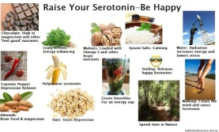
Wall Photos
We @ WSH recommend following to be HAPPY....... have a amazing day.... love only.
By: World School of Happiness

Day 178: OLYMP-I-A for HEALTH (Year 2)- Action: I read research study results documenting that altruism and volunteering are sources of happiness. "There is ... plenty of evidence that people who care more about others are typically happier than those who care more about themselves. But does that mean that altruism increases happiness in a causal sense? Evidence on volunteering and on giving money suggests that it does.... Acts of kindness have a similar effect – in a randomized experiment, the treatment group was told to do three extra acts of kindness a day and this significantly raised their happiness for some weeks.... Moreover altruism can be trained. After two weeks’ compassion training, a control group gave more [to others]... in a laboratory game and showed more neural activity in the reward centers of the brain." Source: " World Happiness Report"

http://www.earth.columbia.edu/sitefiles/file/Sachs%20Writing/2012/World%20Happiness%20Report.pdf
www.earth.columbia.edu

Day 179: OLYMP-I-A for HEALTH (Year 2)- Action: Sharing key information regarding children's health. Eight of the nation’s leading child health and advocacy organizations reacted to the U.S. Supreme Court’s 5-4 ruling today to uphold the Affordable Care Act.
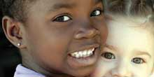
Children’s Health Advocates React to Affordable Care Act Ruling
www.childrensdefense.org
“Today, the Supreme Court upheld a law that invests in children’s health from the ground up.”

Day 180: OLYMP-I-A for HEALTH (Year 2)- Action: I read an inspiring article about a wonderful program of "compassionate companions." More info is found at: http://www.modernmedicine.com/modernmedicine/Modern+Medicine+Now/Will-you-stay-with-me-The-No-One-Dies-Alone-progra/ArticleStandard/Article/detail/602013.
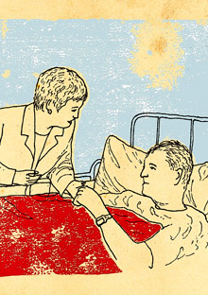
Kindness of Strangers - How One Nurse Made Sure No One Dies Alone - Oprah.com
www.oprah.com
Not everyone goes to their deathbed surrounded by loved ones, which is why an Oregon nurse enlisted an entire hospital

Day 181: OLYMP-I-A for HEALTH (Year 2)- Action: I attended the Texas Parent to Parent conference and heard an informative presentation on health care reform with clear, factual information on the Affordable Care Act. The presenter recommended the following website for consumers to obtain key info: http://www.healthcare.gov/. The website content helps explain the legislation and how it impacts individuals and families. It is refreshing to get the facts.
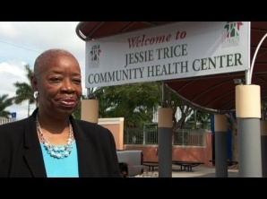
Home | HealthCare.gov
www.healthcare.gov
Take health care into your own hands; find out how the Affordable Care Act affects you. Get the answers at HealthCare.gov.

Day 182: OLYMP-I-A for HEALTH (Year 2)- Action: A glorious, cool morning! Went on a long bike ride.... so quiet and peaceful in the early morning. So amazing to see the beauty of the earth waking up.

Day 183: OLYMP-I-A for HEALTH (Year 2)- Action/Idea: I learned key info about the health impact of a sip of soda. Small, seemingly insignificant actions can and do have impact and ripple effect. We should share and teach such information to children as well as adults. If we choose not to drink soda, we need to explore and learn similar facts about whatever we do choose to drink (and eat). The details matter to our health.
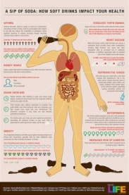
Wall Photos
Sip of Soda
By: Wellness by Carrie

Day 184: OLYMP-I-A for HEALTH (Year 2)- Action: I ate some organic Turkish apricots (with no preservatives) together with some organic plain almonds (no salt). The combination of flavors is a delicious treat. It only takes a few of each (apricots and almonds) to satisfy the mid-afternoon snack attack :))

Day 185: OLYMP-I-A for HEALTH (Year 2)- Action: Celebrated and walked in the July 4th Independence Day neighborhood parade and then took a long walk through the neighborhoods with a friend. A beautiful sunny morning with fireworks of crape (or crepe) myrtle blossoms all along the way! http://en.wikipedia.org/wiki/File:Crepe_Myrtle.jpg

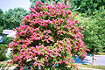
File:Crepe Myrtle.jpg - Wikimedia Commons
commons.wikimedia.org

Day 186: OLYMP-I-A for HEALTH (Year 2)- Action: I had a fun Kung Fu class- good workout, good friends.

Day 187: OLYMP-I-A for HEALTH (Year 2)- Action: Enjoyed a delicious slice of cold watermelon! A great refresher and hydrator on a hot summer afternoon!
Wall Photos
By: Live Love Fruit

Day 188: OLYMP-I-A for HEALTH (Year 2)- Action: Took 3 walks- in the morning, afternoon, and nighttime. Went from hot to hotter to cool. A wonderfully refreshing breeze cooled things off in the evening.

Day 189: OLYMP-I-A for HEALTH (Year 2)- Action: I read a local natural health newsletter article about the health benefits of the spice turmeric. Curcumin, the main component in turmeric, may help suppress the growth of malignancies in the head and neck. Also, turmeric has anti-inflammatory properties. I looked up more about turmeric online: http://www.umm.edu/altmed/articles/turmeric-000277.htm
Turmeric
www.umm.edu

Day 190: OLYMP-I-A for HEALTH (Year 2)- Idea: Again and again I realize that my family and good friends are the heartbeat of my health.

Day 191: OLYMP-I-A for HEALTH (Year 2)- Action: I did quick interval office chair exercises to break up long periods of sitting and working at the computer. Helps my posture, my alertness, and my energy level.

Day 192: OLYMP-I-A for HEALTH (Year 2)- Action: Had a healthy afternoon snack... a delicious, juicy peach from Vogel Orchard. Yum! https://www.facebook.com/pages/Vogel-Orchard/135194009856525
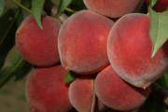
Vogel Orchard
Peaches, plums, blackberries, pumpkins, and more raised by the Vogel family for you and your family. Vogel Orchard was established 1953, and our roadside market has been located on Hwy 290 2 miles west of Stonewall and 12 miles east of Fredericksburg since 1971."

Day 193: OLYMP-I-A for HEALTH (Year 2)- Action: I read key facts from an article by the Center on Budget and Policy Priorities. "Expanding Medicaid will add very little to what states would have spent on Medicaid without health reform, while providing health coverage to 17 million more low-income adults and children.
In Texas, as many as 2 million more low-income adults would gain affordable health insurance, and our state would only have to spend $5.8 billion in five years to cover that. Not to mention, our hospitals wouldn't be over-burdened with growing uncompensated care costs paid for by local taxpayers. This is a win for Texas."
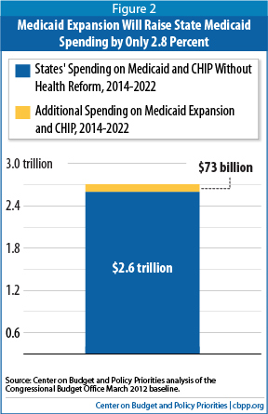

How Health Reform’s Medicaid Expansion Will Impact State Budgets — Center on Budget and Policy Prior
www.cbpp.org

Day 194: OLYMP-I-A for HEALTH (Year 2)- Action: I watched an inspiring and moving video about the importance of sharing and giving life to others, through both physical nutrition (food) and mental nutrition (caring and love). http://www.youtube.com/watch?v=-S74HuDIRa4&feature=youtu.be
A Greatly Inspiring Video
www.youtube.com
I have no words to say about this video. Watch yourself & feel. If this video touches or inspires you please recommend it to others & also extend your comments.

Day 195: OLYMP-I-A for HEALTH (Year 2)- Action: I read an article about the wonderful work of the Seva Foundation and The Nobelity Project- restoring sight in the mountains of Nepal: http://www.huffingtonpost.com/turk-pipkin/the-nobelity-project_b_1525995.html. I found more info about the Seva Foundation at www.seva.org and The Nobelity Project at http://www.nobelity.org/.
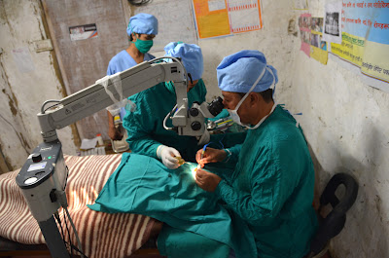
Let There Be Sight
www.huffingtonpost.com
Two hours later, I was in scrubs in a temporary operating room, standing next to Dr. Kamal as he performed intricate surgery after surgery to remove heavy cataracts and restore the patient's vision.

Day 196: OLYMP-I-A for HEALTH (Year 2)- Action: Great Kung Fu workout and stretching, practicing old katas and working on new ones. Good stretching for the mind as well as the body.

Day 197: OLYMP-I-A for HEALTH (Year 2)- Action: I played "blob tag" with a group of children at a summer camp. Awesome game! A fun way to get exercise. Lots of running.

Day 198: OLYMP-I-A for HEALTH (Year 2)- Action: I danced with children at a summer camp.

Day 199: OLYMP-I-A for HEALTH (Year 2)- Action: I had fun at a summer camp for children... giving lots of piggy-back rides, and giving and receiving lots of hugs :))

Day 200: OLYMP-I-A for HEALTH (Year 2)- Action: Kung Fu class- awesome!

Day 201: OLYMP-I-A for HEALTH (Year 2)- Action: Had fun jumping like a frog with children at a summer camp... a good cardio workout. It's a good thing I've done those "frog-leaps" in Kung Fu class :))

Day 202: OLYMP-I-A for HEALTH (Year 2)- Action: Had a great Kung Fu class this morning, lots of energy in the class and good times with friends. Some people were testing (and passed!) which made the class extra special. Also, stayed and taught some of the pre-K students and got another boost of energy :))

Day 203: OLYMP-I-A for HEALTH (Year 2)- Action: Started the day with a breakfast of organic Bulgarian yogurt with granola and blueberries. Yum!!

Day 204: OLYMP-I-A for HEALTH (Year 2)- Action: I did some office exercises and stretches today at work to break up the time sitting at the computer. Helps give me a needed boost of energy and is a good substitute for snacking and/or caffeine.

Day 205: OLYMP-I-A for HEALTH (Year 2)- Action: I did some floor exercises and stretching while watching a T.V. show.

Day 206: OLYMP-I-A for HEALTH (Year 2)- Action: This week is the International AIDS Conference in Washington D.C. I looked up The Global Fund on Facebook and read about its work to fight AIDS, malaria, and tuberculosis: https://www.facebook.com/theglobalfund. The video, "The New Picture of Health" describes the progress of programs supported by The Global Fund: https://www.youtube.com/watch?v=XaqCKcCAHXY.
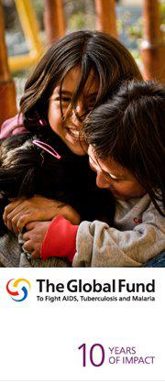
The Global Fund to Fight AIDS, Tuberculosis and Malaria
The Global Fund to Fight AIDS, Tuberculosis and Malaria is an international financing institution that invests the world’s money to save lives. To date, it has committed US$ 22.6 billion in 150 countries to support large-scale prevention, treatment and care programs against the three diseases.

Day 207: OLYMP-I-A for HEALTH (Year 2)- Action: I went to a waterpark with relatives and had lots of fun along with a total body workout tubing, sliding, splashing (and crashing :)).

Day 208: OLYMP-I-A for HEALTH (Year 2)- Action: I was introduced to "Zyflamend" by a friend several years ago and have been taking it ever since. I looked it up online so I can share with others the details about its many health benefits. http://www.newchapter.com/zyflamend/zyflamend-whole-body
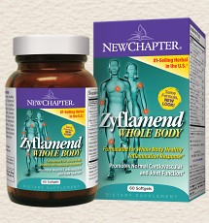
New Chapter Zyflamend® Whole Body
www.newchapter.com
Inflammation affects the whole body, not just your joints and back. Zyflamend® Whole Body supports a natural healthy inflammation response.

Day 209: OLYMP-I-A for HEALTH (Year 2)- Action: I learned about the book "The Inner Game of Tennis" at Kung Fu class: http://books.google.com/books?id=IiWMQe070QcC&source=gbs_book_other_versions. The book reveals how a person's internal state affects performance. Awareness of the "inner game" is critical for all sports and life in general.
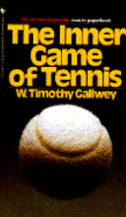

The Inner Game of Tennis
books.google.com
The Inner Game of Tennis is a revolutionary program for overcoming the self-doubt, nervousness, and lapses of concentration that can keep a player from winning. Now available in a revised paperback edition, this classic

Day 210: OLYMP-I-A for HEALTH (Year 2)- Action: Got up early and weeded the garden in the cool morning.

Day 211: OLYMP-I-A for HEALTH (Year 2)- Action: I am enjoying watching the Olympics. The extraordinary skill and will of the athletes, forged through focus, dedication, and practice is an inspiration. The message is clear. The path to strength in our lives is through attention, commitment, and practice. These are not passive activities. They are hard work, yet well worth it. The positive results can be amazing!

Day 212: OLYMP-I-A for HEALTH (Year 2)- Action: Sharing a story that shows the impact of love and nurturing on health. Loves comes in all shapes and sizes and sometimes it's camouflaged :)). Caring and nurturing others is the pathway to health.
Wall Photos
A female tiger lost her cubs from premature labor. Shortly after her health decl...

See More
By: TabooJive.com

Day 213: OLYMP-I-A for HEALTH (Year 2)- Action: Sharing a chart with info on foods and activities that help boost serotonin and happiness.
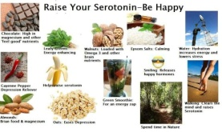
Wall Photos
By: Nutrition Research Center

Day 214: OLYMP-I-A for HEALTH (Year 2)- Action: Did some chair push-ups while taking a short 5-minute break at work. Also, got some needed leg movement and blood flowing with simple cycling on my office pedaling machine.

Day 215: OLYMP-I-A for HEALTH (Year 2)- Action: I went for a swim. It was a hot day and the water felt cool and refreshing. As I swam some laps, I let my imagination take hold and transport me into the Olympics with the crowd cheering me on and the adrenalin pumping as I pushed toward the end of the race. Then I emerged "victorious." What fun! Ahhh... never underestimate the power of positive imagination :)).

Day 216: OLYMP-I-A for HEALTH (Year 2)- Action: Kung Fu class this morning! Lots of stretching, katas, and more stretching. As is often the case, I learned something new about several of the katas I've been doing for years. I realize there is so much left to discover in the katas I already know as well as those I have yet to learn.

Day 217: OLYMP-I-A for HEALTH (Year 2)- I watched history in the making as Oscar Pictorius ran in the 400m semi-finals at the Olympics. So inspiring!! http://www.telegraph.co.uk/sport/olympics/athletics/9454624/London-2012-Olympics-Oscar-Pistorius-out-but-achievements-will-resound-for-years-to-come.html

London 2012 Olympics: Oscar Pistorius out but achievements will resound for years to come - Telegrap
www.telegraph.co.uk

Day 218: OLYMP-I-A for HEALTH (Year 2)- I did some stretching while watching the news on T.V.

Day 219: OLYMP-I-A for HEALTH (Year 2)- I took a short 5 minute break at work and did some armchair push-ups and deep knee bends. A quick way to boost mood, focus, and energy level.

Day 220: OLYMP-I-A for HEALTH (Year 2)- Action: Working on a long Tai Chi form... the practice of the balance and integration of complementary forces, and of recognizing and accepting them as one. Definitely a challenge for the brain which has a strong tendency to study and understand life by compartmentalizing and separating.

Day 221: OLYMP-I-A for HEALTH (Year 2)- Action: I learned about "Blogust" the Blog Relay for Good: http://www.youtube.com/watch?v=zF4tgiF172Q&feature=youtu.be. Each day for 31 days, one after the other, 31 influential bloggers will post about someone who inspires them. Each time that a person comments on one of the posts it will generate $20 to help immunize a child in a developing country (up to $200,000). I found out more info at http://www.shotatlife.org/blogust/. I commented on one of the posts and helped raise money. So simple, yet powerful!

Blogust: Blog Relay for Good
www.youtube.com
http://www.blogust.org Blogust is a 31-day "relay" of blog posts, one per day for the month of August, each post

Day 222: OLYMP-I-A for HEALTH (Year 2)- Action: I saw a television ad about the US Paralympics Military and Veterans Programs so I looked it up online to learn more about it: http://www.teamusa.org/US-Paralympics/Military.aspx. "The U.S. Olympic Committee (USOC) Paralympic Military & Veteran Programs provide post-rehabilitation support and mentoring to American servicemen and women who've sustained physical injuries such as traumatic brain injury, spinal cord injury, amputation, visual impairment/blindness and stroke.... The program isn't just about sports; it's also about attitude, camaraderie and promoting healthy, active lifestyles." I found a listing of military athlete U.S. Paralympians: http://www.teamusa.org/US-Paralympics/Military/Military-Athletes.aspx. True inspiration!

U.S. Paralympics | Military | USOC
www.teamusa.org
Military

Day 223: OLYMP-I-A for HEALTH (Year 2)- Action: I found out about "Make a Hero:" http://www.makeahero.org/. It is "a non-profit that keeps on giving; establishing a cycle in which people are sharing their passion for sports and recreation with others that need rehabilitation... Make A Hero is committed to making adaptive recreation and activity accessible and welcoming to all individuals with disabilities."
Make a Hero | Helping individuals with disabilities enjoy the freedom of sports and recreation
www.makeahero.org
Helping individuals with disabilities enjoy the freedom of sports and recreation

Day 224: OLYMP-I-A for HEALTH (Year 2)- Action: Going on an early morning bike ride. Destination unknown :)) Always a great way to start the day!

Day 225: OLYMP-I-A for HEALTH (Year 2)- Action: I walked my dog in the early morning. Good for her health and mine. I love exploring the neighborhood on our walks. It is interesting how there are different neighborhood communities (different people and different animals out and about) at different times of day. This morning we were among the "early risers." Off to a fresh start for the new day.

Day 226: OLYMP-I-A for HEALTH (Year 2)- Action: I learned about the "Half the Sky Movement" at http://www.halftheskymovement.org/pages/movement. The movement "brings together video, websites, games, blogs and other educational tools to not only raise awareness of women's issues, but to also provide concrete steps to fight these problems and empower women." As part of the movement, a 4 hour PBS TV series is being filmed in 10 countries. Three mobile phone games are available in communities in India and East Africa: "9 Minutes" (on healthy birthing practices), "Worm Attack!" (de-worming awareness) and "Family Values" (highlighting the value of girls in families). The movement is a far-reaching and powerful collaboration for positive change!

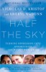

Half The Sky
www.halftheskymovement.org

Day 227: OLYMP-I-A for HEALTH (Year 2)- Action: I read an article about how we can enjoy and treasure our diversity and find joy and celebration of life in artistic expression (thanks to a friend for sharing): http://clicks.robertgenn.com/joyous-mind.php
The joyous mind
clicks.robertgenn.com

Day 228: OLYMP-I-A for HEALTH (Year 2)- Action: Discovered a fun and creative way to make ice cubes part of healthy eating and drinking :)) http://www.brit.co/ice-ice-baby-5-creative-takes-on-the-ice-cube/
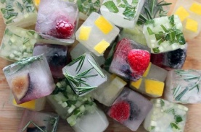
Wall Photos
Ready to revolutionize the way you make ice cubes? Try adding fruit, herbs, or...freshly squeezed juice to your ice cube trays for an easy, extra spark of flavor. http://www.brit.co/ice-ice-baby-5-creative-takes-on-the-ice-cube/.
By: Brit + Co..

Day 229: OLYMP-I-A for HEALTH (Year 2): Action: I learned about World Mosquito Day and "Mozzy Air," a creative campaign by "Malaria No More UK" to increase awareness and gain support of the battle against malaria. I entered my story (via "Mozzy Air") of witnessing the impact of malaria in my travel to Ghana.
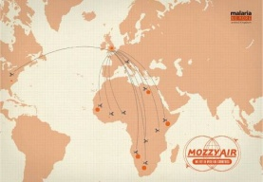
Wall Photos
Check out Mozzy Air – the latest awareness campaign from Malaria No More UK! It’s a spoof airline that flies to over 100 malaria destinations brought to life with compelling real life stories. Help spread the word and upload your own story to help save lives: http://malarianomore.org.uk/mozzyair
By: Malaria No More.

Day 230: OLYMP-I-A for HEALTH (Year 2)- Action: I enjoyed Kung Fu class this morning. Lots of exercise and fun (and punches) with good friends. Some among us are getting ready for major testing events this week and the rest of us are rallying support. Anticipating great tests by all!

Day 231: OLYMP-I-A for HEALTH (Year 2)- Action: I took advantage of the weekend and slept late this morning. The "down-time" in the day is definitely as important and the "up-time." Health is found in the balance.

Day 232: OLYMP-I-A for HEALTH (Year 2)- Action/Idea: I was eating at a macrobiotic restaurant yesterday and read about the 30 macrobiotic principles on a set of small flipcards on the table. Today, I read an online article about the 30 principles, as elaborated by Verne Varona (http://macrobiotics.co.uk/articles/principles.htm). Quoted from the article: "In these principles, you can hear the echos of the Old and New Testament, of Talmudic scholars, Buddhistic precepts and essential Taoism, as well as the inspirational works of Lao Tzu, Ishizuka, Kibara, Hufeland, Gurdjieff, Ouspensky, Russell, and so many more that share credit for their existence... The payoff for learning these principles and being able to identify them, is the gift of living a great life (macro = great / bios = life)." It would be a good challenge to take each principle and try to see how it is working (or not working) in my life.
The Macrobiotic Principles - 30 Natural Laws of Life and Change
macrobiotics.co.uk
I've always felt like a closet cult member telling someone that, "I'm macrobiotic." I could have said: "Hi, I'm part of the "Humu-Humu clan," and it really wouldn't have made any difference. ...

Day 233: OLYMP-I-A for HEALTH (Year 2)- Action: I read a great blog post about plant-based food ideas for children's lunch boxes. Easy, fun, tasty, and healthy options (and good ideas for adults as well)! http://happyherbivore.com/2012/08/plant-based-lunchboxes/
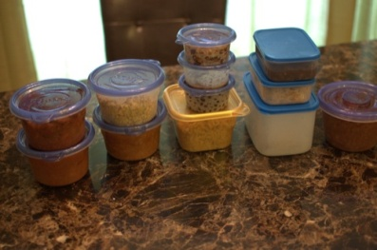
Plant-Based Lunch Boxes
happyherbivore.com
We have a Herbie Parents group on Facebook that is a great tool for parents who are working towards or on a plant-based diet. There's so many discussions and recipe

Day 234: OLYMP-I-A for HEALTH (Year 2)- Action: I read the Centers for Disease Control and Prevention's fact sheet on West Nile Virus: http://www.cdc.gov/ncidod/dvbid/westnile/wnv_factsheet.htm. Recently, there has been an increase in human West Nile Virus infections in Texas. It helps to stay informed on prevention measures.
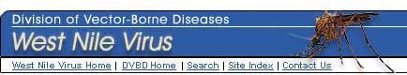
CDC: West Nile Virus - What You Need To Know
www.cdc.gov
The West Nile Virus Home Page of the U.S. Centers for Disease Control and Prevention (CDC), an agency of the U.S. government.

Day 235: OLYMP-I-A for HEALTH (Year 2)- Action: Today is a day for enjoying a variety of exercise: I got up early and walked my dog. After work, I practiced Kung Fu and then biked to the store. The slightly cooler weather is inspiring me!

Day 236: OLYMP-I-A for HEALTH (Year 2)- Action: Taking a vacation day! The early morning dawned with a beautiful, soft, rose-colored light. There was a gentle, cool breeze and I went for a long walk, enjoying this special moment in time.

Day 237: OLYMP-I-A for HEALTH (Year 2)- Action: I took an amazing Shaolin Do Kung Fu seminar with the Grand Master. Lots of rolling, leaping, spinning, punching... I love the challenge of it all! Great teaching! Great exercise! Such inspiration! I think there was a true awakening of some new muscle groups :))

Day 238: OLYMP-I-A for HEALTH (Year 2)- Action: I went for an early morning bike ride with a friend. Met some challenging hills. A beautiful day!

Day 239: OLYMP-I-A for HEALTH (Year 2)- Action: I allowed myself an extra hour of sleep this morning... good body and soul recuperation time!

Day 240: OLYMP-I-A for HEALTH (Year 2)- Action: I read about the "Save the Children" and "Ad Council's" campaign, "Every Beat Matters," for newborn and child survival. The campaign is raising money for frontline healthcare workers around the globe. To partner in the effort, "One Republic" has created a new song, "Feel Again," using real heartbeats of children from Malawi and Guatemala (http://www.iheartradio.com/player/?mid=22365393). A portion of proceeds from downloads and sales of the song will go to support the campaign. I found out more info about the campaign and how to download the song at: http://www.everybeatmatters.org/#heartbeatNav.

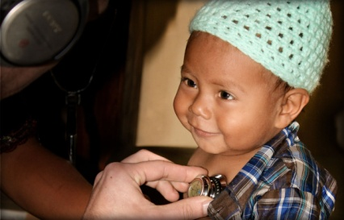

Day 241: OLYMP-I-A for HEALTH (Year 2)- Action: I read a helpful article and chart about gluten-free foods: http://www.thedailymeal.com/what-gluten-free. Some good guidance!

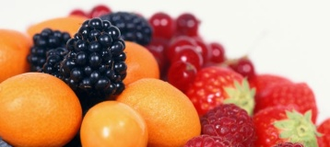

Day 242: OLYMP-I-A for HEALTH (Year 2)- Action: I learned about the "mHealth Alliance" (http://www.mhealthalliance.org/), which promotes the use of mobile technologies to advance public health, and "Health Unbound" (HUB) (http://www.healthunbound.org/content/about ), an "interactive network and online knowledge resource center for the mobile health (mHealth) community." Great info about the vast potential for information networking (through mobile phones and other mobile technologies) for health.

Day 243: OLYMP-I-A for HEALTH (Year 2)- Action: I went on a long walk this morning in the cool, early-morning air. I awakened to the day along with the birds, squirrels, and other early risers. A simple, beautiful way to enjoy exercise, listening to the musical rhythm of nature.

Day 244: OLYMP-I-A for HEALTH (Year 2)- Action: I had a great work-out at Kung Fu class. We drilled the same kata over and over with attention to the details. It is amazing how practicing a kata multiple times can awaken you to nuances you never realized or understood before. As in life, we strengthen what we practice. However, for positive change and growth to occur, the practice must be mindful with intentional awareness.

Day 245: OLYMP-I-A for HEALTH (Year 2)- Action: Starting early this morning, I joined a group of friends and walked 3 miles along the river, then walked my dog in the neighborhood, and then went to practice some Kung Fu. If it weren't for stretching at every turn, my body would be hollering at me right now. Instead, it is just muttering :)). "Scientific proof" of the benefits of stretching! :)))

Day 246: OLYMP-I-A for HEALTH (Year 2)- Action: I saw a friend of mine competing in a triathlon this morning. I got inspired and did my own mini-triathlon- walked my dog (with some jogging), went on a bike ride which ended up at a swimming pool, and then went for a swim and biked back home :))

Day 247: OLYMP-I-A for HEALTH (Year 2)- Action: I saw free sunscreen offered at a local swimming pool and noticed a sign posted about the "Play Safe in the Sun" campaign. Then, I looked up the campaign online and read more about it: http://www.playsafeinthesun.org/. The campaign works at "curbing the incidence of skin cancer by providing free screenings, sun damage assessments, sun safety education, and free sunscreen to the public."
Play Safe in the Sun | A Women's Dermatologic Society Community Outreach Service
www.playsafeinthesun.org

Day 248: OLYMP-I-A for HEALTH (Year 2)- Action/Idea: I'm enjoying some "unprescribed" time. In a fast-paced world with multi-multi-tasking, it is good to take time on occasion (even if just 30 minutes) to enjoy free time, no plans, a blank page before you. Often, in such times, freedom and creativity find their way to join you.

Day 249: OLYMP-I-A for HEALTH (Year 2)- Action: I read an interesting article about how music (especially when we play music together) may help promote empathy. Empathy is a key component of mental health. http://startempathy.org/blog/2012/09/does-playing-music-boost-kids’-empathy

Day 250: OLYMP-I-A for HEALTH (Year 2)- Action: I walked my dog this morning. As we passed a house with a fenced yard, I looked up expecting to see a dog behind the fence and, instead, I saw a pig (a big one at that!)... On other walks I've happened across a house with goats and ducks. Though commonplace in some neighborhoods, these animals are a bit unusual for where I live. A fun surprise to start my day and all because I got outside and went for a walk! Exercise can be a path to discovery!

Day 251: OLYMP-I-A for HEALTH (Year 2)- Action: Enjoyed Kung Fu class and, afterward, helped teach a young Pre-K martial artist. The young ones help us stay young at heart whether or not we are still young in body :))

Day 252: OLYMP-I-A for HEALTH (Year 2)- Action: An early morning run, a walk, a bike ride, and Kung Fu. Next?? Rest and ice! :)))

Day 253: OLYMP-I-A for HEALTH (Year 2)- Action: I found a website that helps you quickly find out the nutritional value of different kinds of foods, compare foods, create recipes, analyze the nutrition value of recipes, etc.: http://nutritiondata.self.com/.
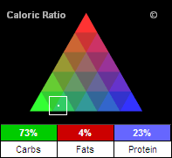
Nutrition facts, calories in food, labels, nutritional information and analysis – NutritionData.com
nutritiondata.self.com
Find nutrition facts, including food labels, calories, nutritional information and analysis that helps promote healthy eating by telling you about the foods you eat.

Day 254: OLYMP-I-A for HEALTH (Year 2)- Action: I enjoyed some delicious figs with a woman who lives in a senior living center. She does not go outside of the center very often. Figs always remind her of Italy since she has relatives there and used to eat figs with them when she visited. For fun, we decided to imagine ourselves eating the figs in a beautiful Italian villa. Healthy treat. Even healthier imaginations!

Day 255: OLYMP-I-A for HEALTH (Year 2)- Action/Idea: I read an article posted by a friend about McDonald's decision to post calorie counts of their menu items. I also noted in the article that the "McDonald's, based in Oak Brook, Ill., is also testing healthier options for next year, such as an Egg McMuffin made with egg whites and a whole grain muffin. The sandwich has Canadian bacon and white cheddar cheese and clocks in at 260 calories." These are steps in a better direction. However, it seems to me that McDonald's could also offer vegetarian options. It would be simple for them to offer vegetarian nuggets as an alternative to chicken nuggets. Why not???
McDonald's to post calorie counts nationwide
www.cbsnews.com
Company also announced Wednesday it is testing healthier foods such as an egg white Egg MucMuffin

Day 256: OLYMP-I-A for HEALTH (Year 2)- Action: I am enjoying some of my friend's home-grown limes. I like squeezing lime juice in water for a change of flavor or sprinkling lime juice on avocado slices. Limes are a good source of Vitamin C. I found a great website where you can select a food item from a list of foods and the website then provides you will all kinds of recipes that include that food item. I selected "lemon/limes" and got a huge assortment of delicious recipe options! http://www.whfoods.com/recipestoc.php. The website is also an excellent resource for information about the nutrient content of different foods, etc.
WHFoods: Over 100 Quick and Easy Recipes
www.whfoods.com
Non-profit foundation providing reliable, scientifically accurate, personalized information for convenient and enjoyable healthy eating.

Day 257: OLYMP-I-A for HEALTH (Year 2)- Action: I watched a video and learned about "The Happy Kitchen," a program of the Sustainable Food Center: https://vimeo.com/43852382. The Happy Kitchen offers classes and recipes for cooking healthy, local, and economical meals.

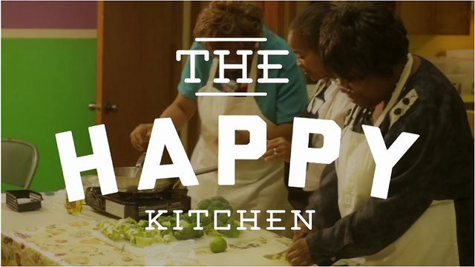

The Happy Kitchen, a program of Sustainable Food Center
vimeo.com
The Happy Kitchen/La Cocina Alegre™, a nationally recognized cooking and nutrition education

258: OLYMP-I-A for HEALTH (Year 2)- Action: After seeing The Nobelity Project's short film "Let There Be Sight" (which features a Seva Foundation eyesight restoration clinic in a remote village in Nepal), I read more online about the Seva Foundation. I learned that for the first time in history, the number of people with blindness is decreasing:http://www.seva.org/site/PageServer?pagename=News_WHO_blindness_report. This decrease is felt to be due, in large part, to the efforts of the many governments and organizations involved in the "VISION 2020: The Right to Sight Global Initiative."

WHO Announces Global Blindness Levels Reduced - Seva Foundation
www.seva.org
WHO releases new data showing that global blindness levels have been reduced.

Day 259: OLYMP-I-A for HEALTH (Year 2)- Action: I found a website with info and reviews of books relevant to parents of children with special needs: http://www.specialneedsbookreview.com/. A good resource!

Special Needs Book Review
www.specialneedsbookreview.com
Special Needs Book Review is the number one review site for parents of special needs children to read about the latest releases and best sellers of literature relating to autism, aspergers and other special needs areas

Day 260: OLYMP-I-A for HEALTH (Year 2)- Action: I read an informative article about the adverse health impacts of too much sugar in our diets and what we can and should do to reduce the sugar we consume. Some impressive facts. Good reference sources. http://livinggreenmag.com/2012/09/17/food-health/sugary-drinks-addiction-in-america-infographic/
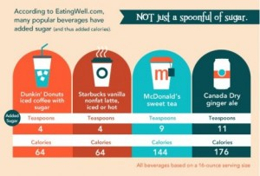
Sugary Drinks Addiction In America [Infographic]
livinggreenmag.com
Why be concerned about the sugar in your children’s drinks? How about the stat that children consuming just one 8-ounce sugar-sweetened drink daily increase their odds for

Day 261: OLYMP-I-A for HEALTH (Year 2)- Action: Had a wonderful time listening to the life stories of a woman in her 90's. Her stories connected and rejuvenated us. We became stronger in the listening and the sharing... a new, vibrant, intergenerational strength.

Day 262: OLYMP-I-A for HEALTH (Year 2)- Action: I read an inspiring article about Special Olympics and the Law Enforcement Torch Run (LETR), a story of collaboration across borders with global impact on health and unity. http://specialolympicsblog.wordpress.com/2012/09/19/fromcanadatoafghanistan/. I learned more about LETR online at: http://www.specialolympics.org/Sections/Donate/Special_Olympics_Torch_Run.aspx. "At its most basic level, the Torch Run is a running event in which officers and athletes carry the Flame of Hope to the Opening Ceremony of local Special Olympics competitions, state/provincial Games, and National Summer or Winter Games." LETR supports fund-raising efforts worldwide for Special Olympics.

From Canada to Afghanistan – Lives are changed
specialolympicsblog.wordpress.com
John Langford, a mentor and trainer to the Afghanistan National Police Force from Canada and a member of the Law Enforcement Torch Run (LETR), recounts a beautiful story of the power of LETR and th...

Day 263: OLYMP-I-A for HEALTH (Year 2)- Action: I started my day with some simple meditation. Being the breath. Being the moment.

Day 264: OLYMP-I-A for HEALTH (Year 2)- Action: I took a nice walk with my dog. However, along the way I saw billowing clouds of pollen in the air. Amazing to see, but worrisome for the allergy potential. I read online about how saline can be used for natural allergy relief: http://www.webmd.com/allergies/saline-spray.

Natural Allergy Relief: Saline Nasal Sprays
www.webmd.com
Saline nasal sprays are a natural remedy that may give you good allergy relief. Learn more from the experts at WebMD.

Day 265: OLYMP-I-A for HEALTH (Year 2)- I got a great conditioning workout at Kung Fu class- push-ups, sit-ups, kicks, punches, and katas (with stretching before and after).

Day 266: OLYMP-I-A for HEALTH (Year 2)- Action: I got up for an early morning run with friends. I was able to run about 5 miles but most of the group ran 7. Friends are great motivators :))

Day 267: OLYMP-I-A for HEALTH (Year 2)- Action: I went for a walk with my dog. She usually goes at a slow pace since she loves to sniff and explore all along the way. This was great for me since I was working out some sore muscles. I find that if I keep doing movement (albeit slow and gentle movement), even when I'm sore, that the soreness often resolves more quickly.

Day 268: OLYMP-I-A for HEALTH (Year 2)- Action: I enjoyed visiting with a woman in her 90's. Helps to put my life and any aches and pains I may have in a new perspective. She mentioned that you have to "listen to your body" and know when to take a break from activities and rest, etc. It was so interesting that she said that. It is something I've been realizing more and more. So true!

Day 269: OLYMP-I-A for HEALTH (Year 2)- Action: I regularly use the stairs instead of the elevator when going between floors at my workplace. A simple way to get some exercise.

Day 270: OLYMP-I-A for HEALTH (Year 2)- Action: I watched a wonderful video revealing the insight and perspective of a young girl with autism. Inspiring and enlightening! http://www.youtube.com/watch?v=34xoYwLNpvw&feature=related

Autism Angel - Carly Fleischmann
www.youtube.com
This is the amazing story of a little girl with autism and how the dedication and perseverance of her parents changed not only there lives but the lives

Day 271: OLYMP-I-A for HEALTH (Year 2)- Action: I took some short breaks and walked outside in the fresh air during a long day working on the computer. The breaks help clear my mind and I find that just a few minutes helps me re-energize and I am more focused and efficient when I return to my work.

Day 272: OLYMP-I-A for HEALTH (Year 2)- Action: I ate an organic pasta dish (spinach lasagna)... thinking that maybe a few more carbohydrates in my diet might help since I've been running more often. I looked up "carb-loading" on the Internet and read an interesting article:http://walking.about.com/od/marathontraining/f/carboloading.htm

Should I Carbo Load Before the Marathon?
walking.about.com
How do you carb load before a marathon? How should you increase your carbohydrate intake before walking or running a marathon?

Day 273: OLYMP-I-A for HEALTH (Year 2)- Action: I went for an early morning run with a group of friends, who, of course, inspired me to run farther than I would have by myself. The encouragement of friends is a powerful motivator :)). Beautiful morning and great exercise!

Day 274: OLYMP-I-A for HEALTH (Year 2)- Action: I pedaled my small stationary cycling machine while working at the computer. It fits under my desk. The exercise is simple and the movement helps stretch my legs during long periods of sitting.

Day 275: OLYMP-I-A for HEALTH (Year 2)- Action: I got a notice from a friend about a "Buddy Walk" event coming up soon in my community. I read more about the Buddy Walk Program online at http://www.ndss.org/buddy-walk/.
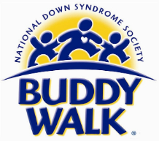
Buddy Walk® - National Down Syndrome Society
www.ndss.org
The Buddy Walk® was established in 1995 by the National Down Syndrome Society to celebrate Down Syndrome Awareness Month in October and to promote acceptance

Day 276: OLYMP-I-A for HEALTH (Year 2)- Action: I went for a 3 mile jog. It was interesting how many times my mind kept telling my body to stop. I found that if I pre-occupied my mind with something else... the beautiful day, nature, some problem I was trying to solve... that my mind left my body alone and let me finish in peace :))

Day 277: OLYMP-I-A for HEALTH (Year 2)- Action: I had a challenging Kung Fu class- kicks, leaps, sweeps, rolls... a full body workout on the ground, in the air, and in-between. :))

Day 278: OLYMP-I-A for HEALTH (Year 2)- Action: Since I try to be sure to take in enough Calcium in my diet, I found a great chart on calcium-rich foods.

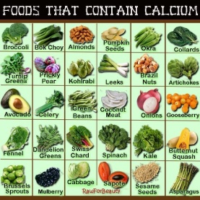
Timeline Photos
What's your favorite calcium-filled food to help build strong bones?
By: Rhythm Superfoods

Day 279: OLYMP-I-A for HEALTH (Year 2)- Action: Went on a nice bike ride around the neighborhood streets with a friend, enjoying the cooler weather.

Day 280: OLYMP-I-A for HEALTH (Year 2)- Action: Ran 9 miles this morning with my running buddies (all much faster than me by the way :)). Settled into a good jogging rhythm around half-way through the run. I was glad to make the distance!

Day 281: OLYMP-I-A for HEALTH (Year 2)- Action: I read an article about scientific research studies that show the impact of compassion meditation on health. Psychologist Barbara Fredrickson at the University of North Carolina-Chapel Hill states that “Just like physical exercise improves muscle tone, emotion training improves vagal [nerve] tone. High vagal tone is related to both a person’s physical health and their ability to feel loving connections with others... In a way, our bodies are designed for love, because the more we love, the more healthy we become.” http://esciencecommons.blogspot.com/2010/10/are-hugs-new-drugs.html

eScienceCommons: Are hugs the new drugs?
esciencecommons.blogspot.com

Day 282: OLYMP-I-A for HEALTH (Year 2)- Action: I ate a delicious broccoli-almond crunch salad-- small broccoli flowerets, shredded carrots, cranberries, chopped almonds, red onion, Greek yogurt, etc. It was tasty and healthy. I looked up the company that made it, "The Green Cart," a local, prepared-foods wholesaler and caterer. "The Green Cart" provides healthy "grab and go" choices. They use hormone-free beef, organic vegetables, and high fructose corn syrup-free ingredients. http://thegreencart.com/
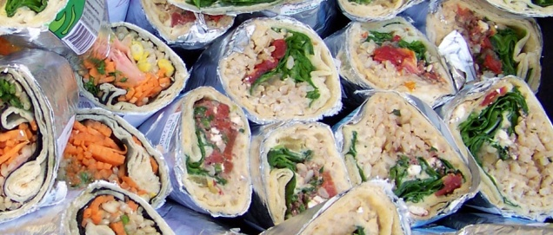

The Green Cart
thegreencart.com
We are a prepared foods wholesaler and caterer. You can find our products in many cafes and local grocery stores here in Austin, Texas.

Day 283: OLYMP-I-A for HEALTH (Year 2)- Action: I attended a lecture on prevention of premature birth. The key message is for women to get early and quality prenatal care. The speaker provided perinatal stats from the March of Dimes website http://www.marchofdimes.com/peristats/Peristats.aspx. The website is a great resource with an abundance of key information. There are over 500,000 preterm births/ year in the United States with a societal cost of greater than $26 billion.
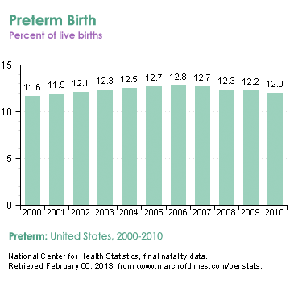

Peristats | March of Dimes
www.marchofdimes.com
The PeriStats Web Site is your online source for perinatal statistics, providing free access to graphs, maps, and tables of maternal and infant health data at the US, state, county, and city level.

Day 284: OLYMP-I-A for HEALTH (Year 2)- Action: I went to Vitamin Cottage to buy some energy/electrolyte gels for jogging. When checking out with my purchase, I donated to their campaign for "Vitamin Angels," helping provide Vitamin A to children in need. Saving vision and saving lives. I read more about the Vitamin Angels programs online: http://www.vitaminangels.org/programs.

| Vitamin Angels
www.vitaminangels.org
Vitamin A deficiency (VAD) threatens the lives of millions of children every year. Through Operation 20/20, we reduce child and infant mortality rates.

Day 285: OLYMP-I-A for HEALTH (Year 2)- Action: I enjoyed trying a new probiotic drink- KeVita sparkling lemon ginger. USDA certified organic! Quite a tasty treat! http://kevita.com/
KeVita Probiotic Drinks |
kevita.com
KeVita is a probiotic superdrink. KeVita™ is made using a fresh new approach. Water or tea is combined with Certified Organic KeVita™ culture, a blend of beneficial bacteria, healthy yeast cultures.

Day 286: OLYMP-I-A for HEALTH (Year 2)- Action: Went on a bike ride and was caught in a downpour. Fun! Waterpark and bike ride all in one :))

Day 287: OLYMP-I-A for HEALTH (Year 2)- Action: I was up early to run this morning but a thunderstorm cancelled plans. So, I did some floor exercises and stretching instead.

Day 288: OLYMP-I-A for HEALTH (Year 2)- Action: I'm trying to pay more attention to my posture (sitting up straight and not slumping) when I work at the computer. I see that some people at my workplace have standing work stations, so they are standing up while they do computer work. I read an article which lends support to the health benefits of standing over sitting. Standing probably helps with posture too. http://www.bbc.co.uk/news/health-19910888

Too much sitting 'bad for health'
www.bbc.co.uk
Sitting for long periods increases the risk of diabetes, heart disease and death, researchers suggest.

Day 289: OLYMP-I-A for HEALTH (Year 2)- Action: Sharing the American Public Health Association's new public health infographic, illustrating the importance of prevention and public health funding. http://action.apha.org/site/PageNavigator/Infographic_Page_2012_10_04_Round_2.html

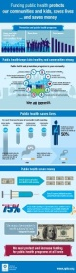

Timeline Photos
Check out American Public Health Association's new public health infographic!ht...See More
By: AMCHP

Day 290: OLYMP-I-A for HEALTH (Year 2)- Action: I attended a public health lecture on mood disorders in youth. I searched online and discovered the American Academy of Child and Adolescent Psychiatry Resource Centers website, providing facts, references, and resource network information: http://www.aacap.org/cs/resource.centers
Resource Centers | American Academy of Child & Adolescent Psychiatry
www.aacap.org
AACAP Resource Centers empower consumers through patient education. Each AACAP Resource Center contains consumer-friendly definitions, answers to frequently asked

Day 291: OLYMP-I-A for HEALTH (Year 2)- Action/Idea: Took a nice long walk today at the lake. A beautiful, sunny day. Found a "bicycle boat" option for cruising on the water. I'm planning to try it out :))

Day 292: OLYMP-I-A for HEALTH (Year 2)- Action: I learned a lot about backyard mushrooms. My dog ate one and ended up at the Vet with a lot health problems. She is fine now but it was worrisome. This event emphasizes the importance of knowing what's in the food we eat. I re-watched the video "Genetic Roulette" which talks about the impact of GMO food on animals and humans.

Day 293: OLYMP-I-A for HEALTH (Year 2)- Action: I had a good workout at my Kung Fu class and got to help teach some pre-school children as well.

Day 294: OLYMP-I-A for HEALTH (Year 2)- Action: Did a 12 mile run today (actually more of a walk/run). Had a great time with good friends. Our mutual support pulled us through.

Day 295: OLYMP-I-A for HEALTH (Year 2)- Action: I took a long walk with a friend. Walking together and talking together. Good for health!

Day 296: OLYMP-I-A for HEALTH (Year 2)- Action: I watched a compelling video about a new book called "The Patient's Checklist: 10 Simple Hospital Checklists to Keep you Safe, Sane & Organized" by Elizabeth Bailey. The video talks about the importance of good communication and prevention of costly errors. I resonate with this book due to my experience with my own father's hospitalization.https://plus.google.com/u/0/110952301528063225908/posts/fniZC3fFvXU

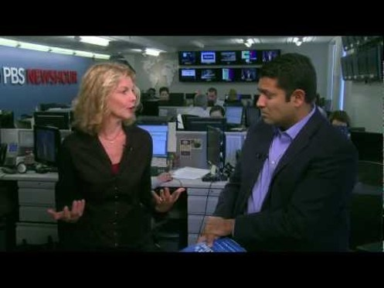

Iain Macadair - Google+

Day 297: OLYMP-I-A for HEALTH (Year 2)- Action: I did some stretching, went for a 3 mile jog, and then did some more stretching. A lesson I've learned in life which I'm also trying to learn to follow: preparation beforehand and time for rest and recovery after are key elements of effective action.

Day 298: OLYMP-I-A for HEALTH (Year 2)- Action: Went on a walk with my dog. We both got some good exercise.

Day 299: OLYMP-I-A for HEALTH (Year 2)- Action: I read an article about how the use of an Ipod Touch helped support an employment opportunity for a man with autism. Creative and innovative! http://specialedpost.com/2012/09/10/an-ipod-touch-can-revolutionize-daily-living-for-the-severely-disabled/
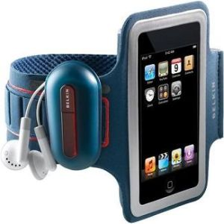

The Ipod Touch Can Revolutionize Daily Living For the Severely Disabled
specialedpost.com
The tasks required of Jeffrey by his minimum wage job at a fast food restaurant were not beyond his physical or mental capacities to complete -- he was responsible each day for emptying garbage cans, wiping down tables, sweeping, stocking condiments, and cleaning

Day 300: OLYMP-I-A for HEALTH (Year 2)- Action: I have read about Canola Oil being one of the primary genetically modified products on the market today. So, I shopped and found some non-GMO Canola Oil (Napa Valley Naturals) for baking my pumpkin pie and pumpkin bread. http://www.napavalleynaturals.com/

Welcome to Napa Valley Naturals Official Website & Online Store | Makers of Fine Oils, Vinegars & Co
www.napavalleynaturals.com
At Napa Valley Naturals, we are a small family owned business devoted to brining you deliciousCertified Organic

Day 301: OLYMP-I-A for HEALTH (Year 2)- Action: Did a run with friends around the lake on a beautiful, crisp, blue-sky morning.

Day 302: OLYMP-I-A for HEALTH (Year 2)- Action: Visited a food co-op deli and had a delicious variety of vegan salads and tofu for supper.

Day 303: OLYMP-I-A for HEALTH (Year 2)- Action: I ate some fresh figs for a healthy mid-day snack. Good source of calcium and fiber. I found out more nutrition info about figs online: http://www.whfoods.com/genpage.php?tname=foodspice&dbid=24
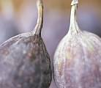

WHFoods: Figs
www.whfoods.com
Non-profit foundation providing reliable, scientifically accurate, personalized information for convenient and enjoyable healthy eating.

Day 304: OLYMP-I-A for HEALTH (Year 2)- Action: Did a 3-mile run today and followed it up with a fruit and veggie smoothie.

Day 305: OLYMP-I-A for HEALTH (Year 2)- Action: I did some simple breathing and stretching exercises. Helps to relax the mind and the body.

Day 306: OLYMP-I-A for HEALTH (Year 2)- Action: I watched a compelling video about health care for pregnant women:https://www.youtube.com/watch?feature=player_embedded&v=J0TUSeN6T0o#t=12s. I explored the websitehttp://everymothercounts.org/, working to make pregnancy and childbirth safe for all moms.

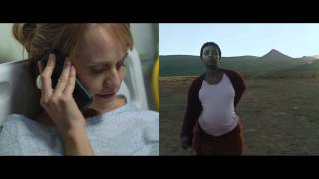

The Walk
www.youtube.com
'The Walk' aims to raise awareness for the hundreds of thousands of girls and women who die each year due to complications related to pregnancy and childbirt...

Day 307: OLYMP-I-A for HEALTH (Year 2)- Action: Had a good workout at Kung Fu class. Great way to start the day!

Day 308: OLYMP-I-A for HEALTH (Year 2)- Action: Did a 14 mile run today. For me, it was pushing the envelope, but I made it... thanks to my friends :))

Day 309: OLYMP-I-A for HEALTH (Year 2)- Action: Ate a delicious vegan meal- field roast fajitas with kale salad. Yum!

Day 310: OLYMP-I-A for HEALTH (Year 2)- Action: I watched a video about a simple type of exercise that can help people with memory and brain function: https://www.youtube.com/watch?feature=player_embedded&v=KSwhpF9iJSs#t=0s. Fascinating!!

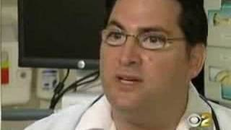

Super Brain Yoga
www.youtube.com
Superbrain Yoga® is a simple and effective technique to energize and recharge the brain. It is based on the principles of subtle energy and ear

Day 311: OLYMP-I-A for HEALTH (Year 2)- Action: A beautiful day for a run- 3 miles around the lake.

Day 312: OLYMP-I-A for HEALTH (Year 2)- Action: Explored a website with key info and resources for people who care for people with Alzheimer's: http://www.alzheimers.gov/.
For the people helping people with Alzheimer's | alzheimers.gov
www.alzheimers.gov
Welcome to alzheimers.gov. The government's resource for Alzheimer's and related dementias.

Day 313: OLYMP-I-A for HEALTH (Year 2)- Action: I read an informative article about the benefit of yoga for kids: http://www.yogajournal.com/lifestyle/210. Yoga can employ the body, mind, spirit in movement, story-telling, creativity, engaging all forms of learning and helping kids deal with the stress of a fast-paced world.

Yoga for Kids
www.yogajournal.com
Yoga article: How yoga can teach kids to be active, relieve stress, and think in positive ways.

Day 314: OLYMP-I-A for HEALTH (Year 2)- Action: I went to Kung Fu/Tai Chi class, followed by teaching some of the Pre-K Kung Fu students, and then stretching. Great morning workout!

Day 315: OLYMP-I-A for HEALTH (Year 2)- Action: I watched an informative video, providing the evidence for the health benefits of a vegan diet: https://www.youtube.com/watch?feature=player_embedded&v=5VWi6dXCT7I#t=2386s. Great info!

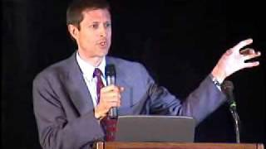

Chocolate, Cheese, Meat, and Sugar -- Physically Addictive
www.youtube.com
Neal Barnard MD discusses the science behind food additions. Willpower is not to blame: chocolate,

Day 316: OLYMP-I-A for HEALTH (Year 2)- Action: I went on a walk with my dog in the brisk, cool afternoon. Refreshing!

Day 317: OLYMP-I-A for HEALTH (Year 2)- Action: I took care of my health and had an eye exam. Glad I did! I explored the NIH National Eye Institute website: http://www.nei.nih.gov/health/. A great source of info!
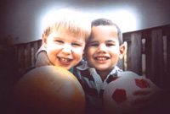

Eye Health Information [NEI]
www.nei.nih.gov
Eye health information and resources for the public and professionals.

Day 318: OLYMP-I-A for HEALTH (Year 2)- Action: I read about a research study showing the impact of infant stress on the brain. Early stress can have a permanent effect: http://www.nature.com/news/infant-stress-affects-teen-brain-1.11786. This evidence emphasizes the importance of paying attention to infant and childhood experiences.
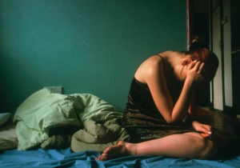
Infant stress affects teen brain
www.nature.com
Two-decade study reveals neural connection between early stress and anxiety and depression in girls.

Day 319: OLYMP-I-A for HEALTH (Year 2)- Action: I had some tasty homemade granola (made by a friend) along with some organic vanilla, fat-free Greek yogurt for breakfast. A delicious combination and great way to start to the day.

Day 320: OLYMP-I-A for HEALTH (Year 2)- Action: I was in a medical clinic waiting room which had a television showing the "AccentHealth" CNN broadcast. The television program offers practical health info and makes good use of patient's waiting time. I found out more about "AccentHealth" online: http://www.accenthealthmedia.com/waiting_room_network.shtml
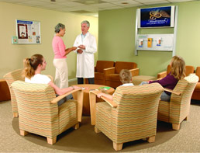

Waiting Room TV Network - Accent Health
www.accenthealthmedia.com
AccentHealth is an exclusive point-of-care television network reaching 172 million health conscious viewers annually, in 12,500 doctors' waiting rooms nationwide.

Day 321: OLYMP-I-A for HEALTH (Year 2)- Action: I did some early morning stretching and then went to Kung Fu class. Got good exercise with good friends.

Day 322: OLYMP-I-A for HEALTH (Year 2)- Action: Did a 16-mile run at the lake with good friends (though I didn't see them for very long since most of them are faster than me :)). It was a beautiful, glorious day for a run!

Day 323: OLYMP-I-A for HEALTH (Year 2)- Action: I read about the latest research showing how meditation can help reduce pain. "The findings help explain how opening to pain, rather than avoiding it, can reduce the anxiety that can worsen the experience of pain." http://www.news.wisc.edu/releases/17664

RELEASE: Meditation expertise changes experience of pain
www.news.wisc.edu
CONTACTS: Alison DeShaw Rowe, Center for Investigating Healthy Minds, 608-890-3074, deshaw@wisc.edu; Dian Land, UW Health and UW School of Medicine and Public Health, 608- 261-1034, dj.land@hosp.wisc.edu

Day 324: OLYMP-I-A for HEALTH (Year 2)- Action/Idea: Took a long walk with my dog on a beautiful, sunny afternoon. I love watching her explore everything with such curiosity. If we stay curious, life is never dull :))

Day 325: OLYMP-I-A for HEALTH (Year 2)- Action: Jogged about 3 miles around the lake, enjoying a beautiful autumn day with golden leaves falling along the path, and then had an organic veggie/fruit smoothie. Good for mind, body, spirit...

Day 326: OLYMP-I-A for HEALTH (Year 2)- Action: Enjoyed several walks and visiting with neighbors. It was a glorious day to be outside!

Day 327: OLYMP-I-A for HEALTH (Year 2)- Action: Tried coconut oil on yams as a substitute for butter/margarine. A delicious and healthy alternative. I read an interesting article regarding the health benefits of coconut oil: http://www.huffingtonpost.com/dr-mercola/coconut-oil-benefits_b_821453.html
Coconut Oil: When Fat Is A Good Thing
www.huffingtonpost.com
The truth about coconut oil is obvious to anyone who has studied the health of those who live in native tropical cultures, where coconut has been a primary dietary staple for thousands of years.

Day 328: OLYMP-I-A for HEALTH (Year 2)- Action: I ate a delicious macrobiotic meal and explored a resource for macrobiotic recipes on Facebook: https://www.facebook.com/macrobioticrecipes

Macrobiotic Recipes
Add your macrobiotic recipes to this page! Post a photo, video or share your reviews on recipes posted. If you love "Macrobiotic Recipes" then invite your friends to join this community of macro recipe lovers. THE KITCHEN PRAYER May this kitchen be so filled with peace that all who eat food pre...

Day 329: OLYMP-I-A for HEALTH (Year 2)- Action: Did an 8 mile run in the early morning and then 2 more short walks later (in the afternoon and evening). Couldn't get enough of the beautiful day.

Day 330: OLYMP-I-A for HEALTH (Year 2)- Action: I ate some fresh, organic pomegranate and read about the health benefits: http://www.drfuhrman.com/library/article19.aspx

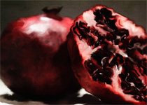

Powerful Health Benefits of the Pomegranate
www.drfuhrman.com
One of the oldest known fruits, found in writings and artifacts of many cultures and religions, the pomegranate (punica granatum) is an original native of Persia. This

Day 331: OLYMP-I-A for HEALTH (Year 2)- Action: I attended a lecture about integrated care, a quality-focused and evidence-based health care model, recognizing that the mind and body are one and should be treated as such. http://uwaims.org/overview-integrated.html

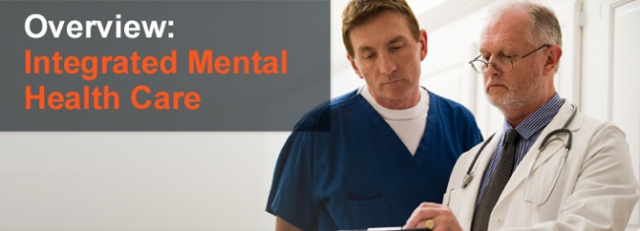

AIMS Center - Integrated Mental Health Care
uwaims.org
The core principles of effective integrated care include a patient-centered care team providing evidence-based treatments for a defined population of patients using a measurement-based treat-to-target approach. For more information about the

Day 332: OLYMP-I-A for HEALTH (Year 2)- Action: I went for a 3-mile run. Such a beautiful afternoon to be outside... blue sky, colorful leaves, crisp air. So refreshing!

Day 333: OLYMP-I-A for HEALTH (Year 2)- Action: Had a great Kung Fu class. Good exercise with good friends!

Day 334: OLYMP-I-A for HEALTH (Year 2)- Action: I did some floor exercises and stretching, concentrating on my breathing and being "in the moment."

Day 335: OLYMP-I-A for HEALTH (Year 2)- Action: I watched this video in which a woman talks about her experience in the "Grandparents Against Poverty and AIDS" (GAPA) program (a program of Comfort the Children International). I read more about the GAPA program online: http://www.ctcinternational.org/gapa.

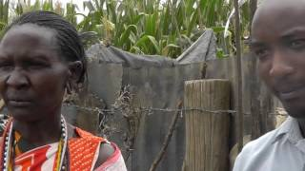

Gapa Interview 2012
www.youtube.com
Grandparents Against Poverty & AIDS is a CTC International support group and income generating activity that brings grandparents together, who are taking car...

Day 336: OLYMP-I-A for HEALTH (Year 2)- Action: I attended a meeting of "RESULTS- The Power to End Poverty," a grassroots organization with domestic and global goals (http://www.results.org/) . The meeting focus was on the organization's activities to help ALL children reach their 5th birthday. Current global campaigns include:
Global Health (Tuberculosis; the Global Fund to Fight AIDS, TB and Malaria; and Child Survival)
Economic Justice (IMF and Microfinance)
Educational for All

RESULTS - The Power to End Poverty
www.results.org
Nonprofit, grassroots citizen's lobby working to create the political will to end hunger and the worst aspects of poverty.

Day 337: OLYMP-I-A for HEALTH (Year 2)- Action: I went walking in the evening under the stars... a beautiful way to feel connected with the universe.

Day 338: OLYMP-I-A for HEALTH (Year 2)- Action: I had a delicious salad with organic kale, chard, spinach, and sliced carrots. Yum!

Day 339: OLYMP-I-A for HEALTH (Year 2)- Action: I watched a news story about the health benefits of therapy dogs:http://www.keyetv.com/news/top-stories/stories/therapy-dogs-heal-broken-hearts-bones-5357.shtml. I read more about the "Divine Canines" therapy dog program online: http://www.divinecanines.org/. "Therapeutic interaction with... specially trained dogs results in emotional and physical benefits such as improved mood, confidence, communication, relaxation, and trust."

KEYE-TV - keyetv.com :: News - Top Stories - Therapy Dogs Heal Broken Hearts & Bones
www.keyetv.com
They're one of a kind volunteers who need to be calm, people-oriented and comfortable in unfamiliar

Day 340: OLYMP-I-A for HEALTH (Year 2)- Action: I did some stretching exercises in the early morning before going to work. I call it a "stretching meditation." A great way to wake up and feel refreshed and ready for the day.

Day 341: OLYMP-I-A for HEALTH (Year 2)- Action: I walked around the neighborhood at dusk. The sun was setting with beautiful pink ribbons of clouds across the sky. Nature's gift of tranquility.

Day 342: OLYMP-I-A for HEALTH (Year 2)- Action: I attended Shaolin Do Kung Fu class and a special seminar taught by Senior Master Joe Schaefer. It is so amazing how the katas help give you strength and insight for everyday life.

Day 343: OLYMP-I-A for HEALTH (Year 2)- Action: I jogged around the lake and enjoyed being out in nature. The lake was beautiful with swans and swooping cranes. Also, there is a regular group of bright green parrots that we pass on the trail.

Day 344: OLYMP-I-A for HEALTH (Year 2)- Action: I watched an inspiring video about the power of music to heal the soul. "United by Music North America" builds unity and supports the limitless possibilities within us all.

United by Music North America
www.ubmna.org
Imagine a world in which no prejudice exists based upon race, creed, color—or intellectual capacity. That is the world that we at United by Music North America, and our growing support base, envision. In our case, we have

Day 345- OLYMP-I-A for HEALTH (Year 2)- Idea: Health is feeling the joy of running through mud puddles and knowing you have a friend who understands and will be patiently waiting for you when you finish :))

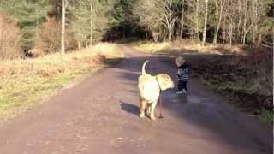

Best friends
www.youtube.com
Watson the dog stands by while Arthur does a quick assessment of the puddle situation. Could this be the cutest video ever?

Day 346: OLYMP-I-A for HEALTH (Year 2)- Action: I read an interesting article on electronics and children's health:http://www.educationnews.org/parenting/julia-steiny-the-jurys-in-screen-time-hurts-little-kids/

Julia Steiny: The Jury’s In, Screen Time Hurts Little Kids | Education News
www.educationnews.org
by Julia Steiny I study kids and families when I’m out in public, and recently observed this crazy-making family: Dad pushed a double stroller with a young toddler and a girl who

Day 347: OLYMP-I-A for HEALTH (Year 2)- Action: I took a long walk. I love afternoon walks that drift into dusk. Everything looks so magical as the daylight fades from the sky and is replaced by the twinkling lights from peoples' homes. So beautiful!

Day 348: OLYMP-I-A for HEALTH (Year 2)- Action: I had some good laughs with friends. I learned more about the health benefits of laughter:http://www.webmd.com/balance/features/give-your-body-boost-with-laughter. :)))

Laughter: Good For Your Health - WebMD
www.webmd.com
Laughter stretches muscles, burns calories and produces a natural energy booster.

Day 349: OLYMP-I-A for HEALTH (Year 2)- Action: I had a great workout at Kung Fu class and stayed to help teach a pre-K student who tested today. She was awesome! A wonderful way to start the day!

Day 350: OLYMP-I-A for HEALTH (Year 2)- Action: I did a long-distance run and felt almost every muscle by the end of it. Stretching along the way was key to finishing. A good full-body workout.

Day 351: OLYMP-I-A for HEALTH (Year 2)- Action: I did some simple floor exercises and stretches... helping to relax body and mind.

Day 352: OLYMP-I-A for HEALTH (Year 2)- Action: I went to Kung Fu class and had a great workout. We finished class with Tai Chi, letting go of the hectic pace of life and moving with and experiencing the present moment.

Day 353: OLYMP-I-A for HEALTH (Year 2)- Action: I jogged around the lake. It was a beautiful, cool and windy day. It is interesting to see the different moods of the lake. With the wind blowing, the water was active and spirited. The movement of the water and the wind inspired me to pick up my pace a little :)).

Day 354: OLYMP-I-A for HEALTH (Year 2)- Action: I took a brisk and refreshing walk with my dog. The late afternoon was cool and crisp and I could smell some wood-burning fires. A beautiful day!

Day 355: OLYMP-I-A for HEALTH (Year 2)- Action: I had a beautiful walk at night. It was cold and invigorating. The moonlight and holiday lights made the evening magical.

Day 356: OLYMP-I-A for HEALTH (Year 2)- Action: Practiced and reviewed katas in Kung Fu class, did some slow stretching, and helped a pre-K student practice her self-defense. Felt good!

Day 357: OLYMP-I-A for HEALTH (Year 2)- Action: Did a 10 mile run this morning with my running team. Strength in numbers... Even though we run at different paces, knowing they are out there with me provides the needed morale boost when my muscles start complaining :)).

Day 358: OLYMP-I-A for HEALTH (Year 2)- Action: Doing some floor exercises and gentle stretching to work out sore muscles.

Day 359: OLYMP-I-A for HEALTH (Year 2)- Action: Good cheer, good laughter... celebrating the holidays with family! Good for the body and soul!

Day 360: OLYMP-I-A for HEALTH (Year 2)- Action: I had some wonderful heart-to-heart talks with family. In these days of quick communication and multi-tasking, it is good when we can slow down and spend time with each other. It takes some uninterrupted time to share, listen, and discover the true meaning of our words. Such talks are full of the richness of life. Great gifts for our well-being.

Day 361: OLYMP-I-A for HEALTH (Year 2)- Action: I jogged around the lake. After spending several days mostly indoors, it felt great to be outside.

Day 362: OLYMP-I-A for HEALTH (Year 2)- Action: I took a walk/run with my dog and enjoyed a refreshing, cool afternoon.

Day 363: OLYMP-I-A for HEALTH (Year 2)- Action: Had a good practice and much-needed review of katas at Kung Fu class.

Day 364: OLYMP-I-A for HEALTH (Year 2)- Action: Sharing a video about a remarkable journey of recovery and the life-giving force of pursuing your dreams. Inspiring!
Janine Shepherd: A broken body isn’t a broken person | Video on TED.com
www.ted.com
TED Talks Cross-country skier Janine Shepherd hoped for an Olympic medal -- until she was hit by a truck during a training bike ride. She shares a powerful story about the human potential for recovery. Her message:

Day 365: OLYMP-I-A for HEALTH (Year 2)- Action: I read an interesting article about Kenya's banning of importation of GMO foods until studies of GMO food safety are complete: http://www.digitaljournal.com/article/338369.

Kenya bans importation of all GMO foods (video)
www.digitaljournal.com
In a groundbreaking act, Public Health Minister Beth Mugo of the Kenyan government has advised that Kenya has completely banned the importation of all genetically modified (GMO) food into the country, until exhaustive tests on health effects are complete.

