365-Day “Olymp-i-a Challenge” for GREEN-LIVING- Year 2
Author: Lesa R. Walker, MD, MPH**

**Author’s comments: In this document I present my daily positive ideas and actions for green-living, generated (and posted in Facebook) in the Year 2012. This journal is a journey of positive discovery. I hope it provides you with inspiration for your own positive ideas and actions for green-living. Many of the ideas and actions are timeless and are relevant now and in the future. Some, however, are specific to a particular event in 2012. Nevertheless, the journal entries provide you with tangible examples of positive steps taken on a daily basis. The journal entries frequently include and reference websites and their content. Due to the fluid and changing landscape of the Internet, some links may not work over time. If a link does not work or a website no longer exists, you can enter key words from the subject matter of the journal entry in “Google” or other search engine to locate current relevant websites and launch your own exploration. As you will see, the journal entries reflect my personal interests, passion, and culture. They serve merely as prompts to motivate and encourage you to create your own, personal and unique journey.
After reading an idea or action, write down your own positive idea or action for that day along with the date and re-save this file so you record your positive idea or action. Do this as often as you can over time. Ideally, do this for 21-30 consecutive days to help engrain the habit. The more you practice, the stronger you become! You will create a living journal of your positive ideas and actions.

365 Daily Positive Ideas and Actions for Green-Living:

Day 1: OLYMP-I-A for GREEN-LIVING (Year 2)- Action: Sharing a positive song: http://www.youtube.com/user/jackjohnsonmusic#p/u/27/x1C4p1Z1F-I
Mobile Uploads https://www.facebook.com/lesa.r.walker#!/photo.php?fbid=10150548491267559&set=a.10150250459027559.363714.588602558&type=1&theater
There's a world we've never seen, there's still hope between the dreams. The weight of it all can blow away with the breeze... Perfect time for Jack Johnson!
Shared by a friend on Facebook.

Day 2: OLYMP-I-A for GREEN-LIVING (Year 2) - Action: Sharing an informative link on Facebook:
http://www.slideshare.net/unyouth/world-youth-report-youth-and-climate-change
World Youth Report- Youth and Climate Change
www.slideshare.net
The World Youth Report focus on youth and climate change, and is intended to highlight the important role young people play in addressing climate change, and to

Day 3: OLYMP-I-A for GREEN-LIVING (Year 2) - Action: Sharing information about climate change from "National Geographic": http://newswatch.nationalgeographic.com/2011/12/29/witnessing-change-and-searching-for-wilderness-circumnavigating-the-svalbard-archipelago-in-the-arctic-circle/?source=link_fb20120102newswatch-svalbardarchipelago

Circumnavigating the Svalbard Archipelago in the Arctic Circle
newswatch.nationalgeographic.com
Reflection of a polar bear in the icy Arctic waters. They are classified as a vulnerable species, with 8 of the 19 sub-populations in decline. What does the future hold for these

Day 4: OLYMP-I-A for GREEN-LIVING (Year 2) - Action: Going shopping to get some organic foods and natural anti-inflammatory remedies to ward off joint/tendon soreness. Works well for me!

Day 5: OLYMP-I-A for GREEN-LIVING (Year 2) - Action: Helped a child recycle paper after an art project.

Day 6: OLYMP-I-A for GREEN-LIVING (Year 2)- Action: I learned about Stonyfield Organic's "Moo Crew" and the "Moo Crew" challenges: http://moocrew.stonyfield.com/about.php
Join the Moo Crew
moocrew.stonyfield.com
Care about the food you eat? I do, and I'm a proud member of the Stonyfield Moo Crew!

Day 7: OLYMP-I-A for GREEN-LIVING (Year 2)- Action: Sharing a link from a friend: http://www.youtube.com/embed/nGeXdv-uPaw

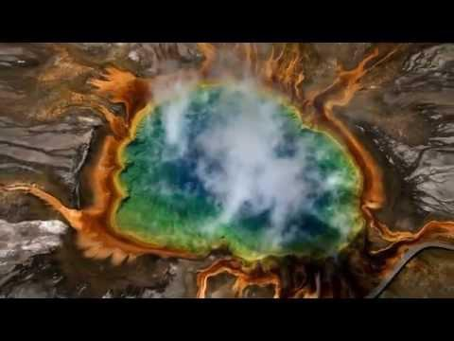
She's Alive... Beautiful... Finite... Hurting... Worth Dying for.
www.youtube.com
This is a non-commercial attempt to highlight the fact that world leaders, irresponsible corporates and mindless

Day 8: OLYMP-I-A for GREEN-LIVING (Year 2)- Action/Idea: I looked up the definition, synonyms, and antonyms of "sustainable": Definition: "of, relating to, or being a method of harvesting or using a resource so that the resource is not depleted or permanently damaged... Synonyms: defendable, defensible, justifiable, maintainable, supportable, tenable... Antonyms: indefensible, insupportable, unjustifiable, unsustainable, untenable." Interesting... It seems an obvious choice. We must work to support and implement sustainable methods to preserve the resources, wildlife, and cultures of our earth. The antonyms above demonstrate the result of our actions if we don't. http://www.merriam-webster.com/dictionary/sustainable
Sustainable - Definition and More from the Free Merriam-Webster Dictionary
www.merriam-webster.com
Definition of sustainable from the Merriam-Webster Online Dictionary with audio pronunciations, thesaurus, Word of

Day 9: OLYMP-I-A for GREEN-LIVING (Year 2): Action: I watched the "Nature" documentary entitled, "Birds of the Gods" on PBS. I found the video online. The documentary is about the New Guinea conservation efforts to protect the amazing "birds of paradise." The documentary captures incredible footage of these beautiful birds and discusses the local customs and important conservation initiatives. http://www.pbs.org/wnet/nature/episodes/birds-of-the-gods/introduction/6229/ )

Day 10: OLYMP-I-A for GREEN-LIVING (Year 2)- Action: I read some good tips for green-living in 2012: http://www.mygreenface.com/forum/topics/green-resolutions-for-2012-simple-actions-to-protect-the-planet-b
Green Resolutions for 2012: Simple Actions to Protect the Planet By Richard Kujawski - my green fac
www.mygreenface.com
Experts say that the most successful New Year’s resolutions are those where an action is practiced regularly to achieve

Day 11: OLYMP-I-A for GREEN-LIVING (Year 2)- Action: When there wasn't an obvious place to recycle trash at a local cafe, I asked one of the staff if they recycled. He answered that they did and told me where to leave the trash so it would be recycled. You never know what's possible if you don't ask. Also, if we ask for recycling regularly, more places will find a way to provide it.

Day 12: OLYMP-I-A for GREEN-LIVING (Year 2)- Action: Sharing an important message via Nature's Path Organic Foods. 8 easy things to do to help support mandatory labeling of GMOs: http://justlabelit.org/take-action/8-things-you-can-do/
Just Label It
justlabelit.org
2. Eat fresh! While some produce is genetically engineered, most GEs will be found in processed foods containing soy and corn. Eat more fresh vegetables and unprocessed

Day 13: OLYMP-I-A for GREEN-LIVING (Year 2)- Action: Trying out Veggytopia this week. Had a wonderful vegan, organic dish made with quinoa for supper. Delicious! https://www.facebook.com/pages/Veggytopia/167813309953837

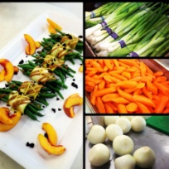

Day 14: OLYMP-I-A for GREEN-LIVING (Year 2)- Action: Enjoyed visiting the El Anatsui exhibit "When I Last Wrote to You About Africa." The beautifully constructed artwork from cast off material (bottle caps, tin cans, pieces of wood, broken pottery) symbolizes how we can renew our world. https://www.facebook.com/pages/El-Anatsui/111815595501082?sk=info
El Anatsui
El Anatsui (born 1944) is a Ghanaian sculptor active for much of his career in Nigeria.

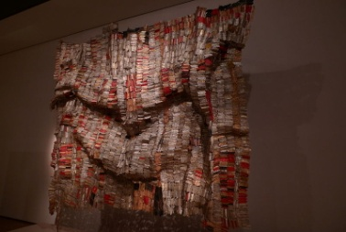

Day 15: OLYMP-I-A for GREEN-LIVING (Year 2)- Action: Ate a delicious vegetarian meal at a local cafe that serves organic and locally-grown food. Got inspired and explored a great online resource, sharing veggie/vegan recipes from around the globe: http://earth911.com/news/2012/01/11/vegetarian-recipes-from-around-the-globe/. I found out from the website that "eating one vegetarian meal each week will save about 35 pounds of meat a year - which amounts to 84,000 gallons of water, 245 pounds of grain and 15.5 gallons of gasoline. So, going veg (even occasionally) can have a big impact on the planet."
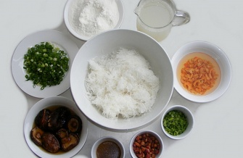
Vegetarian Recipes From Around the Globe - Earth911.com
earth911.com
Guide to local resources including recycling centers, how to recycle, pollution prevention and how help protect the

Day 16: OLYMP-I-A for GREEN-LIVING (Year 2)- Action: I explored Stonyfield Organic's website for collecting "sweetitude." Here is a company taking positive steps to spread organic sweetness... :)) http://sweetitude.com/
Spread the Sweetitude
sweetitude.com
A little natural sweetness goes a long way. Help Stonyfield spread the #sweetitude and enter daily to win one of 100 prizes! Share what Sweetitude means to you at

Day 17: OLYMP-I-A for GREEN-LIVING (Year 2)- Action: Created a designated box at home to collect used batteries for recycling. There is a place to recycle them at a nearby public library.

Day 18: OLYMP-I-A for GREEN-LIVING (Year 2)- Action: Watched a powerful video shared with me by a friend. Nature's beauty cultivates gratitude and sets the context for experiencing "a good day." It is worth watching the entire video. Magnificent! http://www.ted.com/talks/lang/en/louie_schwartzberg_nature_beauty_gratitude.html

Louie Schwartzberg: Nature. Beauty. Gratitude. | Video on TED.com
www.ted.com
TED Talks Nature’s beauty can be easily missed -- but not through Louie Schwartzberg’s lens. His stunning time-lapse photography, accompanied by powerful words from Benedictine monk David Steindl-Rast, serves as a

Day 19: OLYMP-I-A for GREEN-LIVING (Year 2)- Action: Helped a child enjoy and appreciate the beauty of a wonderful, blue-sky day.

Day 20: OLYMP-I-A for GREEN-LIVING (Year 2)- Action: I watched a video about climate change in Bangladesh and local efforts for disaster preparedness. Preparedness efforts are supported by "RDRS", an NGO that focuses on community development and environmental conservation, addressing climate change through organization, education, and unity. http://www.youtube.com/watch?v=zIckHzxSmS8&feature=youtu.be
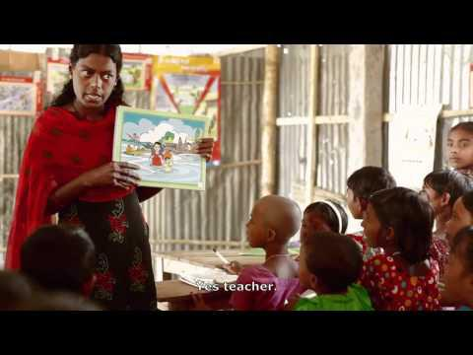
Ripples: Climate Change and Disaster Management in Bangladesh
www.youtube.com
By Soren Vestergaard Neilsen, for RDRS

Day 21: OLYMP-I-A for GREEN-LIVING (Year 2)- Action: Sharing info: On January 21st, 2012 (today), the Earth Child Institute (ECI) is hosting an online webcast (at 9 am EST) to build international enthusiasm and momentum about ECI Nepal's "Event 21." Event 21 officially launches ECI Nepal's Green school campaign, with a goal to plant 100,000 trees with 100,000 children in 2012 in Kathmandu earlier that day.
The webcast provides info about Event 21 and participants can talk directly with ECI staff members in different countries, and find out how to get involved!
To join the webcast, go to www.anymeeting.com/EarthChild1 at the scheduled time and login with your own name and location.

ECI Test 1 - AnyMeeting | Free Web Conferencing, Webcast and Webinar Service
www.anymeeting.com
ECI Test 1 powered by: Completely Free Web Conferencing and Webinar Service. Produce your own high quality online meetings, with registration

Day 22: OLYMP-I-A for GREEN-LIVING (Year 2)- Action: I read about 10 products you can buy that are reusable and reduce waste. Great info! http://earth911.com/news/2012/01/19/10-things-you-didnt-know-you-could-buy-reusable/
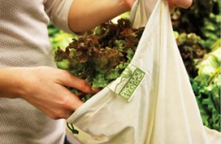
10 Things You Didn’t Know You Could Buy Reusable - Earth911.com
earth911.com
Guide to local resources including recycling centers, how to recycle, pollution prevention and how help protect the

Day 23: OLYMP-I-A for GREEN-LIVING (Year 2)- Action: Sharing great news from the David Sheldrick Wildlife Trust!
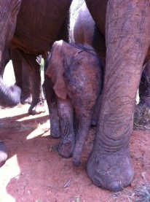
Wall Photos https://www.facebook.com/lesa.r.walker#!/photo.php?fbid=10150563300429889&set=a.167086934888.112085.120805694888&type=1&theater
We have wonderful news - on Friday morning (20th), now wild orphan Yatta came to the Ithumba Stockades, a tiny newborn baby sticking close to mum's side! That's right, Yatta has had her first baby, born into the wild.As with Mulika, who had her own first wild born calf at the end of last year, this new life is a reminder, were it ever needed, of the life saving impact of the orphans project. Not only the immediate life of a rescued orphan baby, but the potential future lives which that baby might mother or father. This is only possible thanks to our dedicated teams on the ground and our global network of foster parents and supporters - we are grateful to each and everyone of you.

Day 24: OLYMP-I-A for GREEN-LIVING (Year 2)- Action: I read an informative article (shared with me by a friend) about a daunting threat to organic foods. Compels me even more to eat organic! It provides both the health and financial reasons to eat organic foods. http://articles.mercola.com/sites/articles/archive/2010/11/11/how-monsanto-controls-the-future-of-food.aspx
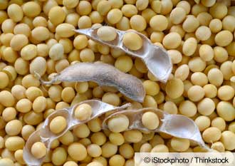
How Monsanto Monopolizes Genetically Modified Seeds
articles.mercola.com
Monsanto and other biotech corporations monopolize patents of genetically modified seeds, thus controlling the

Day 25: OLYMP-I-A for GREEN-LIVING (Year 2)- Action: This morning I saw the beauty of the Earth responding to last night's much needed rain. It was like a welcoming embrace. The air was clean and the plants were vibrant green. When living in a drought, the gift of rain is so glorious!

Day 26: OLYMP-I-A for GREEN-LIVING (Year 2)- Action: Helped some children in after-school childcare learn about the wonder of animals through listening, acting, and drawing.

Day 27: OLYMP-I-A for GREEN-LIVING (Year 2)- Action: I explored the website for the BBC show "Super Smart Animals." There are amazing video clips and links to great resources on the site. We have so much to learn about the intelligence of animals! http://www.bbc.co.uk/programmes/b01by4w1
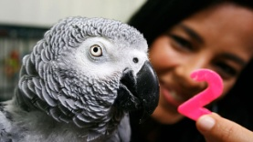
Super Smart Animals
www.bbc.co.uk
Prepare to be amazed, entertained, and even outwitted by the world's Super Smart Animals

Day 28: OLYMP-I-A for GREEN-LIVING (Year 2)- Action: I read about "Reuse Weekend" and explored 60+ tips to reuse and recycle. This weekend I am going to pay attention and save some reusable items for children's art projects. https://www.facebook.com/photo.php?fbid=10150513518837861&set=a.106185232860.92514.6608442860&type=1&ref=nf
Wall Photos
All right guys, it's time to stop making excuses and start reusing more and wast...

Day 29: OLYMP-I-A for GREEN-LIVING (Year 2)- Action: Watched a powerful video where a young and wise boy speaks about the importance of eating organic and local. An example of how children can learn what's important and can exercise their power to make change through positive choices: http://www.youtube.com/watch?v=SvVZwJbs54c&feature=youtu.be
Monsanto Corporation Gets Owned By 11 Yr Old Boy?
www.youtube.com
http://www.facebook.com/akyastv What are you waiting for? Now is the time to STAND UP for yourself, to be BOLD,

Day 30: OLYMP-I-A for GREEN-LIVING (Year 2)- Action: I gathered together the reusable items I saved over this last weekend ("Reuse Weekend"). I have about 11 items from the weekend that I will keep and recycle into arts/crafts projects for children as part of an after-school daycare program. "Earth911" on Facebook has great posts on reuse and recycling and is where I found out about "Reuse Weekend." https://www.facebook.com/Earth911
Earth911
Have you downloaded our free Android & Apple iOS app, iRecycle? http://earth911.com/iphone Earth911.com is the place to go for all you need to know about reducing your impact, reusing what you’ve got and recycling the rest. Visit Earth911.com to read the latest in green lifestyle stories, and most...

Day 31: OLYMP-I-A for GREEN-LIVING (Year 2)- Action: I talked with young children 4-6 years old about the importance of helping animals and how we all need the same sort of care: food, a home, love, water.

Day 32: OLYMP-I-A for GREEN-LIVING (Year 2)- Action: Connected with Earth Child Institute and discussed possibilities for future collaboration with their project sites. https://www.facebook.com/pages/Earth-Child-Institute/324008488174?ref=ts&sk=wall
Earth Child Institute
Earth Child Institute is committed to combating climate change, deforestation and water scarcity by investing in hands-on environment and educational projects with and for children, both in and out of schools. Our goal is to engage with and support empowerment of the world’s 2.2 billion people under...

Day 33: OLYMP-I-A for GREEN-LIVING (Year 2)- Action: Helped a group of children learn about birds and animals and worked with them to make drawings of their favorite animals showing what people can do to help animals. They made some creative artwork and told me the stories behind their drawings.

Day 34: OLYMP-I-A for GREEN-LIVING (Year 2)- Action: I read about the six recipients of the 2012 EnviroKidz Giving Back Fund: Greenkids, Ceres Community Garden, YEA Camp, SEE Turtles, IslandWood, and National Wildlife Federation (NWF). "These organizations are doing... amazing work empowering children to change their present and future worlds by protecting endangered species and their environments." http://www.naturespath.com/blog/2012/01/27/and-winners-are
And the winners are... | Nature's Path Foods
www.naturespath.com
Did you know that 1% of EnviroKidz sales are donated to projects that support endangered species, habitat conservation and environmental education for kids

Day 35: OLYMP-I-A for GREEN-LIVING (Year 2)- Action: I watched a video about the "Green School" movement in the U.S. and ten strategies to create positive transformation: http://womenofgreen.com/2012/01/green-schools-how-to-move-a-movement/. School buildings as well as the information taught to children within the school buildings are changing to green.
Green Schools: How to move a movement
womenofgreen.com
[youtube]http://www.youtube.com/watch?v=juWktbF-Wwc[/youtube] Wanna move a movement? Rachel Gutter of the U.S. Green Building Council pre

Day 36: OLYMP-I-A for GREEN-LIVING (Year 2)- Action/Idea: Passing along an article shared by a friend: http://www.triplepundit.com/2012/02/years-super-bowl-will-be-super-green/. Interesting info about the Super Bowl efforts to be more environmentally conscious. People should ask all such large-scale public events to post a similar "green" accountability statement and encourage people attending such events to be "green-minded" as well- recycling their trash, etc.

This Year's Super Bowl Will Be Super Green
www.triplepundit.com
The NFL is going to great lengths to make this year's Super Bowl as green as possible by purchasing carbon offsets, supporting forestry programs and donating a solar array.

Day 37: OLYMP-I-A for GREEN-LIVING (Year 2)- Action: I read a great article about "The Urban Farmer," Randy Jewart, founder of Austin Green Art and 5 Mile Farms, which installs farms in the yards of homeowners. Great article! I enjoyed my volunteering at 5 Mile Farms and hope to go back and do more. Wonderful and inspiring people! http://lauranormand.com/blog/50-the-urban-farmer/.
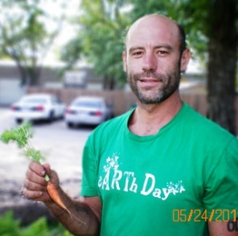
#50 The Urban Farmer
lauranormand.com
[caption id="attachment_245" align="alignright" width="300" caption="Randy Jewart grows community (and carrots)."][/caption] The man: Randy Jewart, founder of

Day 38: OLYMP-I-A for GREEN-LIVING (Year 2)- Action: Drank a great smoothie made with organic veggies and fruit, with added Vitamin C. Also, having a delicious organic, gluten-free soba noodles dish with kale, edamame, carrots, onions, and sesame seeds for supper.

Day 39: OLYMP-I-A for GREEN-LIVING (Year 2)- Action: I read a book to children about the importance of being kind to animals and told them about my adventures with the elephants in Kenya. We talked about how people can help elephants.

Day 40: OLYMP-I-A for GREEN-LIVING (Year 2)- Action: Shared info from “One Green Planet” about ways to celebrate Valentine's Day and green-living! [NOTE: the specific article is no longer accessible via the Web. Suggestion: check out the “One Green Planet” website.]

http://www.onegreenplanet.org/

Day 41: OLYMP-I-A for GREEN-LIVING (Year 2)- Action/Idea: Found about an important survey launched by PBS NewsHour. The more people share their insights and experiences, the more we can shed light on this critical issue.
What's happening to the climate in your community?
www.publicinsightnetwork.org
Just mention of the term 'climate change' has the ability to set off vociferous debate as governments, scientists, and policymakers grapple with the issue. But as the debate rages on, the PBS NewsHour wants to hear your firsthand perspective about the climate in your backyard. Are you seeing and fee...

Day 42: OLYMP-I-A for GREEN-LIVING (Year 2)- Action: Found an inspiring article about rescued dolphins being tracked after rescue. Most of the dolphins being tracked are doing well and swimming free off the coast of Maine. The dolphins were rescued by members of the International Fund for Animal Welfare (IFAW). http://livinggreenmag.com/2012/02/02/mother-nature/satellites-show-rescued-dolphins-swimming-off-coast-of-maine/ IFAW saves animals in crisis around the world and has projects in more than 40 countries (www.ifaw.org).
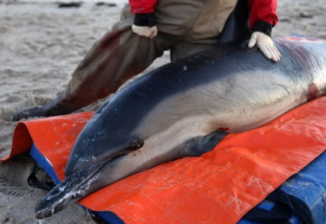
Satellites Show Rescued Dolphins Swimming Off Coast of Maine | Living Green Magazine
livinggreenmag.com
Satellite tracking data from the International Fund for Animal Welfare (www.ifaw.org) suggests the majority of dolphins rescued during recent mass strandings have

Day 43: OLYMP-I-A for GREEN-LIVING (Year 2)- Action: Went to a music concert and noted that there were signs up stating that the concert building was in the process of becoming LEED certified. I looked up "LEED" (Leadership in Energy and Environmental Design) certification on the Internet and found out that it was developed by the U.S. Green Building Council & provides independent, third-party verification that a building, home or community was designed and built using strategies aimed at achieving high performance in key areas of human and environmental health: sustainable site development, water savings, energy efficiency, materials selection and indoor environmental quality." http://www.usgbc.org/DisplayPage.aspx?CMSPageID=1988
USGBC: What LEED Is
www.usgbc.org

Day 44: OLYMP-I-A for GREEN-LIVING (Year 2)- Action: Spent some creative, fun time with children talking about what animals need to live and how people can care for animals.

Day 45: OLYMP-I-A for GREEN-LIVING (Year 2)- Action: I read a blog post from "The Climate Reality Project" reflecting a personal inspired commitment to address the climate change challenge. I liked this quote from the post: "Meeting the climate challenge is our collective responsibility. There is no room within this challenge for politics, or finger pointing. Because if we do not act, there will be no winners. What we stand to lose belongs to all of us." http://climaterealityproject.org/2012/02/08/a-personal-commitment/. The Climate Reality Project brings facts about the climate crisis into the mainstream and engages the public in conversation about how to solve it (http://climaterealityproject.org/about-us/).

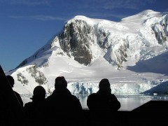
A personal commitment
climaterealityproject.org
Meeting the climate challenge is our collective responsibility. There is no room within this challenge for politics, or finger pointing. Because if we do not act, there will be no winners.

Day 46: OLYMP-I-A for GREEN-LIVING (Year 2)- Action: I played out some scenarios with children to help them learn about and practice making good decisions to help animals and people.

Day 47: OLYMP-I-A for GREEN-LIVING (Year 2)- Action: Thanks to a friend's post I found out more about the NRDC BioGems Defenders and watched a video about their 2011 successful efforts to help save threatened wild places and wildlife across the Americas.
http://www.youtube.com/watch?feature=player_embedded&v=9YiTAmpze6s.
I found out more info about the organization at http://www.savebiogems.org/.
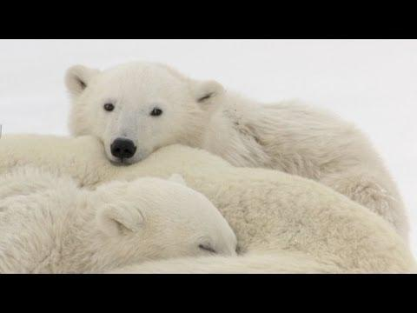

You Made a World of Difference in 2011
www.youtube.com
NRDC Members helped us win many environmental victories in 2011. Narrated

Day 48: OLYMP-I-A for GREEN-LIVING (Year 2)- Action: Talked with a local cafe manager about his recycling process. I saw a truck outside the cafe hauling off lots of cardboard boxes as well as the cafe's compost. I found out that the truck belonged to a recycling hauling business called, "Break It Down." I read about "Break It Down" on Facebook at https://www.facebook.com/pages/Break-it-Down/121828649642?sk=info and on the web at http://breakitdownaustin.org/). "Break it Down’s vision is to maximize the diversion of materials from the landfill in a manner which creates the highest social and economic value." Really cool!!
Break it Down
Break it Down provides the most comprehensive composting and recycling service in Austin.

Day 49: OLYMP-I-A for GREEN-LIVING (Year 2)- Action/Idea: I read an article shared with me by a friend about ways scientists are working with leaves of plants to research more sustainable forms of energy. I think it is ironic that humans have been so destructive to the very elements of nature that may end up helping us reverse that destruction and save the planet. http://cosmiclog.msnbc.msn.com/_news/2012/02/17/10438588-scientists-work-to-build-a-better-leaf
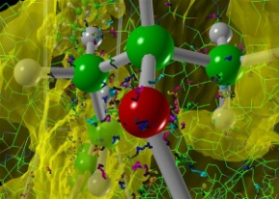
Scientists work to build a better leaf
cosmiclog.msnbc.msn.com
Researchers have been trying for decades to improve upon Mother Nature's favorite solar-power trick — photosynthesis — but now they finally think they see the sunlight at the end of the tunnel. "We now understand

Day 50: OLYMP-I-A for GREEN-LIVING (Year 2)- Action: I read an informative article from "The Ecopax Primer" on deforestation. It gives a great list of things people can do to make a difference and also provides a list of resources for more information: http://ecopax.com/deforestation.html. The more we learn, the more we understand, and the more we do!
Deforestation | The Ecopax Primer
ecopax.com
I wish all to know that I do not propose to sell any part of my country, nor will I have the whites cutting our timber along the rivers, more especially the oak. I am particularly fond of the little groves of oak trees. I love to look at them,

Day 51: Ultra OLYMP-I-A for GREEN-LIVING- Action/Idea: I read an article about an interview with Thich Nhat Hanh: http://www.commondreams.org/headline/2012/02/20-0. Hanh is quoted to say, "When we recognise the virtues, the talent, the beauty of Mother Earth, something is born in us, some kind of connection, love is born.” We need to generate and encourage this connection and love of the Earth in our children from day one.
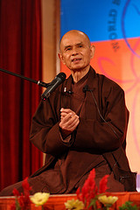
Thich Nhat Hanh: Connect With and Love Mother Earth to Heal the Planet
www.commondreams.org
Thich Nhat Hanh, Buddhist monk, peace activist and scholar, says that we must see the connection between the

Day 52: OLYMP-I-A for GREEN-LIVING (Year 2)- Action: I read a great article from Comfort the Children (CTC) International about the waste management and clean-up work going on in Maia Mahiu, Kenya. Great work! Exciting progress! http://www.ctcinternational.org/blog/2012/02/21/taking-it-next-level-waste-management: "The youth have come up with the great idea of starting a garbage collection group whereby all residential and commercial plots, vendors, and restaurants are required to pay up an agreed amount of money which will be used for waste collection and proper disposal."

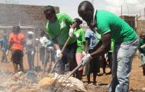
Taking it to the next level with waste management! | Comfort the Children International
www.ctcinternational.org
Providing hope through relationships and using a holistic approach to community development, CTC is empowering

Day 53: OLYMP-I-A for GREEN-LIVING (Year 2)- Action: After receiving a "Positively Green" greeting card, I looked up the company and learned more about their products and philosophy online: http://www.live-inspired.com/positivelygreencards/. "All Positively Green products are 'green manufactured' to leave the lightest possible environmental footprint. Plus, 10% of the profits are donated to organizations that protect our environment and fight global warming." Awesome!!!
Positively Green
www.live-inspired.com
Heart-warming cards, notebooks, gift wrap and gift tags celebrate the occasions in your life-birthdays, friendship, love, congratulations, sympathy and encouragement.

Day 54: OLYMP-I-A for GREEN-LIVING (Year 2)- Action: Sharing info on an interesting book, "Reinventing Fire": http://www.seventhgeneration.com/learn/blog/reinventing-fire-solution-peak-everything. The ultimate message from the book: We don't need oil or coal and can be free of all the headaches they cause by 2050, the same year by which experts say we need to cut global carbon output by 80% to prevent catastrophic global warming.

Reinventing Fire: A Solution to "Peak Everything"
www.seventhgeneration.com
We've all heard about peak oil -- the point at which petroleum production hits its all-time high and then declines forever after -- but over at Bloomberg News, they spent

Day 55: OLYMP-I-A for GREEN-LIVING (Year 2)- Action: Followed a friend's good example and had a vegan meal for supper. We were at a restaurant and ordered spinach enchiladas. We asked to leave off the cheese and substitute some red sauce instead and the restaurant was happy to do so. Change can happen! Sometimes, all it takes is making the choice to ask for it :))

Day 56: OLYMP-I-A for GREEN-LIVING (Year 2)- Action: Found out more about ecoponics and a newly developed structure called an “Ecoponics Wave Growframe”: https://www.facebook.com/pages/Ecoponics-Wave-GrowFrame/151316434888087?sk=info.
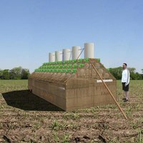
Ecoponics Wave GrowFrame
No company. Independently being developed by Greg Griffin and with help from prototypes in Kona, HI and India.

Day 57: OLYMP-I-A for GREEN-LIVING (Year 2)- Action: Sharing 10 great tips about how to engage children in recycling. https://www.recyclebank.com/live-green/10-ways-to-get-your-kids-thinking-about-recycling/?cm_mmc=Marketing-_-Facebook-_-Article-_-Kids
Live Green - 10 Ways To Get Your Kids To Think About Recycling
www.recyclebank.com
If your kids don’t know where trash goes or what happens to it, how can you expect them to care about reducing the

Day 58: OLYMP-I-A for GREEN-LIVING (Year 2)- Action: Helped pre-school and elementary children learn about different types of animals and how animals communicate with each other. We discovered why it is important that animals are different from each other and have different abilities.... same as people. The more children understand animals, the more they understand themselves and realize how important it is to make the world a place that we all can share.

Day 59: OLYMP-I-A for GREEN-LIVING (Year 2)- Action: Watched a moving video about rhino poaching and the ongoing battle against rhino extinction. I am amazed at the people who devote their lives to saving the rhino. http://video.msnbc.msn.com/rock-center/46434345#46434345 “In South Africa, home to three quarters of the last remaining rhinos on the planet, conservationists, private game reserve owners and security forces are waging a desperate battle against poachers intent on killing the country’s rhinos for their lucrative horns.”
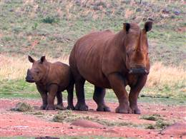
Last Stand: Rhinos under assault by poachers
video.msnbc.msn.com
Video on msnbc.com: In South Africa, home to three quarters of the last remaining rhinos on the planet, conservationists, private game reserve owners and security

Days 60: OLYMP-I-A for GREEN-LIVING (Year 2)- Action: Took children on a nature hike and spotted a woodpecker and cardinal and listened to their birdcalls. We learned about birds and animal and how they communicate.

Day 61: OLYMP-I-A for GREEN-LIVING (Year 2)- Action: Had a veggie and fruit smoothie and vegetarian soba noodle, kale, edamame dish for supper.

Day 62: OLYMP-I-A for GREEN-LIVING (Year 2)- Action: Bought some recycled notecards for a gift.

Day 63: OLYMP-I-A for GREEN-LIVING (Year 2)- Action: Immersed myself in the outdoors and the beauty of nature, marveling at the colorful display of new leaves dancing and shimmering in the sunlight of a gorgeous Spring afternoon. It is important to take time to experience the Earth with all our senses. When we do so, we understand why it is so important to protect this glorious and amazing gift.

Day 64: OLYMP-I-A for GREEN-LIVING (Year 2)- Action: I read about the IHOP partnership with the Universal Studios release of "The Lorax" to invite America to plant 3 million trees. “The Lorax encourages us all to be good stewards to Mother Earth,” said Natalia Franco, senior vice president, marketing for IHOP. “Our limited-edition bookmarks [embedded with seeds] give families a fun and easy way to work together to make the environment three million trees stronger. http://www.businesswire.com/news/home/20120221005290/en/IHOP-Invites-America-Plant-Million-Trees-Celebration
IHOP Invites America to Plant Three Million Trees in Celebration of the Release of Universal Picture
www.businesswire.com
IHOP invites America to plant 3 million trees and enjoy a special, limited time only menu in celebration of the release of Dr. Seuss' The Lorax animat

Day 65: OLYMP-I-A for GREEN-LIVING (Year 2)- Action: Talked with a group of children about the importance of animals in the world and about how we care for animals.

Day 66: OLYMP-I-A for GREEN-LIVING (Year 2)- Action: I read about the importance of the forests in Russia and the increase in Forest Stewardship Council (FSC) certification in Russia. Movement in the right direction! http://www.fsc.org/news.html?&no_cache=1&tx_ttnews%5Btt_news%5D=2094&cHash=ff6d65f18749c5d678a4ef1ab067f29b
FSC: Development of FSC certification in Russia in 2011 -Forest Stewardship Council
www.fsc.org
FSC is an independent, non-governmental, not for profit organization established to promote the responsible management of the world?s forests.

Day 67: OLYMP-I-A for GREEN-LIVING (Year 2)- Action: Worked on an exciting “OLYMP-I-A” collaboration with the Earth Child Institute in their "Power of One Child + One Tree" campaign. https://www.facebook.com/pages/Earth-Child-Institute/324008488174
Earth Child Institute
Earth Child Institute is committed to combating climate change, deforestation and water scarcity by investing in hands-on environment and educational projects with and for children, both in and out of schools. Our goal is to engage with and support empowerment of the world’s 2.2 billion people under...

Day 68: OLYMP-I-A for GREEN-LIVING (Year 2)- Action: I read about the "Green" Standards" adopted for the Winter Olympics 2014: http://www.fsc.org/news.html?&no_cache=1&tx_ttnews%5Btt_news%5D=2093&cHash=1d3bfd536ad4b71712eeedeeccdd868b. "Forest Stewardship Council (FSC) certified timber will be used for all construction... In addition, the organising committee of Sochi 2014 Olympic games will use FSC certified office materials, food packaging and printing products."

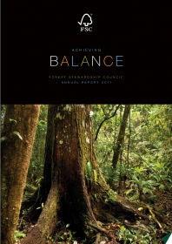
FSC: FSC ‘qualifies’ for the 2014 Winter Olympic Games -Forest Stewardship Council
www.fsc.org
FSC is an independent, non-governmental, not for profit organization established to promote the responsible management of the world?s forests.

Day 69: OLYMP-I-A for GREEN-LIVING (Year 2)- Idea: I am so appreciating the much-needed, life-sustaining rain. I can feel the plants and trees smiling :)). We are in this together! When the plants and trees thrive, we all thrive.

Day 70: OLYMP-I-A for GREEN-LIVING (Year 2)- Action/Idea: Enjoying the beauty and wonders of nature: the brilliant green colors of springtime after a refreshing rain, a beautiful orange-red sunset, and the 5 visible planets in the night sky (Jupiter, Venus, Mercury, Mars, and Saturn). Such experiences may seem simple, however, in truth, they are majestic, profound, and humbling and must never be taken for granted.

Day 71: OLYMP-I-A for GREEN-LIVING (Year 2)- Action: Recycled plastic bags at my local grocery store. I am actively working to reduce/eliminate my use of them.

Day 72: OLYMP-I-A for GREEN-LIVING (Year 2)- Action: Found a link to videos highlighting the impact of climate change around the world and local actions being taken to address it: http://climaterealityproject.org/videotopic/highlights/
Highlights | Climate Reality
climaterealityproject.org
Join our project to reveal the complete truth about the climate crisis.

Day 73: OLYMP-I-A for GREEN-LIVING (Year 2)- Action: I learned about "THE 17 CAMPAIGN" of "Trees for the Future." In 2011, Trees for the Future worked hand-in hand with local organizations, planting approximately 11 million trees in countries in Africa, Asia, South and Central America. The organization's goal this year is to plant 17 million trees, a 50% increase, in 21 nations. Hence the name of the new initiative: THE 17 CAMPAIGN. http://www.plant-trees.org/main.htm
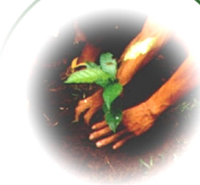
Trees for the Future
www.plant-trees.org
Since 1989, Trees for the Future has been helping communities around the world plant trees. Through seed distribution, agroforestry training, and our country

Day 74: OLYMP-I-A for GREEN-LIVING (Year 2)- Action: I was at the Vet buying supplies for my dog and was checking out when the receptionist asked me if she could throw away a piece of trash for me. Before saying yes, I asked if the trash would be recycled. If not, I told her I would take it home to recycle it. She thought for a moment and then said yes that they do recycle and said she would recycle it. It's always good to ask the question since it serves as a reminder for those who do recycle and as encouragement to start recycling for those who don't yet do so.

Day 75: OLYMP-I-A for GREEN-LIVING (Year 2)- Action: Was out walking my dog and found some paper trash strewn in the street. I almost walked by, but took a moment, picked it up, and put it in a nearby recycling bin. Every little step we take matters :))

Day 76: OLYMP-I-A for GREEN-LIVING (Year 2)- Action: Visited a Farmer's Market and tasted a delicious organic tamale from The Gardener's Feast. Yum! https://www.facebook.com/pages/THE-GARDENERS-FEAST/115073528527535?sk=wall
THE GARDENER'S FEAST
Best tamales according 2011 poll by the Austin Chronicle. We sell in the most important Farmer's Markets around Austin, New Braunfels, San Marcos and San Antonio.

Day 77: OLYMP-I-A for GREEN-LIVING (Year 2)- Idea: I've noticed that ever since I've been helping teach children about the importance of caring for animals and birds, I've had an enhanced appreciation of the sounds of all the birds in my neighborhood. It's as if I've tuned into a new frequency. The bird calls are all so different, complex, and beautiful. It is amazing what we can discover by a simple change in focus and attention.

Day 78: OLYMP-I-A for GREEN-LIVING (Year 2)- Action: Ate an organic vegan soba noodle dish for supper.

Day 79: OLYMP-I-A for GREEN-LIVING (Year 2)- Action: Taught children about the importance of re-using (and not wasting) paper and recycling.

Day 80: OLYMP-I-A for GREEN-LIVING (Year 2)- Action: Enjoyed the beautiful, brilliant Spring and spent the afternoon outside doing some much-needed weeding.

Day 81: OLYMP-I-A for GREEN-LIVING (Year 2)- Action: Sharing an interesting article about playgrounds in New York City built to capture storm water. What a great idea!!
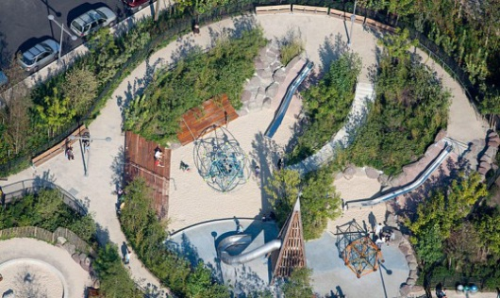
New Green Playgrounds Will Capture Stormwater Throughout NYC | Inhabitat New York City
inhabitat.com
The DEP is teaming up with the Trust for Public Land to create unique stormwater-capturing solutions inside 10 new playgrounds throughout the city.

Day 82: OLYMP-I-A for GREEN-LIVING (Year 2)- Action: Sharing some good news. McDonald’s is piloting a phase-out of polystyrene coffee cups. “The move comes in response to a 2011 shareholder resolution by “As You Sow” [http://asyousow.org/], which asked the company [McDonald’s] to re-evaluate the use of foam cups.” The consumer voice DOES matter!
McDonald's launches pilot program to drop polystyrene coffee cups | GreenBiz.com
www.greenbiz.com
With the launch of a new pilot aimed at phasing out Styrofoam in favor of paper cups, has McDonald's launched

Day 83: OLYMP-I-A for GREEN-LIVING (Year 2)- Action: I read about World Water Day and 4 feasible ways to save water: http://earth911.com/news/2011/03/14/save-27412-gallons-of-water-this-year/. “A glass of water in the morning, washing your hands before dinner, throwing in a load of laundry after work – these things are daily routine for your household. But your water-consuming habits add up to 80-100 gallons of per day, requiring the withdrawal of more than 43 billion gallons per day from public supply systems. That’s the highest usage rate of any other country in the world.”
Save 27,412 Gallons of Water This Year - Earth911.com
earth911.com
Guide to local resources including recycling centers, how to recycle, pollution prevention and how help protect the environment.

Day 84: OLYMP-I-A for GREEN-LIVING (Year 2)- Action: I visited the Lady Bird Johnson Wildflower Center that serves to preserve and sustain native plants and eco-systems and educates about the importance of such efforts and how people can use native plants in landscaping. https://www.facebook.com/wildflowercenter?ref=ts&sk=wall
Lady Bird Johnson Wildflower Center
The Center’s gardens display the native plants of the Central Texas Hill Country, South and West Texas, while the Plant Conservation Program protects the ecological heritage of Texas by conserving its rare and endangered flora. The Native Plant Information Network is a database of more than 7,200 na...

Day 85: OLYMP-I-A for GREEN-LIVING (Year 2)- Action: I read up about "Eco Karnali" on Facebook. ECO KARNALI (an NGO) is grassroots initiative which works with local communities in the Karnali region of Nepal for sustainable livelihoods of people through promotion and management of natural resources. [NOTE: Info is no longer accessible via the Web. Suggestion: Search for key words “Nepal” and “Sustainability.”]

Related link: http://www.nepalrivers.org.np/about_nepal_river.php - about the Nepal River Conservation Trust- “Since its inception in 1995, the NRCT has worked towards conserving Nepal's Himalayan river system, preserving Nepal's cultural heritage and developing an environmentally responsible river tourism industry.”

Day 86: OLYMP-I-A for GREEN-LIVING (Year 2)- Action: A friend of mine is at the Creating Climate Wealth North America 2012 Conference in Washington D.C, so I looked it up online and read more about this initiative. Hope the conference helps build momentum for promoting and generating needed changes. http://creatingclimatewealth.com/projects/ccw-dc/
Washington, DC, USA – Creating Climate Wealth
creatingclimatewealth.com
Access clean technology opportunities, capital, and game-changing partnerships at the Creating Climate Wealth Summits.

Day 87: OLYMP-I-A for GREEN-LIVING (Year 2)- Action: I declined a plastic bag at a store checkout and, instead, just carried out my purchases. I am working hard on making a habit of not accepting plastic bags offered at stores/grocery stores, etc. One step at a time...

Day 88: OLYMP-I-A for GREEN-LIVING (Year 2)- Action: Had a great conversation with 5 and 6 year olds about the importance of planting and caring for trees and recycling paper. They had amazing insight. One little girl said that one way we can care for the birds and squirrels is to plant seeds to grow trees so the birds and squirrels will have places to live. Awesome!

Day 89: OLYMP-I-A for GREEN-LIVING (Year 2)- Action: Purchased some organic fruit and organic coconut-milk-based frozen "icecream" for dessert. Tasty!

Day 90: OLYMP-I-A for GREEN-LIVING (Year 2): Celebrated a special occasion with organic fruit and sparkler candles :)) Simple but special.... celebrating life in ways that help sustain it.

Day 91: OLYMP-I-A for GREEN-LIVING (Year 2)- Action: Sharing something to think about, “While Children Starve, Up to Half of the World’s Food Goes to Waste”: http://www.care2.com/causes/while-children-starve-up-to-half-of-the-worlds-food-goes-to-waste.html.
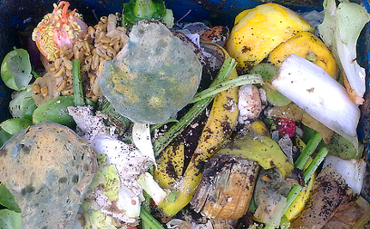
While Children Starve, Up to Half of the World's Food Goes to Waste
www.care2.com
While millions of people worldwide go hungry, new data from the NRDC shows that up to half of the world's food is

Day 92: OLYMP-I-A for GREEN-LIVING (Year 2)- Action/Idea: Inspired by nature's beauty captured by Monet in his paintings. When we save nature (the plants, water, earth), we save not only our health but also the art within our souls.
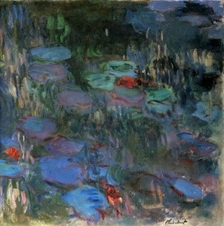
Mobile Uploads https://www.facebook.com/photo.php?fbid=368152276531703&set=a.200050423341890.56043.151300971550169&type=1&ref=nf
CLAUDE MONET "Magical Weeping Willow of the Giverny Garden" " L'arbre de Saule Pleureur" Bravo the Impressionists!
CLAUDE MONET - MONET'S PALATE- GIVERNY-MERYL STREEP - Claude Monet's Passions for food,art,travel,his gardens and LIFE. Monet's Palate a film with MERYL STREEP www.facebook.com/Monets.Palate.Claude.Monet
By: Monet's Palate

Day 93: OLYMP-I-A for GREEN-LIVING (Year 2)- Action: At the elementary school where I volunteer, I noticed that the library is focusing on the theme of green-living. The library has selected and displayed a showcase of books for elementary school children all about green-living... planting trees, taking care of the earth, etc. Great way to encourage children to learn about sustaining the environment.

Day 94: OLYMP-I-A for GREEN-LIVING (Year 2)- Action: Had a delicious lunch at a cafe that earned a 2-Star Green Restaurant Certification by the Green Restaurant Association (GRA). The GRA has strict standards on water efficiency, waste reduction and recycling, sustainable décor and building materials, energy efficiency, chemical and pollution reduction, and the use of sustainable foods. I read an interesting article about Green Restaurant Certification online: http://www.nrdc.org/thisgreenlife/1011.asp. Something to think about when selecting a restaurant!
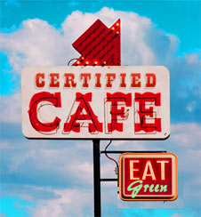
NRDC: Green Certified Restaurants
www.nrdc.org
Dine out with your values intact at restaurants that have made certifiable efforts to lower their environmental footprint in six key areas -- not just food.

Day 95: OLYMP-I-A for GREEN-LIVING (Year 2)- Action: Helped 5 and 6 year olds give a presentation to other children about how we help animals. They were so excited!!

Day 96: OLYMP-I-A for GREEN-LIVING (Year 2)- Action: Sharing a good article about the importance of recycling batteries: http://earth911.com/news/2012/04/05/battery-recycling-the-power-is-yours/. The article talks about "Call2Recycle," so I looked it up and read more about it on FB at https://www.facebook.com/Call2Recycle.
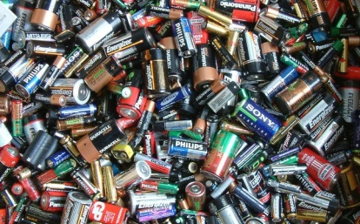
Battery Recycling: The Power is Yours - Earth911.com
earth911.com
Most of us rely on rechargeable batteries daily and for multiple devices. So what happens to all of those batteries

Day 97: OLYMP-I-A for GREEN-LIVING (Year 2)- Action: I discovered "Smencils" and "Smens," scented pencils and pens made out of recycled paper and plastic. Cool idea! http://smencils.com/
SMENCIL WORLD - Smencils.com 1-866-SMENCILS (763-6245)
smencils.com
Smencils - Gourmet scented pencils and pens made from recycled newspapers. Enjoyed by everyone - sold by

Day 98: OLYMP-I-A for GREEN-LIVING (Year 2)- Action: Sharing a wake-up call about global warming.
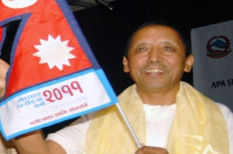
Appa Sherpa worried over mountains losing sheen
www.thehimalayantimes.com
DOLPA: Veteran mountaineer Appa Sherpa is worried over the Himalayan peaks losing their snow cover and turning into bare rock faces over the years due to global warming. Famous mountains of the Himalayas such

Day 99: OLYMP-I-A for GREEN-LIVING (Year 2)- Action: Sharing a link with tips for gardening with kids.
http://kidsactivitiesblog.com/how-to-garden-with-kids/
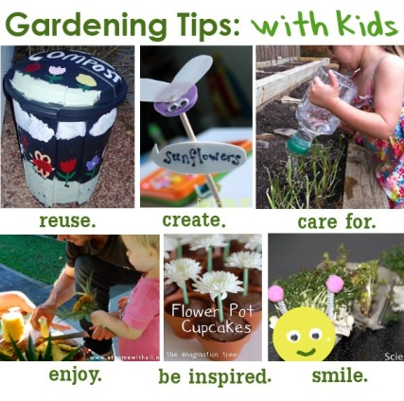
How to Garden with Kids: 18 Tips
kidsactivitiesblog.com
Here are 18 Tips on how to successfully grow a garden with your kids.

Day 100: OLYMP-I-A for GREEN-LIVING (Year 2)- Action: Sharing a video that provides an introduction to Rio + 20 for children: http://vimeo.com/37579437 . Rio + 20 is "a 3 day event [in June, 2012] that will focus on two themes—the green economy and the institutional framework for sustainable development—and has only one objective—to have governments commit to sustainable development."
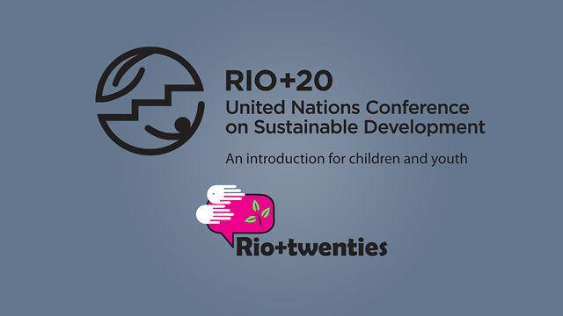
Rio+20: an introduction for children and youth
vimeo.com
This animation video is brought to you by the youth-

Day 101: OLYMP-I-A for GREEN-LIVING (Year 2)- Action: Watched an inspiring video about the need for respect for life and our environment. http://www.youtube.com/watch?feature=player_embedded&v=lvedmu7b3kk. The video is created by youth in Seychelles and is entered as part of the "Global-Rockstar" Rio + 20 Global Youth Music Contest. You can select your choice for the winner and vote online at http://www.global-rockstar.net/category/youth-africa for youth entries from Africa. There are other youth entries from other parts of the world. I enjoyed exploring the website. Awesome and creative work!
RESPECT LIFE MASTER 2012.mp4
www.youtube.com
respect Life by Young Seychellois artist

Day 102: OLYMP-I-A for GREEN-LIVING (Year 2)- Action: I had fun helping children work an animal puzzle and make animal masks, all while talking about how we care for animals. The little ones were busy and had great ideas and creativity.

Day 103: OLYMP-I-A for GREEN-LIVING (Year 2)- Action: Had a delicious organic, vegan meal of noodles, kale, edamame, and carrots. To drink I had organic soy milk. All quite tasty :)).

Day 104: OLYMP-I-A for GREEN-LIVING (Year 2)- Action: Visited a "Half Priced Books" store and recycled some books. Found out about an upcoming event on April 21st when participating businesses in our city, including Half Priced Books, will be contributing 5% of their sales to 6 non-profit organizations that benefit the environment. Great way to honor Earth Day on April 22nd! http://www.hpb.com/community/
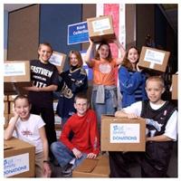
Half Price Books in the Community
www.hpb.com
The community involvement of Half Price Books.

Day 105: OLYMP-I-A for GREEN-LIVING (Year 2)- Action: Sharing a post and link from "Recyclebank": “Start carpools for community events.” A good idea! Learned more about Recyclebank and how to earn points for taking green actions at: https://www.recyclebank.com/how-to-earn/
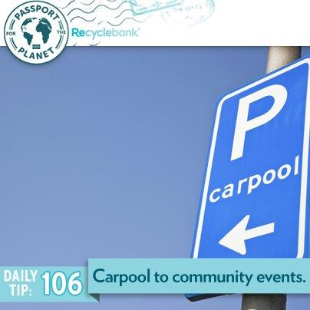
Wall Photos
Start carpools for community events.
By: Recyclebank

Day 106: OLYMP-I-A for GREEN-LIVING (Year 2)- Action: While driving around town in the morning, I noticed about 3 trucks, each owned by businesses that help people recycle, shred, etc. I realized that there is an increasing number of businesses available in our area to assist with some of the more daunting recycling/shredding tasks, etc. Without noticing these trucks, I might not have realized this. Good news! Helps me feel less overwhelmed when I have lot of things to recycle or shred.

Day 107: OLYMP-I-A for GREEN-LIVING (Year 2)- Action: Worked with young children to develop a special celebration/presentation about how we care for animals. They will have a mural, pictures, origami, masks, singing, etc. It is the culmination of many weeks of fun and learning. The children are so excited and created a special song for the event.

Day 108: OLYMP-I-A for GREEN-LIVING (Year 2)- Action: I talked to people involved with the Sustainable Food Center's "Farm to Work" program and found out more about it. Since "Farm to Work" brings fresh, local produce to employees of organizations, I asked if the program is also available for retirees. We all agreed, that retirees would benefit from accessing the program. Will be finding out more. http://www.sustainablefoodcenter.org/farm-direct
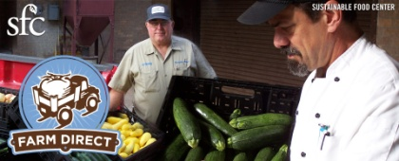
Farm Direct
www.sustainablefoodcenter.org
SFC's Farm Direct program promotes access to fresh, healthy food by making locally-grown produce available in the heart of the city and in locations easily accessible by

Day 109: OLYMP-I-A for GREEN-LIVING (Year 2)- Action: Had a grand finale celebration with young children (ages 5, 6, and 7) in after-school childcare, showing all the projects they have done over the last 2 to 3 months to learn about caring for animals and letting them tell about what they have learned. The children did great and had lots of fun!

Day 110: OLYMP-I-A for GREEN-LIVING (Year 2)- Action: Searched Facebook for interesting organizations and sites with a focus on green-living.

Day 111: OLYMP-I-A for GREEN-LIVING (Year 2)- Action: I am embracing a beautiful Spring day and so glad to have the chance to live in a time and place where I can experience the amazing wonders and relative abundance of plant life, animal life. As I think about the upcoming generations and the overwhelming concerns of climate change that will impact their lives, I am inspired by the actions of youth who are confronting these challenges. I read about the film "An Inconvenient Youth" which documents the activities of youth to build a sustainable future. Powerful! http://aninconvenientyouth.com/
An Inconvenient Youth | Feature Documentary by Slater Jewell-Kemker
aninconvenientyouth.com
An Inconvenient Youth is the feature-length documentary that gives a voice to young people living and working on the

Day 112: OLYMP-I-A for GREEN-LIVING (Year 2)- Action: I read about the Earth Day Network's "Know Green, Go Green" initiative which "aims to educate students about environmental issues so they understand the importance of civic responsibility and are inspired to act on behalf of the planet. Earth Day Network has created this toolkit as a guide to help... educators engage and mobilize students across the nation by providing lesson plans and other exciting resources and ideas." http://www.earthday.org/about-knowgreen
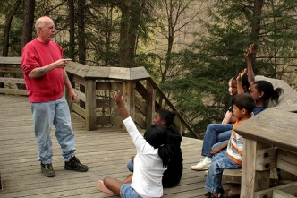
About Know Green, Go Green | Earth Day Network
www.earthday.org
Growing out of the first Earth Day, Earth Day Network works with over 22,000 partners in 192 countries to broaden, diversify, and mobilize the environmental

Day 113: OLYMP-I-A for GREEN-LIVING (Year 2)- Action: I had some "Texas Rain" water in a 100% biodegradable and recyclable bottle (the "greenest" bottle). I read more about the company and the bottle online: http://texas-rain.net/about-texas-rain/the-greenest-bottles/

Texas Rain :: Greenest Bottles
texas-rain.net

Day 114: OLYMP-I-A for GREEN-LIVING (Year 2)- Action: Met with Earth Child Institute via conference call about this upcoming event. So excited about the participation of the children in Ghana in the Earth Child Institute's "OLYMP-I-A" journaling challenge. Building a wonderful collaboration between Earth Child Institute and the "OLYMP-I-A." Working together for positive personal and global transformation, one child and one positive idea and action at a time. "The Power of One Child." https://www.facebook.com/photo.php?fbid=10150692639933175&set=a.345099508174.152271.324008488174&type=1&ref=nf
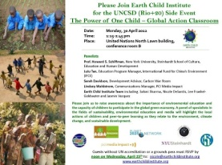
Wall Photos
Please join us on Monday 30 April at the United Nations in New York which will feature video clips and journal entries from kids in action all over the world!

Day 115: OLYMP-I-A for GREEN-LIVING (Year 2)- Action: I found out how I can participate in the Sustainable Food Center's "Farm to Work" program… fresh, local, organic produce is delivered to the worksite and ready to pick up weekly. http://www.sustainablefoodcenter.org/farm-direct
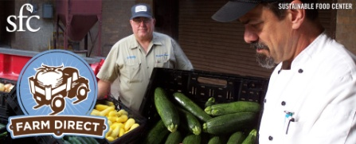
Farm Direct
www.sustainablefoodcenter.org
SFC's Farm Direct program promotes access to fresh, healthy food by making locally-grown produce available in the heart of the city and in locations easily accessible by

Day 116: OLYMP-I-A for GREEN-LIVING (Year 2)- Action: Sharing a powerful video “The Earth Is Full”… a dramatic presentation of the current environmental crisis, moving us to act now to build a more sustainable world: http://www.karmatube.org/videos.php?id=3105. It takes all of us to make the change.
KarmaTube: The Earth Is Full
www.karmatube.org
The earth is full - full of us; full of our stuff. Full of our waste; full of our demands. Our economy is now bigger than our host - this planet - burning through our capital of

Day 117: OLYMP-I-A for GREEN-LIVING (Year 2)- Action: I am sharing a list of important and informative food documentaries (thanks to the post by "Nature's Path Organic Foods" ). http://networkedblogs.com/wwUdw
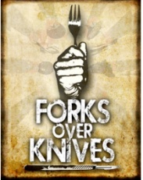
The Top 10 Food Documentaries You Can’t Afford to Miss
networkedblogs.com
Did you know that 90% of the food Americans buy is processed? Even the fast food you personally don’t eat

Day 118: OLYMP-I-A for GREEN-LIVING (Year 2)- Action: I went to a fun ArtFest that was happening along with the Farmer's Market. It was great to see local stores there supporting activities for children, providing them fun, creative, hands-on experiences with potting plants, and helping to teach them at an early age how to care for the earth, etc.

Day 119: OLYMP-I-A for GREEN-LIVING (Year 2)- Action: Sharing an update from the David Sheldrick Wildlife Trust about "One Lucky Leopard Cub." Some good news and important information about leopards and people who work for their survival. http://www.sheldrickwildlifetrust.org/updates/updates.asp?ID=419
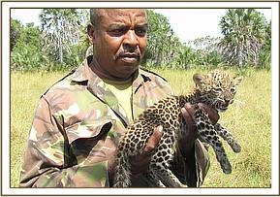
The David Sheldrick Wildlife Trust Updates
www.sheldrickwildlifetrust.org
A haven for elephant orphans, rhinos and other animals. Read about our work on elephant conservation, anti-poaching resource and everything else about elephants.

Day 120: OLYMP-I-A for GREEN-LIVING (Year 2)- Action: After seeing the film "Chimpanzee" by Disneynature, I was so amazed at the cinematography and the message of the film. So incredible and worth seeing. I found a video that gives background about the making of the film and the efforts to save chimpanzees: http://www.youtube.com/watch?feature=player_embedded&v=AdxR5kKiv1c. I also read more on the Facebook page: https://www.facebook.com/DisneynatureChimpanzee
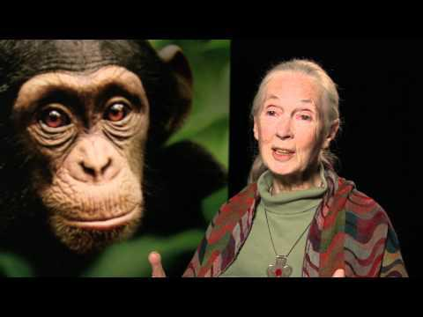
See Chimpanzee, Save Chimpanzees
www.youtube.com
In theaters April 20 See Chimpanzee opening week and Disneynature will make a donation to the Jane Goodall Institute

Day 121: OLYMP-I-A for GREEN-LIVING (Year 2)- Action: I declined a plastic bag for my purchases when checking out at a store. I am trying to do this consistently. I was able to carry out my individual items in my hands. When the items are too many, I just borrow a cart to bring them to the car and then return the cart. Even such a small step usually catches the attention of the cashier and helps promote green-living.

Day 122: OLYMP-I-A for GREEN-LIVING (Year 2)- Action: I found out more information about a farm that provides produce for the "Farm to Work" program, "Gundermann Acres." I'm excited about signing up for some of their local, organic produce. https://www.facebook.com/pages/Gundermann-Acres/112849672093902
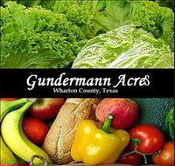
Gundermann Acres
Gundermann Acres is a 90-acre farm located in Elm Grove, Tx. We also have acreage in Glen Flora, Tx (both in Wharton County) where we have our greenhouses.Throughout the year, we grow seasonal organic/sustainable fruits and vegetables....

Day 123: OLYMP-I-A for GREEN-LIVING (Year 2)- Action: Sharing a positive step forward for green-living, posted by Earth911. http://earth911.com/news/2012/05/03/subway-salad-containers-recycled-plastic/
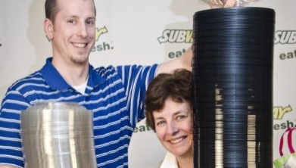
Subway Switches to Recycled Salad Containers - Earth911.com
earth911.com
Michael Fox, packaging technologist, and Elizabeth Stewart, marketing director for Subway restaurants, show off new recycled salad bowls.

Day 124: OLYMP-I-A for GREEN-LIVING (Year 2)- Action: Participated in a wonderful conference call with folks from Earth Child Institute (https://www.facebook.com/pages/Earth-Child-Institute/324008488174) and Global Peace Exchange (GPE) (https://www.facebook.com/pages/Global-Peace-Exchange/12395086279.
Earth Child Institute
Earth Child Institute is committed to combating climate change, deforestation and water scarcity by investing in hands-on environment and educational projects with and for children, both in and out of schools. Our goal is to engage with and support empowerment of the world’s 2.2 billion people under...

Day 125: OLYMP-I-A for GREEN-LIVING (Year 2)- Action/ Idea: Sharing a fantastic video “Change the World in 5 Minutes”: http://www.youtube.com/watch?v=oROsbaxWH0M&feature=share. It lines up 100% with the OLYMP-I-A challenge! So inspiring to see this happening. Thanks to Earth Child Institute for posting this and for all their work to help children around the world learn sustainable and healthy lifestyles. It would be so cool to arrange a conference call between Earth Child Institute and the people involved in organizing the "Change the World in 5 Minutes" school project and video. Perhaps there could be a collaboration with schools in Nepal, Ghana, and other countries.
Change the World in 5 Minutes - Everyday at School
www.youtube.com
Can a bunch of school kids really change the world in five minutes a day? This class

Day 126: OLYMP-I-A for GREEN-LIVING (Year 2)- Action: I read about 6 inspiring community garden projects. Wonderful initiatives! The more we generate this type of local impact, the more we move toward global impact. http://earth911.com/news/2012/05/03/6-inspiring-community-gardens/
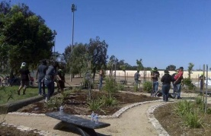
Wall Photos
Get inspired: These 6 community gardens are helping the homeless, teaching the youth of tomorrow and more: http://bit.ly/JQlGVl

Day 127: OLYMP-I-A for GREEN-LIVING (Year 2)- Action: I read and am passing along an amazing article about a utilitarian-style of urban vertical farming. What a fantastic concept! What if the next generation of children grew up surrounded by these structures in cities? http://www.treehugger.com/urban-design/vertical-farm-proposal-woven-fabric-city.html
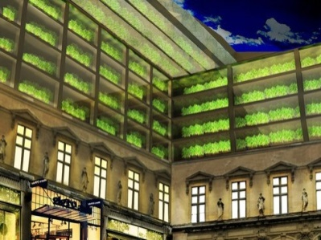
Vertical Farm Proposal Is Woven Into The Fabric Of The City
www.treehugger.com
If vertical farming is going to get real, then it has to get really local and mix it up.

Day 128: OLYMP-I-A for GREEN-LIVING (Year 2)- Action: I learned about the "Urban Farming" organization and the "Global Urban Farming 100 Million Families and Friends Campaign,™" a campaign to encourage 100 Million people to plant and register their gardens as a part of the "Urban Farming Global Food Chain®". This campaign empowers people who are unemployed, underemployed, laid off, malnourished, have unhealthy diets, suffer from hunger or food insecurity. http://www.urbanfarming.org/about.html
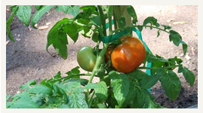
Urban Farming :: About
www.urbanfarming.org
Urban Farming is the adopted charity of Atlantic Records that is ending hunger globally by planting food in food deserts. Win to End Hunger in the Urban Farming Global Games! Urban Farming intends to eradicate hunger while

Day 129: OLYMP-I-A for GREEN-LIVING (Year 2)- Action: Participated in a program that delivers fresh, organic produce from local farms to work locations. A great, cost-effective way to buy local and support organic farming. Got a wonderful box full of veggies and some fruit straight off the farm.

Day 130: OLYMP-I-A for GREEN-LIVING (Year 2)- Action: Added some fresh, organic red potatoes, zucchini, and carrots to "Amy's" organic "No Chicken Noodle Soup". A simple, quick, and delicious meal! https://www.facebook.com/AmysGoOrganic
Amy's Kitchen-GO ORGANIC!
Amy’s Kitchen is a family business. After my parents, Andy and Rachel Berliner had me, Amy, in 1987, they realized they had little time to cook the healthy, organic meals they loved. They formed Amy's Kitchen to help people like them who are sometimes too busy to cook delicious, nutritious meals.

Day 131: OLYMP-I-A for GREEN-LIVING (Year 2)- Action: I learned that "Trees for the Future" is now a permanent partner of the Global Giving fundraising platform. Through this permanent partnership, Trees for the Future will now be able to post multiple projects and get funding from dedicated donors of Global Giving. The latest fundraising projects are posted on the Global Giving website: http://www.globalgiving.org/. Exciting news!
GlobalGiving.org
www.globalgiving.org
Donate to grassroots projects around the world

Day 132: OLYMP-I-A for GREEN-LIVING (Year 2)- Action: I ate a delicious organic, vegan salad with kale, dried radish, sunflower seeds, tomatoes, olive oil, tahini, and garlic. Yum! A taste of the garden :)).

Day 133: OLYMP-I-A for GREEN-LIVING (Year 2)- Action: Sharing an article about recycling left-over food, a collaboration between restaurants and Food Banks which is reducing waste and bringing needed food to children and adults. http://video.msnbc.msn.com/rock-center/47182744#47182744
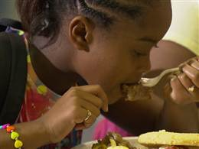
Making a Difference: Turning excess restaurant food into kids' meals
video.msnbc.msn.com
Video on msnbc.com: By some estimates, up to 40 percent of all edible food goes to waste. One large restaurant chain

Day 134: OLYMP-I-A for GREEN-LIVING (Year 2)- Action: I read a remarkable and moving story. “If there ever were a time, when we can truly sense the wondrous ‘interconnectedness of all beings,’ it is when we reflect on the elephants of Thula Thula. A man’s heart’s stops, and hundreds of elephants’ hearts are grieving. This man’s oh-so-abundantly loving heart offered healing to these elephants, and now, they came to pay loving homage to their friend.” http://delightmakers.com/news-bleat/wild-elephants-gather-inexplicably-mourn-death-of-elephant-whisperer/ Thank you to Luanne Stovall for sharing this!
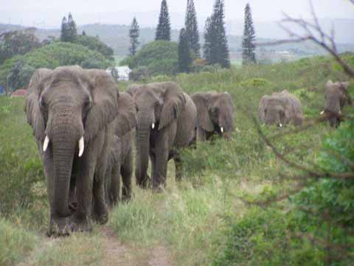
Wild Elephants gather inexplicably, mourn death of “Elephant Whisperer” | Delight Makers
delightmakers.com
Author and legendary conservationist Lawrence Anthony died March 7. His family tells of a solemn procession on

Day 135: OLYMP-I-A for GREEN-LIVING (Year 2)- Action: I worked with young children on the OLYMP-I-A challenge. Several drew pictures of what they think about or do to help keep the earth healthy. I got pictures of beautiful trees (homes for squirrels), rainbows, people watering plants, flowers, and other creative ideas. Wonderful!!!

Day 136: OLYMP-I-A for GREEN-LIVING (Year 2)- Action: I talked with children to help them understand how we are connected to the earth. If the earth is healthy (animals, plants, trees, air, water, soil), we are healthy.

Day 137: OLYMP-I-A for GREEN-LIVING (Year 2)- Action: I found out more about the World Environment Day (WED) Challenge: http://www.unep.org/wed/aroundtheworld/.
World Environment Day - United Nations Environment Programme
www.unep.org
The most environmentally-friendly travel is by train, bus, cycle or on foot. But in some countries making an eco-

Day 138: OLYMP-I-A for GREEN-LIVING (Year 2)- Action: I found some fun and challenging word games and puzzles for Earth Day and gave them to children to engage them in thinking about green-living. It got the children excited and it started some great conversations. http://funschool.kaboose.com/globe-rider/earth-day/printables/puzzles.html?page=2
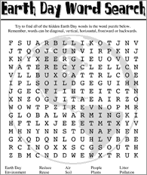
Funschool - Earth Day - Puzzles
funschool.kaboose.com

Day 139: OLYMP-I-A for GREEN-LIVING (Year 2)- Action: I tried a new drink, "Mamma Chia," an organic juice drink with chia seeds. Very delicious!! The Mamma Chia company participates in "1% for the Planet." I looked it up online and learned more. "Since 2002, 1% for the Planet has inspired members of the business community to contribute 1% of sales to environmental groups around the world. In return, this growing alliance of companies is given the opportunity not only to see their self-worth rise, but their net worth climb as well." Awesome!! http://www.onepercentfortheplanet.org/en/aboutus/
1% for the Planet | About Us
www.onepercentfortheplanet.org
1% for the Planet is an alliance of businesses that donate at least 1% of their annual revenues to environmental organizations worldwide.

Day 140: OLYMP-I-A for GREEN-LIVING (Year 2)- Action: I watched a great video posted by the Global Alliance for Clean Cookstoves, demonstrating a simple, yet powerful, step that can dramatically reduce our carbon footprint: http://www.youtube.com/watch?feature=player_embedded&v=FnHtmRSNV48. "...Wonderbag offer[s] a unique way to reduce our carbon footprint while cooking.The Wonderbag assists developing countries and communities with high poverty, a shortage of fuel supplies, a large incidence of health problems associated with air pollution and/or injuries resulting from fuel fires. Learn more at http://nb-wonderbag.com/. "
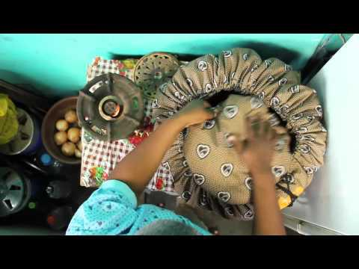
What is Wonderbag?
www.youtube.com
The Wonderbag is a heat retention cooking bag that helps reduce your household's carbon footprint and also shortens cooking time.

Day 141: OLYMP-I-A for GREEN-LIVING (Year 2)- Action: I read an article about Mexico's progress in wind power! So good to see this happening! http://www.triplepundit.com/2012/05/mexico-rapidly-increasing-installed-wind-power/
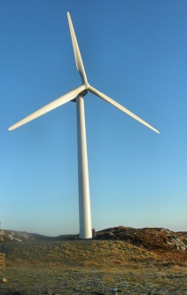
Mexico is Rapidly Increasing Wind Power Installations
www.triplepundit.com
Mexico ranks 24th in wind capacity and is expected to jump to 20, according to the Global Wind Energy Council (GWEC).

Day 142: OLYMP-I-A for GREEN-LIVING (Year 2)- Action: I saw "Eco-Foil" at the grocery store and found out more about it on the "Eco-Foil" Facebook page: https://www.facebook.com/ecofoilpans?ref=ts. The product is from 100% recycled materials.
Eco-Foil
Eco-Foil is made by Handi-Foil, the # 1 aluminum container manufacturer in the U.S. All products are made in the United States and from green materials.The foil pan and the plastic lid are made from 100% recycled material. Contatct Us: ecofoil@handi-foil.com Terms of Use: http://bit.ly/eco-tou

Day 143: OLYMP-I-A for GREEN-LIVING (Year 2)- Action/Idea: I found out more about "Preserve Products." They are seeking nominations for Local Recycling Heroes. I'm thinking of several people I could nominate. http://www.preserveproducts.com/
Preserve: Nothing wasted. Everything gained.
www.preserveproducts.com
Preserve makes stylish, high performance, eco-friendly products for the home. Our personal care, tableware and kitchen products make living green easy without sacrificing

Day 144: OLYMP-I-A for GREEN-LIVING (Year 2)- Action: I showed two videos to children in an after-school childcare program to help them learn about ways to help the planet. The first video showed what school children can do to help the earth in just 5 minutes every day- recycling, gardening, and cutting of lights, and computers not in use, etc. The second video was about an elephant who had been kept alone in a zoo for 20 years and was being moved to a sanctuary and reunited with other elephants. The video showed the feelings of elephants and the importance and strength of elephant friendships. The children learned more about how to respect and care for elephants. A fun afternoon!

Day 145: OLYMP-I-A for GREEN-LIVING (Year 2)- Action: I talked with children about different endangered animals, polar bears, the Mexican gray wolves, manatees, the Florida panther, the sea turtle, etc. They loved the pictures of the animals and they learned some about the importance of helping preserve the animals' habitats.

Day 146: OLYMP-I-A for GREEN-LIVING (Year 2)- Action: I am trying some organic, unsweetened rice drink as a milk substitute. Very tasty! https://www.facebook.com/pages/Rice-Milk/82399988270
Rice Milk
Rice Milk: Its Healthier For You! The perfect alternative to milk. Enjoy a chilled glassful or with your favorite morning cereal. Rice milk taste's great with all your favorite baked pastry and desserts. "Rice Milk, Treat Yourself Good!" -Notis

Day 147: OLYMP-I-A for GREEN-LIVING (Year 2)- Action: I read and watched a video about an amazingly simple technique to reduce usage of paper towels. I will never wash and dry my hands the same way again!!! "13 billion pounds of paper towels are used in the U.S. every year. If all Americans used one less paper towel a day, 571,230,000 pounds of paper would be spared over the course of the year. One man has a simple strategy to make it happen." The technique is the "Shake & Fold". So simple and so powerful!! Thanks to "Earth911" for posting.
http://earth911.com/news/2012/05/15/how-to-use-one-paper-towel-and-save-paper/.
Help Save 571,230,000 Pounds of Paper Towels - Earth911.com
earth911.com
Guide to local resources including recycling centers, how to recycle, pollution prevention and how help protect the

Day 148: OLYMP-I-A for GREEN-LIVING (Year 2)- Action: I saw one of the children who has been doing the OLYMP-I-A challenge. She was out bicycling with her family. I stopped to talk with her and her parents. She was excited to tell me that she had seen some deer yesterday. It's so great to see her growing interest in animals!

Day 149: OLYMP-I-A for GREEN-LIVING (Year 2)- Action: I celebrated and gave awards to young children who completed the 7-day and 14-day OLYMP-I-A challenge for green-living and peace (7 or 14 straight days of positive ideas and actions for helping the earth stay healthy and helping others). Part of their award was a grocery bag to take to the store so they could stop using plastic bags.

Day 150: OLYMP-I-A for GREEN-LIVING (Year 2)- Action: While out on a bike ride, I did some quick grocery shopping at Natural Grocers, a wonderful grocery store with a great selection of all organic fresh produce and no use of paper or plastic bags! Wow!! https://www.facebook.com/NaturalGrocers
Natural Grocers by Vitamin Cottage
Store locations, phone numbers, and announcements here: http://www.naturalgrocers.com/store-info/store-locations

Day 151: OLYMP-I-A for GREEN-LIVING (Year 2)- Action/Idea: I plotted a bike route to my work (about 10 miles). Thinking of trying it..... maybe.... :)). I could test the sustainability of my true, energy-efficient, low carbon footprint, bio fuel (muscle power) :)).

152: OLYMP-I-A for GREEN-LIVING (Year 2)- Action: I learned about "The 6-Minute Speech Project," a unique speech that will be built by people from all over the world... as part of the United Nations Conference on Sustainable Development, Rio+20, starting soon in Rio de Janeiro. The speech will be a compilation of tweets, Facebook posts, etc. from all over the world, expressing peoples' thoughts about the challenges and solutions for sustainability.
http://rioplussocial.com.br/en/#

Rio+Social
rioplussocial.com.br
Rio+Social is an event for everyone who wants to change the world for the better. Get ready to share your voice!

Day 153: OLYMP-I-A for GREEN-LIVING (Year 2)- Action: I learned that roof shingles can and should be recycled. Asphalt roof shingles can be recycled into asphalt for roads, etc., dramatically reducing landfill waste. It is important to work with roofing contractors who pledge to recycle. http://earth911.com/recycling/construction/shingles/
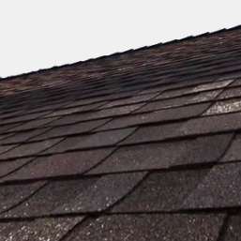
Shingles Recycling - Earth911.com
earth911.com
Guide to local resources including recycling centers, how to recycle, pollution prevention and how help protect the environment.

Day 154: OLYMP-I-A for GREEN-LIVING (Year 2)- Action: I looked up the agenda for the UN Conference on Sustainable Development (Rio+20) and found date, time, and description of the Earth Child Institute's "Side Event". I am excited about the "OLYMP-I-A" collaboration with Earth Child Institute and the positive ideas and actions for sustainability being generated by children in Ghana and other countries!
http://www.uncsd2012.org/rio20/index.php?page=view&type=1000&nr=272&menu=126
Rio+20 : The Power of One Child: youth and children leading the way
www.uncsd2012.org
Rio+20, United Nations Conference on Sustainable Development, will be held in Rio de Janeiro, Brazil, on June 20-22, 2012. The Conference will take place in Brazil in

Day 155: OLYMP-I-A for GREEN-LIVING (Year 2)- Action/Idea: I read about Humana's initiatives for green-living:
http://www.humana.com/resources/about/corporate/healthy_planet.aspx. Info worth reading! The webpage provides a profile of Humana's array of activities! Social and environmental responsibility should be importants aspects of any company's vision, policies, and actions with accountability and quality checks built into company evaluation.
Healthy Planet - Social and Environmental Responsibility
www.humana.com
At Humana, we're committed to doing our part to make the planet a healthier place with corporate policies, associate involvement and member outreach.

Day 156: OLYMP-I-A for GREEN-LIVING (Year 2)- Action: I signed a global petition that now has over 990,000 signatures, with a goal of 1 million by the end of this week. "As the Rio+20 Earth Summit draws near, Earth Day Network has joined a diverse coalition calling for an end to fossil fuel subsidies... [The petition will] send a strong message to world leaders gathered [at Rio+20, the UN Conference on Sustainable Development in June] in Rio: Fossil fuel subsidies drive climate change, drain public resources, and make it virtually impossible for clean energy sources to compete in the market. http://www.earthday.org/rio2/
Road to Rio | Earth Day Network
www.earthday.org
Pretty Simple Content Slider with jQuery and CSS3

Day 157: OLYMP-I-A for GREEN-LIVING (Year 2)- Action: I read about Frances Moore Lappe and her new book "EcoMind:" http://smallplanet.org/about/frances/bio. Check out the recent post on the Natural Grocers Facebook page (https://www.facebook.com/NaturalGrocers). If you have questions for Ms. Lappe, you can send them in by commenting on the "Natural Grocers" post.
Frances Moore Lappé | Small Planet Institute
smallplanet.org
Frances Moore Lappé is the author or co-author of 18 books including the three-million copy Diet for a Small Planet. Her most recent work, released by Nation Books in

Day 158: OLYMP-I-A for GREEN-LIVING (Year 2)- Action: I read an interesting article about water supply- puts it in perspective. Important info and emphasizes the importance of wise water use and conservation. http://www.usgs.gov/blogs/features/usgs_top_story/how-much-water-is-available/?from=image
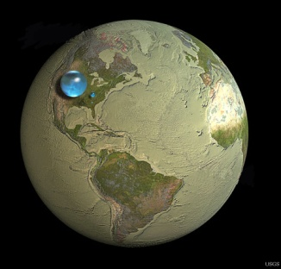
How Much Water is Available?
www.usgs.gov
Are you surprised the water bubbles look so small?<a href="http://www.usgs.gov/blogs/features/usgs_top_story/how-much-water-is-available/?from=textlink">Read

Day 159: OLYMP-I-A for GREEN-LIVING (Year 2)- Action: I learned about the goodness of "Earth's Best" organic baby foods from my great nephew. A good start for babies :)). https://www.facebook.com/EarthsBestOrganic
Earth's Best
Nurture your growing baby with only the purest, natural and organic products from Earth's Best. Earth's Best has been the leader in organic baby food for the last 25 years. Today, you can find better-for-baby products from organic formula, infant cereals, jarred baby food, chlorine free diapers an...

Day 160: OLYMP-I-A for GREEN-LIVING (Year 2)- Action: I watched the movie "WALL-E," a cute Pixar film with a strong message about the importance of green-living. https://www.facebook.com/PixarWallE
WALL•E
After hundreds of lonely years of doing what he was built for, the curious and lovable WALL•E discovers a new purpose in life when he meets a sleek search robot named EVE. Join them and a hilarious cast of characters on a fantastic journey across the universe.

Day 161: OLYMP-I-A for GREEN-LIVING (Year 2)- Action: I used my sturdy and large cloth grocery bag to do some grocery shopping this morning and gave my interested relatives the tip that I got the bag at "Half Priced Books." It's fun to share green-living tips!

Day 162: OLYMP-I-A for GREEN-LIVING (Year 2)- Action: I watched a video and learned more about Emerald Eco Products: paper products made from sugar cane instead of trees! Great potential for reducing deforestation! http://www.youtube.com/watch?v=RVJbbrERDhA&feature=youtu.be. Our family is using the Emerald paper towels!
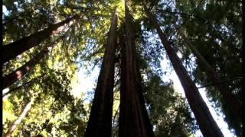
Emerald Eco Products
www.youtube.com
Emerald Eco Products Video offers an overview of our Tree Free products and our

Day 163: OLYMP-I-A for GREEN-LIVING (Year 2)- Idea: What a creative idea for reusing/recycling a file cabinet. Looks like something I could do in my garage :)) http://earth911.tumblr.com/post/24825136892/ajes-via-before-after-less-than-fabulous
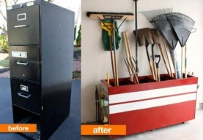
Wall Photos
Trying to figure out how to reuse something? Just...turn it on its side! http://bit.ly/LKLzH3
By: Earth911

Day 164: OLYMP-I-A for GREEN-LIVING (Year 2)- Action: I talked with children at two summer camp programs about the OLYMP-I-A challenge. I was impressed with how much they knew about green-living and how to help the earth (animals, plants, air, water, soil, etc.) stay healthy.

Day 165: OLYMP-I-A for GREEN-LIVING (Year 2)- Action: I asked a group of young children what they can do to help the earth stay healthy. One little girl quickly said, "The 3 R's." I asked, "What's that?" She proudly announced, "Reduce, Reuse, Recycle!" Wow! I was so impressed. Children can be quite knowledgeable about how to help the environment. They are going to have fun practicing green-living in the OLYMP-I-A challenge this summer. I can't wait to see what ideas and actions they generate!

Day 166: OLYMP-I-A for GREEN-LIVING (Year 2)- Action: I explored a great website for children about green-living, the National Institute of Environmental Health Sciences- Kids Pages: http://kids.niehs.nih.gov/explore/reduce/index.htm. The website has lots of great info for kids, stories, games, puzzles, experiments, word definitions, etc. I hope to share some of these things with the children doing the "OLYMP-I-A" challenge this summer.
National Institute of Environmental Health Sciences - Kids Pages - Reduce, Reuse, Recycle
kids.niehs.nih.gov
Waste, and how we choose to handle it, affects our world's environment—that's YOUR environment. The environment is everything around you including

Day 167: OLYMP-I-A for GREEN-LIVING (Year 2)- Action: Sharing info from the United Nations Rio+20 conference in Brazil: "Rio+20- Seven Issues, Seven Experts ... from UN News Centre highlighting the issue of Energy and the Future We Want: http://ow.ly/bC3pw."
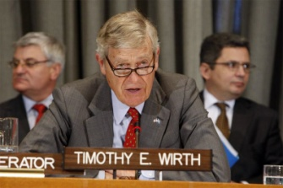
Rio+20 Feature: Seven Issues, Seven Experts Energy
www.un.org
Energy Timothy Wirth, member of the High-Level Group on Sustainable Energy for All

Day 168: OLYMP-I-A for GREEN-LIVING (Year 2)- Action: I went outside in the early morning and let my mind take in the sounds, smells, colors. I felt the gentle brushstrokes of the air. I entered the world's canvas and let it enter me. When we open our windows or step outside for a moment without an agenda, we connect with the earth and gain new perspective. The earth becomes in sight and in mind. It is recognized as an essential interaction, an essential friendship, and something we cannot forget or fail to protect.

Day 169: OLYMP-I-A for GREEN-LIVING (Year 2)- Action: Sharing some great info from the latest issue of Outreach Magazine about the dialogues at Rio+20 ... focusing on sustainable food and agriculture. http://issuu.com/outreachlive/docs/outreachdialogueday3/1
Outreach at Rio+20 Dialogues - 18 June 2012
issuu.com
The focus of today’s edition of Outreach is food and agriculture. Articles explore the importance of building knowledge systems, the interlinkages of food and nutrition

Day 170: OLYMP-I-A for GREEN-LIVING (Year 2)- Action: Sharing a simple, yet important change in habit that can change the world. "Eco Fact: if the entire US were to make a joint effort to wash their clothing in cold water, instead of hot, we would save about $3 billion in energy costs per year and cut national CO2 emission by over 1%." A great example of how just one action can have a huge impact!
HootSuite Photos https://www.facebook.com/photo.php?fbid=10151849071605714&set=a.10150783023635714.733201.224583260713&type=1&ref=nf
By: TerraCycle

Day 171: OLYMP-I-A for GREEN-LIVING (Year 2)- Action: I shared with children an easy example of how to help the earth stay healthy- be sure to cut off the water faucet after washing hands. It saves water. This is a real-life example we all can understand :)).

Day 172: OLYMP-I-A for GREEN-LIVING (Year 2)- Action/Idea: I had a great brainstorming session with Earth Child Institute... thinking of ways to involve more children in practicing daily positive ideas and actions for green-living. I am excited to see that Earth Child Institute has a new website up and running and that the OLYMP-I-A challenge is highlighted! Awesome!! http://www.earthchildinstitute.org/the-olymp-i-a-challenge/
The OLYMP-I-A Challenge | Earth Child Institute
www.earthchildinstitute.org
The OLYMP-I-A Challenge ECI Campaigns/Take Action > THE OLYMP-I-A CHALLENGE Building on the international spirit of the upcoming Rio+20 Earth Summit and the 2012

Day 173: OLYMP-I-A for GREEN-LIVING (Year 2)- Action: Sharing key info from Rio+Social: 10 takeaway messages. http://mashable.com/2012/06/21/rio-plus-social-takeaways/
10 Takeaways From Sustainability Conference Rio+Social
mashable.com
We've boiled down the Rio+Social discussions into 10 key takeaways.

Day 174: OLYMP-I-A for GREEN-LIVING (Year 2)- Action: I talked with a good friend about our different experiences in Kenya. We found out that we had both visited the David Sheldrick Wildlife Trust orphan elephant nursery in Nairobi. A wonderful place that helped opened my eyes and my heart to the world of elephants. I keep up with the news about the orphan elephant rescues and the posts about the orphans on Facebook: https://www.facebook.com/thedswt
The David Sheldrick Wildlife Trust
The DSWT is a registered charity in the UK, a Kenyan non-profit and a 501c3 in the USA, dedicated to the protection and conservation of wildlife and habitats in Kenya. The DSWT was founded by Dr Dame Daphne Sheldrick in Kenya in 1977, in memory of her late husband, David Sheldrick, the naturalist...

Day 175: OLYMP-I-A for GREEN-LIVING (Year 2)- Action: I immersed myself in nature on a wonderful hike. On the top of a rock outcropping with little to no place for anything to grow, we spotted a tiny oasis of flowering plants with tiny butterflies and insects alive and well. It is amazing to see that even in the driest, harshest conditions, the beauty of life still manages to emerge.

Day 176: OLYMP-I-A for GREEN-LIVING (Year 2)- Action: I learned about the United States Dept. of Education "Green Ribbon Schools." "...the Department will recognize schools where staff, students, officials and communities have worked together to produce energy efficient, sustainable and healthy school environments and to ensure the sustainability and environmental literacy of graduates."

http://www2.ed.gov/programs/green-ribbon-schools/index.html
www2.ed.gov

Day 177: OLYMP-I-A for GREEN-LIVING (Year 2)- Action: Sharing a great "reuse" idea... another example of how creativity and a simple action can make a difference and reduce waste.

https://www.facebook.com/photo.php?fbid=412384882133638&set=a.191856864186442.38443.117021665003296&type=1&ref=nf

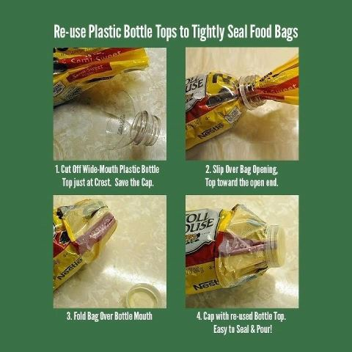
Wall Photos
By: Farmer's Pal

Day 178: OLYMP-I-A for GREEN-LIVING (Year 2)- Action: I read parts of the World Happiness Report: http://www.earth.columbia.edu/sitefiles/file/Sachs%20Writing/2012/World%20Happiness%20Report.pdf. I learned that we now live in what is called the "Anthropocene," a "new epoch in which humanity, through its technological prowess and population of 7 billion, has become the major driver of changes of the Earth’s physical systems, including the climate, the carbon cycle, the water cycle, the nitrogen cycle, and biodiversity.... if we act wisely, we can protect the Earth while raising quality of life broadly around the world. We can do this by adopting lifestyles and technologies that improve happiness (or life satisfaction)
while reducing human damage to the environment. “Sustainable Development” is the term given to the combination of human well-being, social inclusion, and environmental sustainability. We can say that the quest for happiness is intimately linked to the quest for sustainable development."
http://www.earth.columbia.edu/sitefiles/file/Sachs%20Writing/2012/World%20Happiness%20Report.pdf
www.earth.columbia.edu

Day 179: OLYMP-I-A for GREEN-LIVING (Year 2)- Action: I had a delicious vegan, macrobiotic lunch- gazpacho soup, kabocha squash, rice, pumpkin seeds, beans, and kale. The gazpacho looked and tasted like it was made with beets. It was so tasty and refreshing that I looked up beet gazpacho soup recipes on the internet. Yum!

Day 180: OLYMP-I-A for GREEN-LIVING (Year 2)- Action: I was eating some Stonyfield organic yogurt and noticed info on the yogurt container lid about the website https://iwillknowmyfood.com/#home. I visited the website and found out more about it. It has good info, and, if you create your own food superhero profile on the site, Stonyfield will donate $1 to FoodCorps (foodcorps.org). "Knowledge is power. When you know your food, you can make choices that are good for you, your family, the environment, farmers, animals and future generations."
Be a Food Superhero
iwillknowmyfood.com
Snap! Kapow! I'm a Food Superhero! Create your own alter ego at iwillknowmyfood.com and @Stonyfield will donate $1 to FoodCorps. Bam!

Day 181: OLYMP-I-A for GREEN-LIVING (Year 2)- Action: Visited a local vegan trailer cafe and had a delicious organic mock-chicken salad wrap with carrots, sprouts, and avocado. Wonderful meal, spiced with just a pinch of conscience :))

Day 182: OLYMP-I-A for GREEN-LIVING (Year 2)- Action: While reading the paper, I noticed that the city is offering a home composting rebate challenge. People can save 75% on a composting system. If people downsize to a 32 gallon or 21 gallon trash cart and take a free home composting class, then they can purchase a home composting system and get the 75% off rebate. People can register for the free in-person or online composting class at: www.austintexas.gov/composting. Moving in the right direction!!

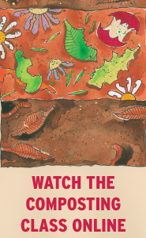
Home Composting Rebate Challenge | AustinTexas.gov - The Official Website of the City of Austin
www.austintexas.gov
The City of Austin's Home Composting Rebate Challenge is

Day 183: OLYMP-I-A for GREEN-LIVING (Year 2)- Action: I read an informative chart (from The Botanical Society of S. Africa) about the time it takes various materials to decompose. Enlightening and disconcerting at the same time. Thanks to Earth Child Institute for posting.
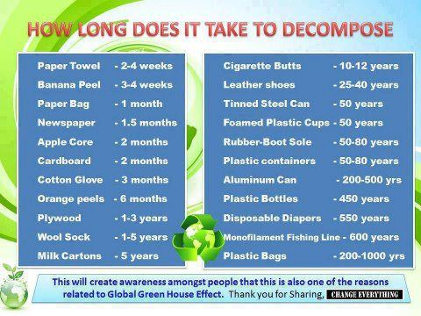
Wall Photos https://www.facebook.com/media/set/?set=a.206098982744700.47904.205627006125231&type=3#!/photo.php?fbid=438703962817533&set=a.206098982744700.47904.205627006125231&type=3&theater
By: The Botanical Society

Day 184: OLYMP-I-A for GREEN-LIVING (Year 2)- Action: I read an article and learned more about "Project Earth" (http://www.marketwatch.com/story/school-kids-solving-the-worlds-environmental-problems-recognized-at-rio20-2012-06-20). "More than 2,400 schools and clubs from 117 countries are currently participating in Project Earth, creating real projects to improve our global environment." The 2012 WORLD ENVIRONMENT DAY GLOBAL SCHOOL CONTEST WINNERS are listed in the article and were announced at the Rio+20 international conference in Brazil in June, 2012. All winners are featured on the Project Earth website (http://www.projectearth.net/ ). .

School Kids Solving the World's Environmental Problems Recognized at RIO+20
www.marketwatch.com

Day 185: OLYMP-I-A for GREEN-LIVING (Year 2)- Action: I heard a radio announcement about the American Lung Association's "Fighting for Air" campaign. I searched on the Internet and found out more about the campaign and ways to support the Clean Air Act: http://www.fightingforair.org/about-clean-air/. "Nationally in 2010, the Clean Air Act prevented:
•160,000 premature deaths;
•1.7 million instances of asthma attacks;
•41,000 respiratory hospital admissions; and
•45,000 cardiovascular hospital admissions."
American Lung Association: Fighting for Air | About Clean Air
www.fightingforair.org
Join the American Lung Association in the fight to protect the Clean Air Act and make sure we all have healthy, safe

Day 186: OLYMP-I-A for GREEN-LIVING (Year 2)- Action: I saw a poster at work that talked about the importance of knowing the watershed region for where you live. I looked up info on watersheds online at http://water.epa.gov/type/watersheds/whatis.cfm. "John Wesley Powell, scientist geographer, put it best when he said that a watershed is: 'that area of land, a bounded hydrologic system, within which all living things are inextricably linked by their common water course and where, as humans settled, simple logic demanded that they become part of a community.' " You can find out specific info on the watershed where you live, resources for watershed protection, etc. at: http://water.epa.gov/type/location/

http://water.epa.gov/type/watersheds/whatis.cfm"John
water.epa.gov

Day 187: OLYMP-I-A for GREEN-LIVING (Year 2)- Action/Idea: I enjoyed an afternoon of driving through the countryside, visiting small towns and peach orchard stands, taste-testing along the way. The beauty of the land, the smells and tastes of the fresh-picked fruit made for a wonderful day. I realized how easy it is in our busy lives to get caught up in an abstract, virtual world where we do not connect with nature. When we take time and experience nature first-hand, its meaning and value to us deepens and we realize the importance of our living in harmony with it.

Day 188: OLYMP-I-A for GREEN-LIVING (Year 2)- Action: Had a delicious agua fresca made with local, organic watermelon and peaches.

Day 189: OLYMP-I-A for GREEN-LIVING (Year 2)- Action: I read that the giant data centers or "clouds" that store and transmit data are a fast-growing consumer of worldwide energy. Much coal is burned to operate and maintain the virtual, online cloud. Facebook and Google are starting to reduce the use of coal. An Apple data center in N. Carolina is being set up to use renewable, biogas-powered fuel cells and solar panels. A Greenpeace initiative is working to try to persuade Apple, Microsoft, Amazon, and others to move to more renewable energy sources. I explored two links that provide info on the Greenpeace campaigns: http://www.greenpeace.org/usa/en/campaigns/global-warming-and-energy/cleanourcloud/apple/ and www.cleanourcloud.com

Clean Apple's Cloud!
www.greenpeace.org
Apple is a leader when it comes to innovative technology. While their products are cutting edge, the giant data centers they use to store and send our iPhotos, iTunes,

Day 190: OLYMP-I-A for GREEN-LIVING (Year 2)- Action/Idea: Loved hearing the rain fall. A refreshing sound!! I could just imagine the plants, rivers, and lakes smiling :))

Day 191: OLYMP-I-A for GREEN-LIVING (Year 2)- Action: I found a wonderful example of the positive impact and ripple effect of simple actions for green-living. Thanks to Earth911 for posting!
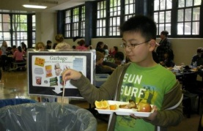
Wall Photos https://www.facebook.com/photo.php?fbid=10150939055237861&set=a.106185232860.92514.6608442860&type=1&ref=nf
An NYC school district pilot program reduced cafeteria food waste by 85%. If the program was rolled out to all schools in the state, an estimated $1 million in garbage bags and $1.1 million in disposal fees could be saved annually http://bit.ly/RRAyrv

By: Earth911

Day 192: OLYMP-I-A for GREEN-LIVING (Year 2)- Idea: Our electricity went out during the thunderstorm. When this happens, I am always impressed with how dependent we have become on electricity for our everyday tasks, work, etc. Such experiences heighten my awareness and serve to remind me of the ever-increasing demand for electricity and the critical need for renewable energy sources.

Day 193: OLYMP-I-A for GREEN-LIVING (Year 2)- Action: I found a handy cheat sheet for composting: http://earth911.com/news/2009/08/31/cheat-sheet-composting/. I learned that 34% of our waste stream could be composted. http://bit.ly/I14WuO. Thanks to Earth911 for posting!
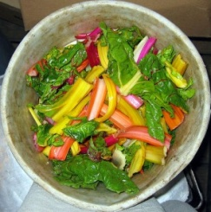
Cheat Sheet: Composting - Earth911.com
earth911.com
Guide to local resources including recycling centers, how to recycle, pollution prevention and how help protect the environment.

Day 194: OLYMP-I-A for GREEN-LIVING (Year 2)- Action: Sharing an interesting idea for gardening.
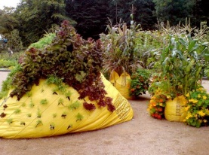
Wall Photos https://www.facebook.com/photo.php?fbid=419349388103854&set=a.191856864186442.38443.117021665003296&type=1&ref=nf
Use construction debris bags with poked holes for lettuce and other garden veggies to peek out of - a great way to build a garden up instead of out - and a lot less weeding! A low-tech version of vertical farming.

By: Farmer's Pal

Day 195: OLYMP-I-A for GREEN-LIVING (Year 2)- Action: I picked up organic fruit and veggies at the grocery store. I steamed some organic green beans for an afternoon snack, especially tasty with a sprinkle of organic spices.

Day 196: OLYMP-I-A for GREEN-LIVING (Year 2)- Action: Sharing key research, presented in a “TED” talk by Shawn Achor, that supports the premise of the "OLYMP-I-A" challenge: http://www.ted.com/talks/shawn_achor_the_happy_secret_to_better_work.html.

Quoted from Shawn Achor- "We've found that there are ways that you can train your brain to be able to become more positive. In just a two-minute span of time done for 21 days in a row, we can actually rewire your brain, allowing your brain to actually work more optimistically and more successfully. We've done these things in research now in every single company that I've worked with, getting them to write down three new ...things that they're grateful for for 21 days in a row, three new things each day. And at the end of that, their brain starts to retain a pattern of scanning the world, not for the negative, but for the positive first.

Journaling about one...positive experience you've had over the past 24 hours allows your brain to relive it. Exercise teaches your brain that your behavior matters. We find that meditation allows your brain to get over the cultural ADHD that we've been creating by trying to do multiple tasks at once and allows our brains to focus on the task at hand. And finally, random acts of kindness are conscious acts of kindness. We get people, when they open up their inbox, to write one positive email praising or thanking somebody in their social support network.

And by doing these activities and by training your brain just like we train our bodies, what we've found is we can reverse the formula for happiness and success, and in doing so, not only create ripples of positivity, but create a real revolution."

This is the power of the OLYMP-I-A!! Now to engage increasing numbers of children, youth, and adults in this simple, yet powerful exercise to make the world a better place! Everyone can do the OLYMP-I-A challenge for green-living, health, and peace.

Shawn Achor: The happy secret to better work | Video on TED.com
www.ted.com
TED Talks We believe that we should work to be happy, but could that be backwards? In this fast-moving and

Day 197: OLYMP-I-A for GREEN-LIVING (Year 2)- Action: Enjoying organic red grapes! Tasty treat and keeps my sweet tooth happy :))

Day 198: OLYMP-I-A for GREEN-LIVING (Year 2)- Action: Spent time with children enjoying flowers, plants, and nature.

Day 199: OLYMP-I-A for GREEN-LIVING (Year 2)- Action: Had fun with children planting sunflower seeds and helping them learn about what sunflowers need to grow.

Day 200: OLYMP-I-A for GREEN-LIVING (Year 2)- Action: Sharing a post from Earth911. Great idea for gyms!
"Anyone who's ever been to a spin class knows how much energy it takes to ride a stationary bike for any amount of time.
Amazingly enough, this bike and other exercise machines at a new Ariz. gym actually capture and reclaim energy generated by users, helping to power the facility: http://bit.ly/Lx8FEW.
Would you consider switching gyms if you knew your workout might help save electricity?"
visCycle
By: PlugOut Fitness

Day 201: OLYMP-I-A for GREEN-LIVING (Year 2)- Action: I was helping some children wash their hands and told them how to save paper and trees. I shared with them that after you wash your hands, you shake your hands 12 times over the sink and then take only 1/2 of a paper towel, fold it, and then dry your hands. This technique really cuts down on use of paper towels and helps trees live longer. The children loved learning the simple technique and took it very seriously. Awesome!! The ripple effect starts with each of us.

Day 202: OLYMP-I-A for GREEN-LIVING (Year 2)- Action: Had a delicious vegan sandwich for lunch, made with local, organic ingredients: organic sourdough bread, field roast, greens, cranberry sauce, and vegannaise. Delicious!

Day 203: OLYMP-I-A for GREEN-LIVING (Year 2)- Action/Idea: Sharing a Facebook post that lists 15 foods you can grow from table scraps. Great way to engage children and adults in reuse and recycling!
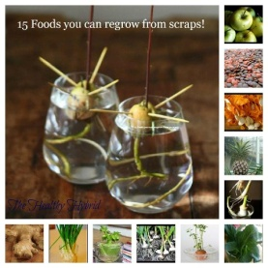
Wall Photos https://www.facebook.com/#!/photo.php?fbid=342544409154898&set=a.289445977798075.66910.284822361593770&type=1&theater
“Various plants (in no particular order) that you can regrow from the food you already have! Woot! Way to reuse and recycle! I constantly have green onions and celery growing. (And potatoes/sweet potatoes but that just because they decided to do that in my pantry) Do you guys regrow any of your food?
Apples- http://www.ehow.com/how_2135774_grow-apple-seeds.html
Tomatoes- http://www.ehow.com/how_5581958_grow-tomatoes-fresh-tomato-seeds.html
Potatoes/Sweet Potatoes- http://www.gardenguides.com/117543-plant-cuttings-potatoes.html
Green Onions- http://www.17apart.com/2012/02/how-to-grow-green-onions-indefinitely.html
http://tipnut.com/nifty-food-plants
Leeks- http://www.alifeenchanted.com/2012/05/02/regrow-leeks-too/
Carrot Tops- http://www.gardeningknowhow.com/children-in-the-garden/grow-carrot-tops.htm
Pineapple- http://www.rickswoodshopcreations.com/Pineapple/pineapple.htm
Romaine Lettuce- Same technique as celery
Cabbage- Same technique as celery
Celery- http://www.17apart.com/2012/02/growing-celery-indoors-never-buy-celery.html
Avocado - http://www.thehungrymouse.com/2009/09/09/how-to-grow-an-avocado-tree-from-an-avocado-pit/
Lentils- http://foodstoragemadeeasy.net/2009/02/19/how-to-grow-sprouts/
Pumpkin- http://pinterest.com/pin/98375573080950437/
Ginger- http://www.gardenswag.com/2011/12/5-foods-you-can-grow-from-kitchen-scraps/
Garlic- http://www.gardenswag.com/2011/12/5-foods-you-can-grow-from-kitchen-scraps/
Bonus: Bok Choy - http://www.17apart.com/2012/02/how-to-regrowing-bok-choy.html “

By: The Healthy Hybrid - A life in transition

Day 204: OLYMP-I-A for GREEN-LIVING (Year 2)- Action: I'm cleaning windows at my house. In the past, I've used paper towels sometimes, especially when I'm cleaning the windows from the inside. Now, I'm making a point of using washing cloths and sponges that can be rinsed, washed, and reused.

Day 205: OLYMP-I-A for GREEN-LIVING (Year 2)- Action: I was watching a show on public television and the T.V. station was promoting its "green membership" program. I read more about the "green membership" online at http://www.klru.org/green/. The green membership encourages people to support local businesses and offers paperless processing, updates, and newsletters. A positive step forward!
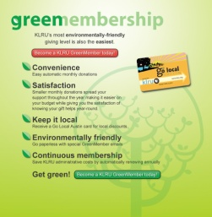
KLRU Green Membership
www.klru.org

Day 206: OLYMP-I-A for GREEN-LIVING (Year 2)- Action/Idea: Sharing a post by Earth Child Institute (https://www.facebook.com/pages/Earth-Child-Institute/324008488174). If trees were companies, we'd have to pay a lot for their services, yet we get them for free. All the more reason for us to donate our money and time to help sustain our parks and forests.

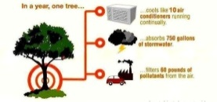
Wall Photos
GROW PLANTS...GO GREEN.
By: Health Remedies (AWHW)

Day 207: OLYMP-I-A for GREEN-LIVING (Year 2)- Action: I visited a waterpark and noticed the presence of many recycling containers. I had not been to this waterpark in over 5 years and was so happy to see this change! The times are changing :))

Day 208: OLYMP-I-A for GREEN-LIVING (Year 2)- Action: I read an amazing article about edible packaging: http://bit.ly/N3B0yc. Thanks to Earth911 for posting! An example of ingenuity working in the right direction!
Wall Photos
These are WikiCells, a new form of edible food packaging that could change the way we purchase and consume edibles. What do you think about eating your packaging, instead of trashing it? http://bit.ly/N3B0yc

By: Earth911

Day 209: OLYMP-I-A for GREEN-LIVING (Year 2)- Action: After eating a vegan sandwich for supper, I got inspired and looked up vegan cooking online. I found out more about the "Happy Herbivore" recipes and books at http://happyherbivore.com/get-started/
LEAF: Low Fat, Everyday, Affordable & Fast Recipes | Happy Herbivore
happyherbivore.com
Lindsay S. Nixon's cookbooks will save you money by using 'everyday' inexpensive ingredients, save you time with

Day 210: OLYMP-I-A for GREEN-LIVING (Year 2)- Action/Idea: I walked outside a little after dawn and felt the fresh dew on my feet and the cool morning breeze. I felt the earth renewing itself for another day. Every day we benefit from Nature's renewal, reuse, and recycling. We should return the favor.

Day 211: OLYMP-I-A for GREEN-LIVING (Year 2)- Ate a delicious macrobiotic, vegan breakfast with extended family and had some great discussions about nutrition and the impact of what we consume on our health and our planet.

Day 212: OLYMP-I-A for GREEN-LIVING (Year 2)- Action: I read an interesting article about Bill Gates' assessment of the future market for plant-based food production and lifestyle change.
Bill Gates: The Future of Meat is Vegan | Pasados
www.pasadosafehaven.org
Bill Gates is no stranger to innovation, troubleshooting, and looking to the future. And what this entrepreneur-turned-humanitarian sees is a future marked not by the consumption of animal products, but by a gradual turn to a

Day 213: OLYMP-I-A for GREEN-LIVING (Year 2)- Action: I read the latest news on the activities of the David Sheldrick Wildlife Trust. Lots of recent rescues of orphan elephants!!
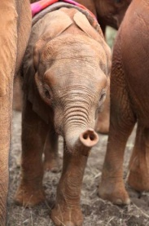
Wall Photos
“RESCUE: On Saturday 28th July our Voi Keepers were called into action again, following 2 rescues just the week before! This time their task was to rescue a young 10 month old male orphan elephant from Taita Ranch. Named Nyika, which means bush/thicket, he comes from an area that is heavily occupied by Somali herdsmen and their livestock. Human wildlife conflict and poaching in such areas is high. Nyika arrived very thin and weak, however in the last few days we are seeing signs of improvement. He has settled down well at the Nursery, with Balguda being a good friendly companion to him and we hope that this support and the dedicated care of our keepers will help him to improve further in the days ahead. We would of course very much welcome any donations to help us cover the recent rescue and care costs we have needed to meet, with 3 rescues in the space of only 8 days - https://www.sheldrickwildlifetrust.org/is/donate_now.asp. “
By: The David Sheldrick Wildlife Trust

Day 214: OLYMP-I-A for GREEN-LIVING (Year 2)- Action: So excited to read this article about a new product made from recycled "ocean-trash" plastic. The article has great info on organizations working to recycle the plastics accumulating in our oceans and on our beaches. Awesome! http://earth911.com/news/2012/08/02/method-to-debut-sea-trash-based-soap-bottle/

Method to Debut Sea Trash-Based Soap Bottle - Earth911.com
earth911.com
Guide to local resources including recycling centers, how to recycle, pollution prevention and how help protect the environment.

Day 215: OLYMP-I-A for GREEN-LIVING (Year 2)- Action: Instead of driving, I walked to the park to go swimming. Good exercise and less use of gasoline :)) I am fortunate that walking to the park was a doable option. "Walkable" neighborhoods are important for health and green-living both: http://www.walkscore.com/walkable-neighborhoods.shtml

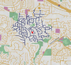
What Makes a Neighborhood Walkable
http://www.walkscore.com/
What makes a neighborhood walkable? Learn about walkability on Walk Score.

Day 216: OLYMP-I-A for GREEN-LIVING (Year 2)- Action: I read and learned more about The Nature Conservancy on Facebook (https://www.facebook.com/thenatureconservancy): Founded in 1951, "The Nature Conservancy has protected more than 117 million acres of land and 5,000 miles of rivers worldwide — and ...operate[s] more than 100 marine conservation projects globally." More info is also online at http://nature.org/.
The Nature Conservancy
The Nature Conservancy is the leading conservation organization working around the world to protect ecologically important lands and waters for nature and people.

Day 217: OLYMP-I-A for GREEN-LIVING (Year 2)- Action: I visited the "Wild Birds Unlimited" website (http://www.wbu.com/) to find out more about local birds in my area. The website is an amazing resource. While exploring the website, I discovered a program called "Pathways to Nature for Kids." The program helps children connect with nature. "Since 2007, Wild Birds Unlimited® has proudly teamed with the National Audubon Society to provide more than 1,250 children with scholarships to attend summer camps across the country. Wild Birds Unlimited scholarship eligibility is determined by each Audubon Center." http://www.wbu.com/pathwaysforkids/index.html
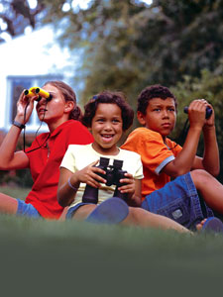
Pathways to Nature for Kids | Wild Birds Unlimited
www.wbu.com
DESCRIPTION

Day 218: OLYMP-I-A for GREEN-LIVING (Year 2)- Action: I enjoyed some organic grapes for an afternoon snack.

Day 219: OLYMP-I-A for GREEN-LIVING (Year 2)- Action: I read about an unprecedented global financial commitment for more sustainable transportation that was made at the Rio+20 conference... "a pledge by the 8 largest multilateral development banks (MDBs) to commit 500 staff and to dedicate $175 billion for more sustainable transportation in the coming decade" (http://www.worldwatch.org/node/11345). Key to these efforts is a new transportation sustainability paradigm called “Avoid, shift, and improve:”
"Avoid unnecessary trips with smarter planning, pricing, and telecommunications;
Shift trips to more sustainable modes with investments in bus rapid transit (BRT), walking, cycling, and traffic management, by limiting and pricing parking, by applying polluter-pays incentives, and offering better traveler information; and
Improve vehicle efficiency with cleaner fuels, better-operated networks, and efficient vehicle technology adapted to local conditions and requirements." We can start the paradigm change at the individual level!
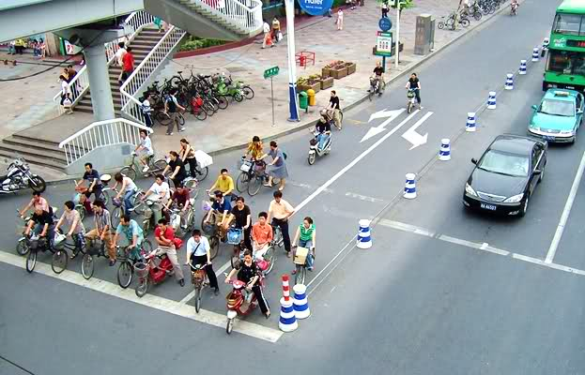
Rio+20: A Move Towards More Sustainable Transportation | Worldwatch Institute
www.worldwatch.org
Emissions from transportation are the fastest growing source of global greenhouse gas emissions, with emissions expected

Day 220: OLYMP-I-A for GREEN-LIVING (Year 2)- Action: Enjoyed a simple and nutritious organic snack/appetizer combo... a slice of organic avocado cradled in a slice of organic bell pepper.

Day 221: OLYMP-I-A for GREEN-LIVING (Year 2)- Action: I read an article about the success of a "Play Pump" water filtration system: http://www.peacecorps.gov/resources/media/press/2105/. What an amazing idea... the "play pump" provides clean water, exercise, fun, and community connectivity all at the same time!
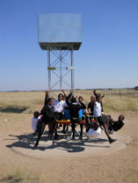
Peace Corps Volunteer Installs Water Pump 'Merry-Go-Round' in South Africa | Peace Corps
www.peacecorps.gov
Peace Corps Volunteers travel overseas to make real differences in the lives of real people. Apply online to Volunteer, find a local recruiting event, donate to a Volunteer

Day 222: OLYMP-I-A for GREEN-LIVING (Year 2)- Action: I watched a video about how trees communicate through an extensive underground network, sharing nutrients and helping to generate biodiversity. Fascinating! http://www.ecopreservationsociety.org/site/index.php/the-news/reforestation-blog/492-community-of-trees-how-trees-communicate-with-one-another.
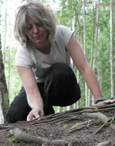
Community of Trees ~ How Trees Communicate with One Another.
www.ecopreservationsociety.org
Mission: Eco Preservation Society is actively engaged in sustainably focused programming for the purpose of wildlife

Day 223: OLYMP-I-A for GREEN-LIVING (Year 2)- Action: I found out info about "Hard Luck Hounds," http://friendsoftlac.com/hlh2/, a program working to find happy homes for ALL dogs, especially those with the most difficulty being adopted.
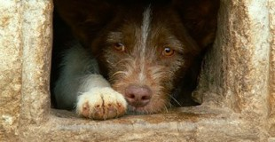
Hard Luck Hounds
friendsoftlac.com
This is Ivan’s second time back at the shelter, and he’s paying the price for a situation that wasn’t his fault. When he first came to us last July, Ivan was a softie, so easy to get along

Day 224: OLYMP-I-A for GREEN-LIVING (Year 2)- Action: I learned more about "Growing Power"... the power of urban farming (http://www.growingpower.org/our_history.htm). Growing Power's vision is to "inspire communities to build sustainable food systems that are equitable and ecologically sound, creating a just world, one foodsecure community at a time." I found a listing of Growing Power's Regional Outreach Training Centers at http://www.growingpower.org/training_centers.htm. Wonderful work!
http://www.growingpower.org/our_history.htm
www.growingpower.org
Sustainable Agriculture at The Food Project

Day 225: OLYMP-I-A for GREEN-LIVING (Year 2)- Action: I learned some climate facts that provide fuel to my motivation and resolve to try my best to do more in my daily life for green-living. https://www.facebook.com/#!/photo.php?fbid=391781404221843&set=a.202486859817966.50855.153278754738777&type=1&theater
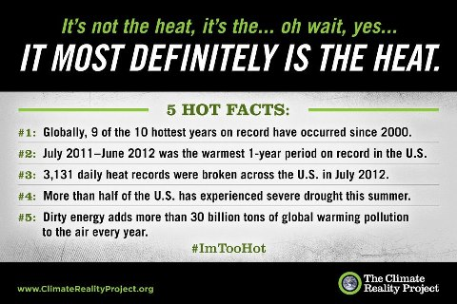
Wall Photos
This summer has seemed hotter than usual and that’s because it is. Share this in...

Day 226: OLYMP-I-A for GREEN-LIVING (Year 2)- Action: Sharing info about the "keepers" at the David Sheldrick Wildlife Trust orphan elephant nursery in Nairobi. I had the privilege of meeting and talking with Edwin and some of the other keepers last summer. Such caring and dedicated people!
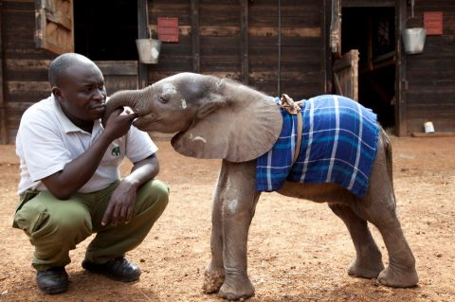
Wall Photos ( Photo link: https://www.facebook.com/#!/photo.php?fbid=10151119200249889&set=a.167086934888.112085.120805694888&type=1&theater)

Info about photo: Rescued just a few days ago, tiny orphan elephant Kinango is relaxed with all the keepers, such as Edwin. Read about Edwin Lusichi, and some of the others keepers, and how they became involved with the Orphans' at http://www.sheldrickwildlifetrust.org/html/keepers_profiles.html.

Day 227: OLYMP-I-A for GREEN-LIVING (Year 2)- Action: On my walk this morning with my dog, I followed closely her curious exploration of nature. Such attention to details, sights, sounds, smells. Following her example and paying close attention in this way awakened my senses and held me immersed in the moment. I no longer walked oblivious to the amazing artistic canvas surrounding me. For the moment, I acknowledged and appreciated the beauty of the earth and did not take it for granted.

Day 228: OLYMP-I-A for GREEN-LIVING (Year 2)- Action: I watched the NBC Nightly News broadcast about the David Sheldrick Wildlife Trust and the rescue of orphan elephants in Kenya. This is the first of two programs "highlighting the terrible effect of ivory poaching and the lifesaving efforts of the Trust to protect elephants. It features the rescue of suspected ivory orphan Bomani." Such news coverage is a key step forward to help spread the word and educate audiences!
http://www.msnbc.msn.com/id/3032619/#48682465

NBC Nightly News with Brian Williams
www.msnbc.msn.com
NBC Nightly News with Brian Williams

Day 229: OLYMP-I-A for GREEN-LIVING (Year 2)- Action: Sharing good news about Goodyear Tire and Rubber Company's plan to use soybean oil to make tires. Tires made with soybean oil are anticipated to have increased tread life, projected to reduce use of petroleum-based oil by 7 million gallons each year. A positive step forward! http://www.sustainablebrands.com/news_and_views/articles/goodyear-says-soybean-oil-makes-better-tires
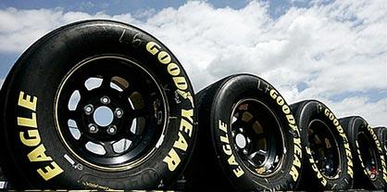

Goodyear Says Soybean Oil Makes Better Tires | Sustainable Brands
sustainablebrands.com
Using soybean oil to make tires could increase tread life by 10 percent and replace seven million gallons of petroleum-based oil each year, according to researchers at Goodyear Tire & Rubber Company. Prototype tires will be tested at Goodyear's

Day 230: OLYMP-I-A for GREEN-LIVING (Year 2)- Action: I found out more about the documentary "Queen of the Sun: What are the bees telling us?," an inspiring and revealing film about the global bee crisis. On the website there is an educational curriculum available to educate students about the critical importance of bees to life on Earth (http://www.queenofthesun.com/educational-curriculum/). I am hoping to see a screening of the film this week. “The beauty of a seed is that out of one you can get millions. The beauty of the pollinator is that it turns that one into the millions. And that is an economics of abundance.” - Vandana Shiva

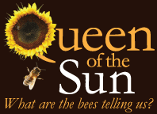

Day 231: OLYMP-I-A for GREEN-LIVING (Year 2)- Action: I read a Facebook post from the David Sheldrick Wildlife Trust about the current work of Yao Ming to raise awareness of elephant poaching. His trip and work are supported by "WildAid" and "Save the Elephants," in preparation for the film "The End of the Wild." It is so great that Yao Ming is involved! His popularity will help the message reach more people worldwide. Awesome!
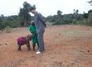
Yao Ming, Former NBA All Star, meets the orphans!
Yao Ming has been in Kenya documenting and creating awareness of poaching , for a film 'The End of the Wild'. On a trip organised by WildAid and Save the Elephants, Yao has come face to face with poached elephants in the bush and spoken with leading conservationists and officials. His trip ended with a visit to our nursery, meeting orphaned baby elephants and rhinos, all too often the victims of poaching.
By: The David Sheldrick Wildlife Trust

Day 232: OLYMP-I-A for GREEN-LIVING (Year 2)- Sharing the latest info on my "adopted" orphan elephant "Ishanga." The David Sheldrick Wildlife Trust moved her and two other orphans (all 3 years old) from the Nairobi nursery to the Ithumba Re-Integration Centre. Upon arrival, they were greeted by the whole herd of 30 Ithumba orphans along with 13 wild elephants who came to the stockades to meet them. Ishanga has graduated! I'm a proud "mama"!!
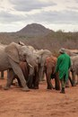
Makireti, Kasigau and Ishanga graduate to the Ithumba Centre https://www.facebook.com/#!/photo.php?fbid=10151132564869889&set=a.10151132564379889.454671.120805694888&type=1&theater
Last Friday 3 of our Nursery babies graduated to the Ithumba Re-integration centre. It had always been planned to move some of the older nursery elephants to Ithumba in the Spring, but due to the very dry conditions in Tsavo East this year the decision was made to wait. With the recent influx of new arrivals at the Nursery, space has become tight at the orphanage, and we are very aware that Makireti, Ishanga and Kasigau at 3 years old, were all in need of the guidance of older elephants – something that cannot be provided in Nairobi. Their size, strength and increasing inquisitiveness meant they were becoming rather too boisterous for the tiny babies and their keepers – so the decision was taken to move them to Ithumba, where they could be guided by the older orphans, as well as the ex-orphans and visiting wild elephants. It was an early start on Friday, and the team were on the road at 3.30am. After many hours on the road, the three graduates were greeted by a wonderful welcome party at the Ithumba centre.. Makireti was first out of our specially designed elephant transporter and was met by Wendi, in a very touching scene. The whole herd of 30 Ithumba orphans returned to greet the new arrivals, and they were joined by 13 wild elephants. Following very heart-warming and happy greetings, Makireti, Ishanga and Kasigau have all settled in well at the Ithumba stockades and we are delighted that they are now embarking in their next steps towards their lives back in the wild.

Day 233: OLYMP-I-A for GREEN-LIVING (Year 2)- I saw a washable, reusable book cover called "Book Sox" at the grocery store. A great way to cover books and be eco-friendly at the same time. I read more online about Book Sox and their eco-friendly product lines: http://www.booksox.com/webstore/productgroup.aspx?grphead=BOOKSOX .
The Turtle Company - Makers of Book Sox, Tissue Box Sox and Cotton Canvas Eco Bags!
www.booksox.com

Day 234: OLYMP-I-A for GREEN-LIVING (Year 2)- Action: I watched the documentary "Queen of the Sun" about the plight of the honey bees. Very unsettling! We depend on the honey bees for our very survival and they are dying out due to our human assaults on their environment. Convincing evidence to compel us to change our agricultural methods. The film inspires me to learn more about honey bees and advocate for sustainable beekeeping methods and preservation of healthy bee habitats. I read more about bee colony collapse disorder online at: http://www.sciencedaily.com/releases/2012/04/120405224653.htm
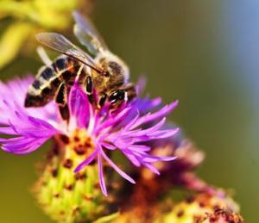
Use of common pesticide, imidacloprid, linked to bee colony collapse
www.sciencedaily.com
The likely culprit in sharp worldwide declines in honeybee colonies since 2006 is imidacloprid, one of the most widely used pesticides, according to a new study.

Day 235: OLYMP-I-A for GREEN-LIVING (Year 2)- Action/Idea: I was at a cafe in a small shopping center and I asked whether they recycled. They said the city only picked up recycling for residences and not businesses. So, if a business recycles, it has to pay extra. Thus, they had found it "not economical" to do recycling. I suggested that, it might be less expensive for a single business if all the businesses in the center worked together to set out several recycling containers and all chipped in to pay for the recycling service. Then, all the businesses could share the cost involved. The cafe owner said he'd share the idea. When we solely focus on our own individual issues in isolation, we may perpetuate a "win-lose" economy and miss the big picture that is vital to us all. We need more collective thought and collective long-term strategies to ensure a sustainable economy and livelihood for the whole and for future generations. Recycling is definitely economical for us all!

Day 236: OLYMP-I-A for GREEN-LIVING (Year 2)- Action: I read a fascinating article about a man who cultivates varieties of figs from around the world: http://www.npr.org/blogs/thesalt/2012/08/22/159750471/meet-a-man-on-a-mission-to-save-rare-and-unusual-figs. I learned a lot about figs and the gardens and gardeners working for their preservation. Each variety of fig represents a taste of the culture from which it originates. The art and passion of finding and sustaining diverse varieties of a vegetable or fruit reveals the beauty and importance of preserving diversity.
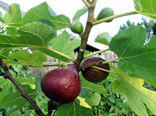
Meet A Man On A Mission To Save Rare And Unusual Figs : NPR
www.npr.org
Bassem Samaan of Bethlehem, Pa., is on a quest to save rare varieties of figs often growing unnoticed, right under

Day 237: OLYMP-I-A for GREEN-LIVING (Year 2)- Action: I enjoyed a long, meandering walk, following the lead of my dog as she scurried along, nose to the ground. Nature holds many surprises. Just follow your dog and you'll discover them... each area of grass and each plant tells a story, each bird call peaks your attention, a scampering squirrel can set you in flight :)), each hole needs investigating, and there is joy in just being close to the earth.

Day 238: OLYMP-I-A for GREEN-LIVING (Year 2)- Action: I ate a delicious organic, macrobiotic meal for supper- veggie soup and salad. Wonderful!!

Day 239: OLYMP-I-A for GREEN-LIVING (Year 2)- Action: A friend of mine recently visited the Butchart Gardens, located on Vancouver Island in Canada. I read about the Gardens and found out that the current 22 acres of brilliant gardens began over a century ago when Jennie Butchart planted some sweet pea seeds and a rose bush. She slowly transformed a barren limestone quarry. I bet Jennie Butchart never dreamed where her first step at gardening would lead. Such amazing beauty began with a simple action.

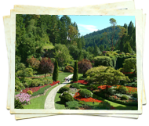

Day 240: OLYMP-I-A for GREEN-LIVING (Year 2)- Action: I bought a Sierra Club notecard for a friend (http://pomegranate.com/siclnoi.html). A portion of my purchase went to support the Club and its mission: "To explore, enjoy and protect the wild places of the earth; to practice and promote the responsible use of the earth’s ecosystems and resources; to educate and enlist humanity to protect and restore the quality of the natural and human planet; and to use all lawful means to carry out these objectives."
Sierra Club Notecards 1
pomegranate.com

Day 241: OLYMP-I-A for GREEN-LIVING (Year 2)- Action: I saw some cute eco-friendly stainless steel drinking bottles for kids. I looked them up online and found a great website, "Inhabitots." "Inhabitots is the baby / parenting focused website in the Inhabitat family... created as a resource for parents, families, and anyone else interested in sustainable modern design for children." I found out more info about the website and read their posted article about the "Top Five 100% BPA Free Reusable Water Bottles for Kids." http://www.inhabitots.com/top-five-100-bpa-free-reusable-water-bottles-for-kids/
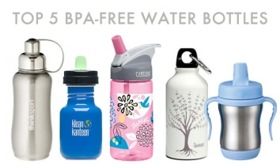
TOP FIVE 100% BPA FREE Reusable Water Bottles for Kids | Inhabitots
www.inhabitots.com
We were just as dismayed as you were to hear the news that SIGG bottles manufactured prior to August 2008 contained BPA. If you previously owned a SIGG

Day 242: OLYMP-I-A for GREEN-LIVING (Year 2)- Idea: I am reading a book about the great philosophers. It is ironic that human beings have spent a lot of time trying to understand and explain the impact (both good and bad) of nature on humans, and yet now, an equally, if not more, pressing issue is for us to acknowledge, understand, and guide the power (both good and bad) that humans have to impact nature.

Day 243: OLYMP-I-A for GREEN-LIVING (Year 2)- Action: I read a helpful article with good tips about how to store veggies and fruits without the use of plastic bags: http://www.naturespath.com/blog/2012/08/23/how-store-fruit-vegetables-without-plastic

HOW TO: Store Fruit & Vegetables Without Plastic
www.naturespath.com
You gotta love summer’s abundant fruits and vegetables: Strawberries, juicy tomatoes, fresh carrots,

Day 244: OLYMP-I-A for GREEN-LIVING (Year 2)- Action: I read about the Ocean Conservancy International Coastal Clean-Up at http://www.oceanconservancy.org/our-work/marine-debris/trash-free-seas-icc-2012.html. At this website, I also browsed through the many ways people can and do participate in ocean clean-up year-round. "Ocean trash is a threat to our economies, wildlife, habitat, health and food safety. Over the past 26 years, Ocean Conservancy volunteers have collected over 150 million pounds of trash from our coasts and waterways, including enough cups and cutlery to host a picnic for 2.15 million people." (http://www.causes.com/causes/463-ocean-conservancy/actions/1677847?utm_source=causes.com&utm_medium=fbpost&utm_campaign=fb830) Wow!

Ocean Conservancy: Trash Free Seas ICC 2012 Landing Page
www.oceanconservancy.org
Here at Ocean Conservancy, we believe it's time to look beneath the surface to see where the health of our planet really begins. It's time to start a sea change. Won't you join

Day 245: OLYMP-I-A for GREEN-LIVING (Year 2)- Action/Idea: While walking this morning at the river, I took time to enjoy the beauty of the plants, water, animals, and birds around me. As I walked, I came within a foot of a brilliant red cardinal that was hopping along on the ground. I think it was the closest I've ever been to one. So amazing to see! Nature is a gift. When we pause to receive it and appreciate it, we recognize its worth. As with any gift, and especially a gift of such magnitude and value, the least we can do is be thankful and treasure it.

Day 246: OLYMP-I-A for GREEN-LIVING (Year 2)- Had a delicious, organic veggie drink made with carrot juice, beets, turmeric, cayenne, and ginger. An organic kick-start to my day!

Day 247: OLYMP-I-A for GREEN-LIVING (Year 2)- Action: I enjoyed an Amy's Kitchen organic vegetarian dinner, "Indian Vegetable Korma.". It is one of my favorite, quick, "on-the-go" meals. I learned more about Amy's Kitchen's organic food products and browsed the online recipes at: http://www.amys.com/health/recipes.

Day 248: OLYMP-I-A for GREEN-LIVING (Year 2)- Action: I read an article about how elementary school students made an impact on recycling! http://bit.ly/Q3OVaC. An example of how each of us matters and can make a difference!
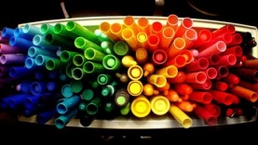
Earth911 News & Features
Who says small kids can't have big ideas?
With the encouragement of a few open-...See More
A glimpse at what we're publishing every day athttp://earth911.com/
By: Earth911

Day 249: OLYMP-I-A for GREEN-LIVING (Year 2)- Action: I learned about the "Food Is Free Project." http://foodisfreeproject.org/ "The Food is Free Project is a community building and gardening movement that launched in January of 2012. [The Project teaches] people how to connect with their neighbors and line their street with front yard community gardens which provide free harvests to anyone." Imagine your street lined with community gardens!

Food is Free Project
foodisfreeproject.org
Come to our Food is Free build days and learn with us as we line entire blocks with low-maintenance garden beds made from salvaged materials. These beds will provide free food to anyone in the community!

Day 250: OLYMP-I-A for GREEN-LIVING (Year 2)- Action: I read about Farm Aid and looked up info about the annual benefit concert and the "Good Food Movement." http://www.farmaid.org/site/c.qlI5IhNVJsE/b.6236707/k.8E86/About_the_Concert.htm "... [The] Farm Aid concert ... bring[s] together a wide variety of musicians, farmers and fans for one mission: keeping family farmers on their land." I found more info about the "Good Food Movement" at: http://www.farmaid.org/site/c.qlI5IhNVJsE/b.2723849/k.F173/Good_Food.htm
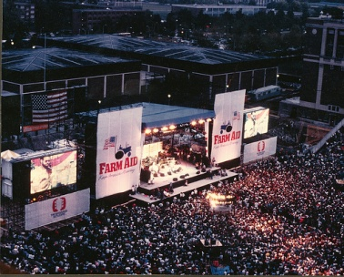
About the Concert - Farm Aid
www.farmaid.org

Day 251: OLYMP-I-A for GREEN-LIVING (Year 2)- Action: Today, while out on a walk, I first heard and then saw quite a few green parrots flying to and from their nest, built high on top of a light tower. I read an article about them online. http://www.austin360.com/recreation/its-true-wild-parrots-live-here-1964551.html Wild Monk parrots (or parakeets) have adapted to our area and there are about 65 nests reported. "... tens of millions of parrots have been removed from the wild worldwide, and have been traded in greater numbers and for far longer than any other group of wild animals. Many parrot species are still threatened by this trade, as well as by habitat loss, predation by introduced species, and hunting for food or feathers." It's nice to see that they have adapted and established a home here in our area.
It's true: Wild parrots live here
www.austin360.com
Established in Austin in the early 1970s from escaped caged birds, Monk parakeets (Myiopsitta monachus) also known as Quaker parrots, are native to the temperate and

Day 252: OLYMP-I-A for GREEN-LIVING (Year 2)- Action: While out on a bike ride, I purchased a refreshing bottle of green tea at a local cafe. Instead of throwing away the glass bottle in the onsite garbage container, I carried it home to recycle it. I found 5 key facts about glass and recycling online:
•Glass takes 1,000,000 years to fully degrade in a landfill.
•Recycling glass takes 30% of the energy required to produce glass from raw materials.
•The United States throws away enough glass every week to fill a 1,350-foot building.
•Recycling one glass bottle saves enough energy to light a 100-watt lightbulb for four hours.
•Glass never wears out and can be recycled forever.
http://www.nps.gov/zion/naturescience/recycling-in-zion-national-park.htm

Day 253: OLYMP-I-A for GREEN-LIVING (Year 2)- Action: I enjoyed reading some of the daily positive ideas and actions that have been generated by youth involved in the Earth Child Institute's "OLYMP-I-A Challenge" in Ghana: http://www.earthchildinstitute.org/the-olymp-i-a-challenge/. Awesome!!

The OLYMP-I-A Challenge | Earth Child Institute
www.earthchildinstitute.org
The OLYMP-I-A Challenge ECI Campaigns/Take Action > THE OLYMP-I-A CHALLENGE Building on the international spirit of the upcoming Rio+20 Earth Summit and the 2012 Summer Olympic Games… Earth Child Institute’s Power of One Child Global Action

Day 254: OLYMP-I-A for GREEN-LIVING (Year 2)- Action/Idea: I read about the "survivor tree" from the 9/11 tragedy. The tree was removed from Ground Zero, nurtured back to health in a Bronx nursery, and then, was replanted at the 9/11 Memorial site. It is a callery pear tree and has grown from 8' to 30' tall. I am reminded of a message from the "Choice Point" movie: we may think of human beings as the observers of nature. If, in fact, everything in the universe is connected and everything shares the same atoms, then we are not the only observers. Nature observes us. I wonder what observations this tree has made.
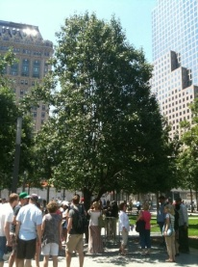
Timeline Photos
The “survivor tree” – a callery pear saved from the rubble of the fallen World T...See More
By: The Nature Conservancy

Day 255: OLYMP-I-A for GREEN-LIVING (Year 2)- Action: I found out about "The Seed Ambassadors Project" and their resource, "A Guide to Seed Saving, Seed Stewardship & Seed Sovereignty:" http://seedambassadors.org/. "SEED STEWARDSHIP is the process of saving seeds with the purpose of maintaining or improving that seed’s health and resilience." Important work!
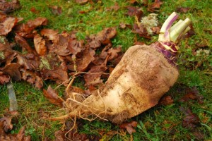

The Seed Ambassadors Project
seedambassadors.org
Some wonderful person has compiled lots of seed saving resources into one place, including a slideshow version of our ‘zine: A Guide to Seed Saving, Seed Stewardship and

Day 256: OLYMP-I-A for GREEN-LIVING (Year 2)- Action: I saw a T.V. announcement about the WWF (World Wildlife Fund) campaign to save tigers. I found out some facts via the WWF website: "We have lost 97% of our wild tigers in just over a century." Only about 3,200 remain. Poaching is one of the major causes of the decline. "WWF works with local governments and others towards 'Zero Poaching of Tigers,' an initiative to stop tiger killing and trading at its source." http://wwf.panda.org/what_we_do/endangered_species/tigers/
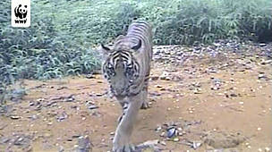
Tiger facts & future
wwf.panda.org
We have lost 97% of our wild tigers this century. With as few as 3,200 remaining, action is needed to increase and strengthen their habitat and protect the species from major threats such as poaching. WWF works with the 13 tiger countries to create a future for wild tigers.

Day 257: OLYMP-I-A for GREEN-LIVING (Year 2)- Action: I attended a film festival (of films for good causes) and watched a short film by The Nobelity Project about a collaborative effort to replant the pines trees lost in the 2011 fire at Bastrop State Park in Texas: http://www.youtube.com/watch?v=rQyvpSWQkaM&feature=player_embedded. The goal is to engage area high school students to plant 40,000 trees this year. The American Youthworks E-Corps is partnering to help with the project. I went to the website, http://nobelityinschools.org/, and clicked on the "Bastrop Replant the Park" tab and learned how schools can get involved. I am looking into how individuals can volunteer as well.
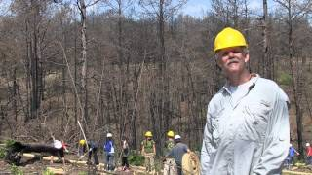

Replant The Park - The Nobelity Project and Bastrop State Park
www.youtube.com
One year after fire destroyed 96% of the Lost Pines forest in Bastrop State Park, The Nobelity

Day 258: OLYMP-I-A for GREEN-LIVING (Year 2)- Action: I learned more about the American Youthworks E-Corps: http://www.americanyouthworks.org/green-jobs-programs/environmental-corps. The Corps helps youth and young adults learn environmental job skills and provide community environmental services while continuing and strengthening their education.

Environmental Corps / Texas Conservation Corps
www.americanyouthworks.org
Environmental Corps (E-Corps) is a green jobs training and service program that allows youth and young adults to build and restore the natural environment through parks and trails projects, forestry, and habitat restoration throughout the state of Texas and the south-central region including: Louisi...

Day 259: OLYMP-I-A for GREEN-LIVING (Year 2)- Action: Sharing a chart describing "Nature-Deficit Disorder:" https://www.facebook.com/photo.php?fbid=10151389609287802&set=a.114118797801.121511.15239367801&type=1&ref=nf. It emphasizes the importance of getting children (and adults) outside and helping them to enjoy wildlife and nature.
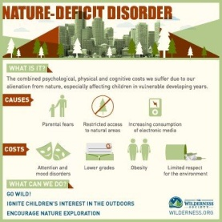
Timeline Photos
What is the solution to nature-deficit disorder?
P.S. If you think this issue is important, please 'like' and share!
By: The Wilderness Society

Day 260: OLYMP-I-A for GREEN-LIVING (Year 2)- Action: I learned more about The Nature Conservancy's "LEAF" program. LEAF stands for Leaders in Environmental Action for the Future. "The LEAF program provides paid summer internships for high school students and helps educators from environmental high schools share best practices and scientific resources. The long-term goal of LEAF is to support more than 30 environmental high schools across the country." http://www.nature.org/aboutus/careers/leaf/index.htm
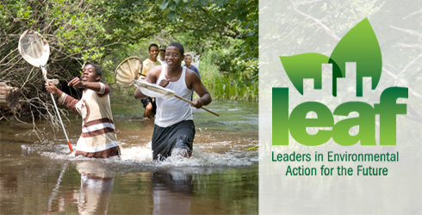

Leaders in Environmental Action for the Future (LEAF) | The Nature Conservancy
www.nature.org
The LEAF Program provides paid summer internships for high school students and helps educators share best practices and scientific resources.

Day 261: OLYMP-I-A for GREEN-LIVING (Year 2)- Action: I went to the Ian Somerhalder Foundation website and read about the Foundation's mission and projects: http://www.isfoundation.com/about-foundation. Some interesting info from the website: 36% of all species on Earth are at risk of extinction. 1/4 of pharmaceuticals are made from natural sources, including plant and animal species. The current rate of extinction will result in the loss of 1 new major drug every 2 years... Interesting perspective.

About the IS Foundation | Ian Somerhalder Foundation
www.isfoundation.com
The IS FOUNDATION aims to empower, educate and collaborate with people and projects to positively impact the planet and its creatures.

Day 262: OLYMP-I-A for GREEN-LIVING (Year 2)- Action: I read an informative article about recycling. Though recycling rates have improved over the last few decades, the amount of waste generated per person has increased dramatically. The article emphasizes that individuals, companies, and municipalities all need to partner together to design and support cost-effective recycling programs. The article presents successful community models. http://www.call2recycle.org/group-effort-recycling-today/

Group Effort - Recycling Today | Call2Recycle | United States
www.call2recycle.org
Many U.S. cities are diverting more than 30 percent of their solid waste to recycling. Most communities have the potential to do far more using a variety of approaches.

Day 263: OLYMP-I-A for GREEN-LIVING (Year 2)- Action/Idea: I scanned a news article about the opening session of the United Nations General Assembly and noted the emphasis on recommendations from the UN Sustainable Development Conference (Rio+20) conference. “Our objective should be the full implementation of the mandate this body received at the Rio+20 Conference. This will require a decisive commitment to observe not only procedural deadlines but also the political and financial objectives it has been designed to accomplish.” (http://www.un.org/apps/news/story.asp?NewsID=42927&Cr=general+assembly&Cr1#.UFsT8rKPWSq) If the world can all agree and come together to eliminate smallpox, then, similarly, we must all come together to acknowledge and address the threats to our environment which pose even greater risks to our lives and very existence.
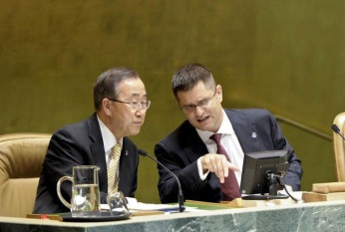

UN News - General Assembly opens new session with call to tackle urgent global issues
www.un.org
The United Nations General Assembly today opened its 67th session with an urgent call for cooperation to tackle the

Day 264: OLYMP-I-A for GREEN-LIVING (Year 2)- Action: I am enjoying watching the beauty of nature with the changing season. As I look out my window, I can see yellow leaves drifting down from the trees... so calming. I looked up information online about the many ways that plants and nature help the well-being of people: http://ellisonchair.tamu.edu/emphasis-areas/marketing-economics/health-and-well-being-benefits-of-plants/#.UGDj2bKPVv0. More evidence of the critical partnership we have with nature.
Health and well-being benefits of plants | Ellison Chair in International Floriculture
ellisonchair.tamu.edu
Concentration and Memory.Being around plants helps people concentrate better in the home and workplace. Studies show that tasks performed while under the calmin

Day 265: OLYMP-I-A for GREEN-LIVING (Year 2)- Action: I ate a wonderful, delicious vegan macrobiotic meal with quinoa, greens, salad, broccoli soup, beans, and squash (cushaw). So tasty!

Day 266: OLYMP-I-A for GREEN-LIVING (Year 2)- Action: I enjoyed a beautiful morning in nature, running on a city park trail alongside a lake. The lake water was smooth as glass in the early morning and two swans were gliding along. I read an informative article with key points about the importance of parks to the green infrastructure of cities:http://www.planning.org/cityparks/briefingpapers/greeninfrastructure.htm. "Green infrastructure is a community's natural life support system, the ecological framework needed for environmental and economic sustainability...In their role as green infrastructure, parks and open space are a community necessity."
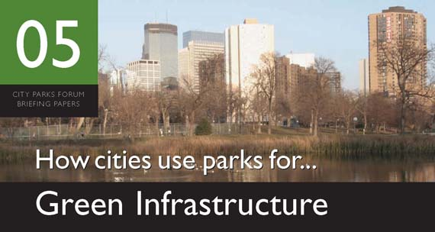

How Cities Use Parks for ... Green Infrastructure
www.planning.org
Just as growing communities need to upgrade and expand their built infrastructure of roads, sewers, and utilities, they also need to upgrade and expand their green infrastructure, the interconnected system of green spaces that conserves natural ecosystem values and functions, sustains

Day 267: OLYMP-I-A for GREEN-LIVING (Year 2)- Action: While on a walk, I was looking around at the various plants along the way. On one of the leaves of a green fern I was surprised to see a tiny chameleon! Its color was an exact match for the leaf. The chameleon reminded me of the critical balance of give and take among species. The chameleon used the leaf for camouflage and the plant benefited from the chameleon for pollination (http://www.ehow.com/list_6757940_ways-plants-important-animals_.html). Unfortunately, we humans have tipped the balance way over to the taking side. Now we need to move rapidly to the giving so the balance can be restored.
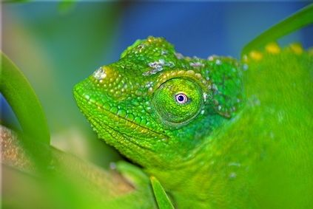

In What Ways Are Plants Important to Animals?
www.ehow.com
The most basic classification of living things consists of the plant kingdom and the animal kingdom. While the differences within these two kingdoms are vast, the species within the kingdoms interact and rely on one another to survive. Plant species rely on animals to

Day 268: OLYMP-I-A for GREEN-LIVING (Year 2)- Action/Idea: I enjoyed seeing all the beautiful flowers at a grocery store. It is amazing how much we use flowers to send messages- of love, happiness, celebration, hope, condolence, sympathy, get-well wishes... Flowers are part of our life rituals and cultural heritage. What would we do if we got up one day and there were no more flowers around?? Our world would shift and we would search for answers to regain what we had lost. Right? I guess it would be sort of like polar bears waking up and finding the ice melting and less food to eat. I think I'll decide to care now instead of panic later.

Day 269: OLYMP-I-A for GREEN-LIVING (Year 2)- Action: I read an article describing how elephants and hippos are vital to the support of water resources. Fascinating info! Reinforcing our need to respect the delicate balance of nature.
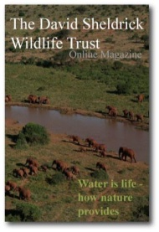
Timeline Photos
DSWT Wilderness Journal: Water is life — how nature provides by Dame Daphne Shel...See More
By: The David Sheldrick Wildlife Trust

Day 270: OLYMP-I-A for GREEN-LIVING (Year 2)- Action: I was listening to a T.V. news report about Consumer Reports and wondered if Consumer Reports analyzes products in terms of their impact on the environment. I searched online and found this informative Consumer Reports website: http://www.greenerchoices.org/.

GreenerChoices.org
www.greenerchoices.org

Day 271: OLYMP-I-A for GREEN-LIVING (Year 2)- Action: I put some old batteries in a recycling container instead of throwing them in the trash! Yeah!

Day 272: OLYMP-I-A for GREEN-LIVING (Year 2)- Idea: I felt true happiness when I heard the rain coming down today. It was the same feeling I get when I see a friend I haven't seen in a while. It is important for us to acknowledge and respect the relationship we have with the Earth. As with friends, we should not take the land, water, or sky for granted.

Day 273: OLYMP-I-A for GREEN-LIVING (Year 2)- Action: I saw two white swans flying over the river. An incredible sight, their long necks and bodies straight as arrows sailing through the air. Such grace and beauty in motion... Nature's dazzling display on the big screen of life.

Day 274: OLYMP-I-A for GREEN-LIVING (Year 2)- Action/Idea: I enjoy being outside and observing nature. I find it a wonderful way to relax. Today, my dog and I were watching squirrels playing and jumping around in the tree canopy above our yard. I wondered what the world looked like from the perspective of the squirrels, high up in the trees, leaping among the branches. I realized that the tree canopy has a culture of its own. It is a place where birds, squirrels, and other creatures commune separate from human beings. Trees are living and breathing homes. Trees are places where communities thrive. When we recognize this sacred role of trees, we are more committed to protecting them.

Day 275: OLYMP-I-A for GREEN-LIVING (Year 2)- Action: I read a good tip from the "World Wildlife Fund" about a simple thing people can do to help protect the earth: "... if you're getting catalogs [in the mail] from companies you don't buy from, call them and tell them to get you off their list." Reduces paper waste!

Day 276: OLYMP-I-A for GREEN-LIVING (Year 2)- Action: I noticed a huge recycling truck picking up the recycling at my workplace. Large bins of recyclable materials were being loaded into the truck. I was so happy to see the volume of items for recycling. I looked up the recycling company online and read more about their services: http://www.balconesresources.com/. It is good to be informed about the recycling companies that serve your workplace, neighborhood, etc. and their policies on recycling materials.
Dallas Recycling, Austin Waste Management Solutions, Recycled Paper, Dallas Waste & Recycling
www.balconesresources.com
Balcones Resources specializes in Dallas Recycling, Austin

Day 277: OLYMP-I-A for GREEN-LIVING (Year 2)- Action: I read people's suggestions about how to lead us out of the climate predicament. Interesting comments. http://www.guardian.co.uk/environment/interactive/2012/oct/01/50-months-climate-interactive?fb=native
50 months to save the world – interactive
www.guardian.co.uk
We asked Guardian readers and public figures what they would do to lead us out of this climate predicament. Here are their suggestions

Day 278: OLYMP-I-A for GREEN-LIVING (Year 2)- Action: I read an article about an amazing innovation, a reverse vending machine that recycles and allows you to contribute the cash you earn for recycling to charities including Nature Conservancy, The Fisher House Foundation, Relay for Life and various local charities. Cool!http://earth911.com/news/2012/05/22/reverse-vending-machines-pay-out-in-new-ways/

Reverse Vending Machines Pay Out in New Ways - Earth911.com
earth911.com
Guide to local resources including recycling centers, how to recycle, pollution prevention and how help protect the environment.

Day 279: OLYMP-I-A for GREEN-LIVING (Year 2)- Action: Watched a ground-breaking, informative movie, "Genetic Roulette," about the impact of GMOs on our health: http://geneticroulettemovie.com/
Genetic Roulette Movie
geneticroulettemovie.com
Genetic Roulette Movie, The Institute for Responsible Technology

Day 280: OLYMP-I-A for GREEN-LIVING (Year 2)- Action: After my run, I had a smoothie made with organic vegetables and fruit. Delicious, nutritious, good for my body, and good for the environment :)).

Day 281: OLYMP-I-A for GREEN-LIVING (Year 2)- Action: I learned that many of the new superefficient lightbulbs contain mercury and proper disposal is crucial. It is important to ask about disposal methods at the store where you purchase the lightbulbs. Or, consumers can contact their local municipal solid waste agency directly, or go to epa.gov/cfl/cflrecycling.html or www.earth911.org to identify local recycling options.

Recycling and Disposal After a CFL Burns Out | Compact Fluorescent Light Bulbs (CFLs) | US EPA
www.epa.gov
Store fluorescent light bulbs in containers that prevent them from breaking, such as in their original boxes, boxes from replacement bulbs, or containers

Day 282: OLYMP-I-A for GREEN-LIVING (Year 2)- Action: I saw a Jane Goodall special on Animal Planet and read more about it online. "Concurrent with the airing of JANE’S JOURNEY, Animal Planet is partnering with JGI [(the Jane Goodall Institute)] for the network’s second annual R.O.A.R. Matching Campaign. During the campaign, Animal Planet will match all donations given to JGI dollar for dollar through October 31, 2012. JGI will use the funds to provide care for the more than 150-orphaned chimpanzees living at the Institute’s Tchimpounga sanctuary in the Republic of Congo." People can donate by visiting:http://www.globalgiving.org/projects/help-feed-over-150-orphaned-chimpanzees/.
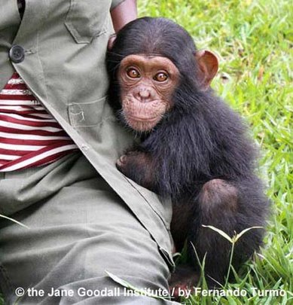

Help Feed over 150 Orphaned Chimpanzees
www.globalgiving.org
The Jane Goodall Institute's Tchimpounga Chimpanzee Rehabilitation Center (TCRC) in the Republic of Congo is home to more than 150 orphaned chimpanzees. The chimps, victims of the illegal commercial bush meat trad

Day 283: OLYMP-I-A for GREEN-LIVING (Year 2)- Action/Idea: I enjoyed a beautiful, shaded walk among large oak trees. I had walked among these same trees many years ago. It was a wonderful reunion! I could sense their strength and their life stories. I felt a palpable wisdom... a spirit of survival... a vital connection and call to believe in the value of all living things.

Day 284: OLYMP-I-A for GREEN-LIVING (Year 2)- Action: I tried the vegetarian cafe, Maoz. The restaurant specializes in falafel. Delicious vegetarian and vegan sandwiches, salads and soups. Very tasty and good for the environment! http://www.maozusa.com/
www.maozusa.com |
www.maozusa.com

Day 285: OLYMP-I-A for GREEN-LIVING (Year 2)- Action: While in the grocery store, I looked to see which food products have GMO labeling. I read an informative article about the GMO labeling issue:http://www.huffingtonpost.com/2012/03/30/gmo-labeling-food-just-label-it_n_1391459.html
Does Your Meal Contain GMOs? Consumers Want To Know
www.huffingtonpost.com
By Hanna Brooks Olsen, for Blisstree.com If you’ve recently eaten corn, soy beans (or products containing them, like soy milk and tofu) zucchini, yellow crookneck squash, or conventionally-raised meat, worn anything made of cotton, or cooked with canola oil, you’ve probably pretty familiar with gene...

Day 286: OLYMP-I-A for GREEN-LIVING (Year 2)- Action: Tried some organic steamed brussel sprouts... incredibly sweet tasting and delicious! I looked up a simple brussel sprouts recipe online: http://www.simplyrecipes.com/recipes/brussels_sprouts/
Brussels Sprouts
www.simplyrecipes.com
Simple and delicious Brussels sprouts recipe with lightly steamed or boiled sprouts, mixed with sauteed onions, butter, and toasted almonds.

Day 287: Ultra OLYMP-I-A for GREEN-LIVING- Action: I went to the grocery store- a co-op that has a wide selection of organic foods. When I was leaving, I saw 2 moms with their small children in the carts leaving the store. I noticed their carts were full of groceries, but not one plastic bag. Both moms had brought their own bags to shop! It looked like the "norm." Signs of times changing for the better and such great examples being set for the children.

Day 288: OLYMP-I-A for GREEN-LIVING (Year 2)- Action: Sharing a poster with some facts that should be enough to convince us of the importance of recycling and of purchasing environment-friendly products.https://plus.google.com/111418474601985915957/posts/M6q2x8puC5n
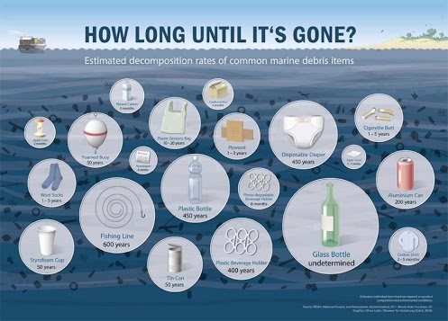

Randall Beggs - Google+ - Decomposition of things thrown into the ocean #environment…
plus.google.com
Decomposition of things thrown into the ocean #environment #reef #florida #floridakeys #earth #science

Day 289: OLYMP-I-A for GREEN-LIVING (Year 2)- Action: I read about the movie "Dirt!" (http://www.thedirtmovie.org/). "DIRT! The Movie–narrated by Jaime Lee Curtis–brings to life the environmental, economic, social and political impact that the soil has. It shares the stories of experts from all over the world who study and are able to harness the beauty and power of a respectful and mutually beneficial relationship with soil... The movie teaches us: 'When humans arrived 2 million years ago, everything changed for dirt. And from that moment on, the fate of dirt and humans has been intimately linked.' ...The Movie is a call to action."
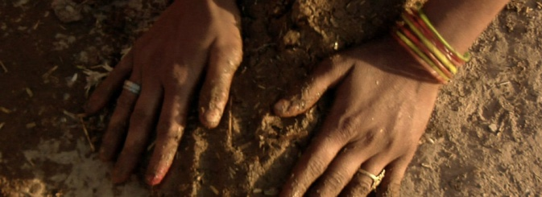

Dirt! | The Movie
www.thedirtmovie.org
Inspired by William Bryant Logan’s acclaimed book Dirt: The Ecstatic Skin of the Earth, Dirt! The Movie takes a humorous and substantial look into the history and current state of

Day 290: OLYMP-I-A for GREEN-LIVING (Year 2)- Action: I learned about StoveTeam International: http://www.stoveteam.org/what-we-do. StoveTeam works to replace dangerous open cooking fires with fuel-efficient, safe cookstoves. "StoveTeam's model has been awarded the U.S. Environmental Protection Agency Partnership for Clean Indoor Air Award for Developing Local Markets for our innovative approach creating local employment while improving health and reducing air pollution."

StoveTeam - Improving lives through fuel-efficient Ecocina cookstoves - StoveTeam International
www.stoveteam.org
StoveTeam assists local entrepreneurs to start factories using local labor and materials. These businesses produce safe, affordable, fuel-efficient cookstoves to replace dangerous

Day 291: OLYMP-I-A for GREEN-LIVING (Year 2)- Action/Idea: I watched a great video of a child demonstrating the importance of natural eco-systems for a clean water supply. We have a responsibility to our children to educate them about ecology and the environment.http://www.youtube.com/watch?v=Dw9p8jEB7m0&feature=player_embedded
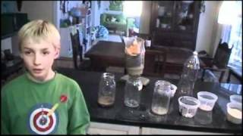

Third-grader Explains Nature's Role in Providing Clean Water
www.youtube.com
Conservancy freshwater scientist Jeff Opperman and his eight-year-old son Luca give a tour of their homemade science project that demonstrates the

Day 292: OLYMP-I-A for GREEN-LIVING (Year 2)- Action: I listened to a talk given by Dean Ornish about the importance of vegetarian/vegan diets and the positive impact on healing and on the environment:http://www.ted.com/talks/dean_ornish_on_healing.html. However, he emphasizes that every positive step we take matters. Even incorporating an occasional vegan/vegetarian meal in our diet is a positive step in the right direction.

Dean Ornish: Healing through diet | Video on TED.com
www.ted.com
TED Talks Dean Ornish talks about simple, low-tech and low-cost ways to take advantage of the body's natural desire to heal itself.

Day 293: OLYMP-I-A for GREEN-LIVING (Year 2)- Action: I went to a neighborhood food co-op/cafe and had several different delicious organic dishes for lunch- a kale salad with shredded carrots, pumpkin seeds, & spices; barbeque tofu; and a wheatberry, cranberry, and almond treat. I heard that the co-op is expanding and will be opening another location which means more people are shopping there! I found a great infographic about the impact of food co-ops vs. conventional grocery stores on local food systems, sustainable foods, and the environment: http://strongertogether.coop/wp-content/uploads/2013/07/How-Does-Your-Grocery-Store-Check-Out.jpg. The infographic is part of an article about the results of a new study, "Healthy Foods Healthy Communities: The Social and Economic Impacts of Food Co-ops":http://strongertogether.coop/food-coops/food-co-op-impact-study/.
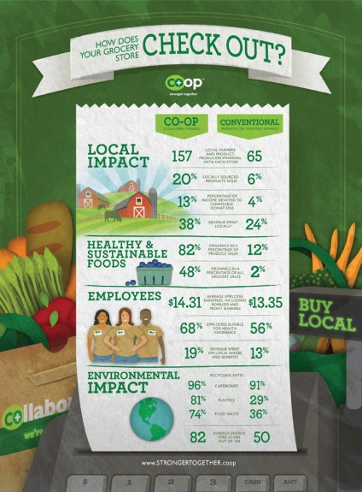

http://strongertogether.coop/wp-content/uploads/2013/07/How-Does-Your-Grocery-Store-Check-Out.jpg
strongertogether.coop

Day 294: OLYMP-I-A for GREEN-LIVING (Year 2)- Action: I got a drink at a store and could not find a place to recycle my cup. So, instead of putting my cup in the store's trash can, I took it home to recycle.

Day 295: OLYMP-I-A for GREEN-LIVING (Year 2)- Action: I had a delicious, organic, vegan, macrobiotic meal and found a website with wonderful macrobiotic recipes and nutrition info: http://www.edenfoods.com/recipes/browse.php?tags_id=25

Eden Foods - Macrobiotic - Recipes
www.edenfoods.com

Day 296: OLYMP-I-A for GREEN-LIVING (Year 2)- Action: I read a wonderful article about the elephants rescued by Lawrence Anthony, "The Elephant Whisperer" (http://www.cbc.ca/strombo/social-issues/saying-goodbye-elephants-hold-apparent-vigil-to-mourn-their-human-friend.html). The elephants are now living happily in the wild due to the continuing elephant conservation work of Lawrence Anthony's son Dylan through the Earth Organization (http://www.earthorganization.org/).
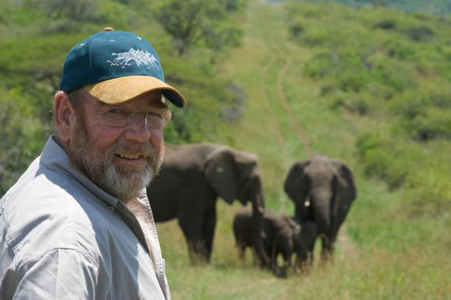
UPDATE: Elephants Who Appeared To Mourn Their Human Friend Remain Protected
www.cbc.ca
Back in March, Lawrence Anthony, a conservationist and author known as \

Day 297: OLYMP-I-A for GREEN-LIVING (Year 2)- Action: I read about the "Karama" organization and their micro rooftop greenhouse projects in refugee camps: http://www.karama.org/eng/rooftop_farms.html. "This project does not only provide food security to [the participants'] extended families and increase the health of the women and their families, but also will help to develop ‘green space’ in the local area which is heavily affected by the long-time occupation." Thanks to the "Earth Child Institute" for sharing this info!
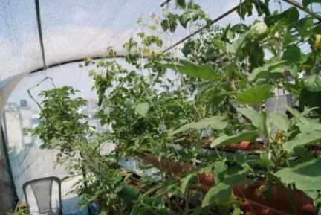
Image
www.karama.org
Karama provides new perspectives to women and young people in Deheishe Refugee Camp, Palestine through educational activities and workshops.

Day 298: OLYMP-I-A for GREEN-LIVING (Year 2)- Action: I read about how to "opt out" of unsolicited mail to reduce the amount of paper waste. Interesting info! http://ftc.gov/bcp/edu/pubs/consumer/alerts/alt063.shtm
Unsolicited Mail, Telemarketing and Email: Where to Go to “Just Say No”
ftc.gov
Tired of having your mailbox crammed with unsolicited mail, including preapproved credit card applications? Fed up with getting telemarketing calls just as you're sitting down to

Day 299: OLYMP-I-A for GREEN-LIVING (Year 2)- Action: Thanks to a friend I found a great fat-free vegan recipe website with enticing seasonal recipes: http://blog.fatfreevegan.com/2006/10/and-answer-is.html
Impossible Vegan Pumpkin Pie | recipe from FatFree Vegan Kitchen
blog.fatfreevegan.com
This gluten-free, vegan pumpkin pie forms its own crust as it bakes. Delicious and addictive–and low-fat and only 153 calories per serving!

Day 300: OLYMP-I-A for GREEN-LIVING (Year 2)- Action: I bought some recycled greeting cards... one way to promote the "recycle" message.

Day 301: OLYMP-I-A for GREEN-LIVING (Year 2)- Action: A friend and I cooked up a delicious vegan pumpkin bread using non-GMO Canola Oil. So moist and tasty!

Day 302: OLYMP-I-A for GREEN-LIVING (Year 2)- Action: I am collecting old batteries for recycling instead of throwing them in the trash. The nearby local library is a battery-recycling location.

Day 303: OLYMP-I-A for GREEN-LIVING (Year 2)- Action: I read about an amazing group of 21 children and their innovative projects to help the world. Many of the projects are focused on protecting the environment!http://www.treehugger.com/culture/future-bright-21-super-kids-will-save-world-adults.html

21 Super Kids that Will Save the World from Adults
www.treehugger.com
These kids are much more impressive than you. If we adults can figure out how to raise more youngsters like this, we

Day 304: OLYMP-I-A for GREEN-LIVING (Year 2)- Action: I read an interesting article about the connection of hurricane "Sandy" with climate change: http://www.huffingtonpost.com/2012/10/31/superstorm-sandy-2012-climate-change_n_2049039.html?ncid=txtlnkushpmg00000040#slide=1218515

Climate Scientist Predicted Sandy Months Ago
www.huffingtonpost.com
WASHINGTON -- Climate scientist Michael Oppenheimer stood along the Hudson River and watched his research come to life as Hurricane Sandy blew through New York. Just eight months earlier, the Princeton University professor reported that what used to be once-in-a-century devastating floods in New

Day 305: OLYMP-I-A for GREEN-LIVING (Year 2)- Action: I read about the work of "Trees for the Future" in Haiti. Haiti has endured a series of devastating natural disasters. "Trees can replenish forest cover destroyed by the recent storms. Fast-growing trees can create windbreaks to better protect homes and farms against future storms. Trees can also produce sustainable charcoal for cooking and heating. And trees can provide construction materials used to repair damaged homes and community buildings." The situation in Haiti demonstrates the vital and life-sustaining role of trees in our world. http://www.treesforthefuture.org/projects/haiti/
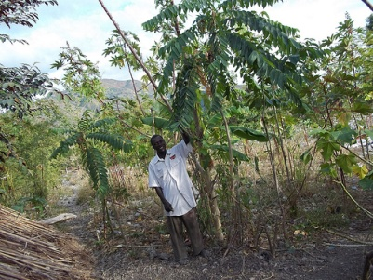

Trees for the Future » Blog Archive » Haiti
www.treesforthefuture.org
Working with more than 1,600 farmers to plant 1 million trees in 2012Three training and administrative centers established

Day 306: OLYMP-I-A for GREEN-LIVING (Year 2)- Action: I read some good news shared by the NRDC BioGems Defenders about special protections established for the gray whales!
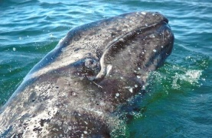
Timeline Photos
Some good news to share! The Mexican government has granted special protection t...See More
By: NRDC BioGems Defenders

Day 307: OLYMP-I-A for GREEN-LIVING (Year 2)- Action: I read that "Target," one of the U.S. largest food retailers, is eliminating gestation crates from its pork supply chain (https://www.facebook.com/photo.php?fbid=476145975763674&set=a.211657472212527.56622.199101346801473&type=1&ref=nf). To find out more facts, I read about the use of gestation crates for pig breeding in America (http://www.humanesociety.org/issues/confinement_farm/facts/gestation_crates.html). What a tragedy! I immediately signed the pledge to stop the use of gestation crates at https://secure.humanesociety.org/site/Advocacy?cmd=display&page=UserAction&id=5699
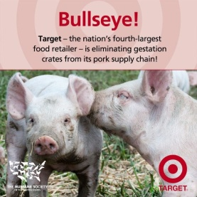
Timeline Photos
Way to go, Target! Folks can join us in saying no to gestation crates by signing our pledge for pigs: http://bit.ly/PledgeForPigs
By: The Humane Society of the United States - Farm Animal Protection Campaign

Day 308: OLYMP-I-A for GREEN-LIVING (Year 2)- I went with a friend to an organic gardening store. In addition to selling plants, they had a wonderful garden of vegetables, fruit trees, and flowering plants. One of the flowering plants had hundreds of honey bees humming around it. Honey bees are a sign of a healthy garden! So good to see!

Day 309: OLYMP-I-A for GREEN-LIVING (Year 2)- Action: I read an article demonstrating the power gained from the simple act of recycling:http://earth911.com/news/2012/10/17/how-much-energy-water-saved-by-recycling/. Our everyday actions matter!!
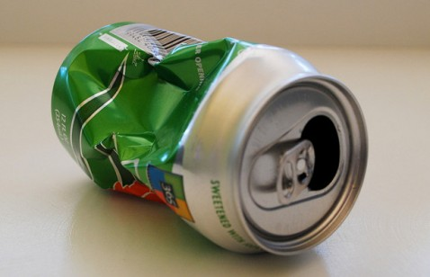

What We Really Save by Recycling - Earth911.com
earth911.com
Guide to local resources including recycling centers, how to recycle, pollution prevention and how help protect the

Day 310: OLYMP-I-A for GREEN-LIVING (Year 2)- Action: I bought some gift bags made from recycled paper. I found an informative article about why it's important to buy recycled products: http://www.recycleworks.org/paper/paper_wbr.html
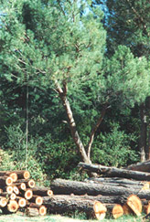

Why Buy Recycled? | Buying Recycled Products | Buy Recycled Products | San Mateo County RecycleWorks
www.recycleworks.org
San Mateo County RecycleWorks - Information on Reuse and Recycling, Green and Recycled Products

Day 311: OLYMP-I-A for GREEN-LIVING (Year 2)- Action: Had a delicious smoothie made with organic and locally-grown veggies and fruits. Then, recycled my cup.

Day 312: OLYMP-I-A for GREEN-LIVING (Year 2)- Action: I read about the successful use of solar ovens in Haiti... saving trees and improving health: http://www.nature.org/newsfeatures/specialfeatures/nature-feeds-our-families.xml
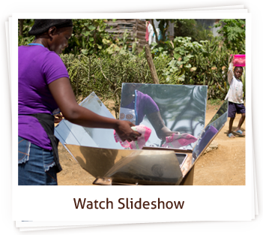
Nature Feeds our Families | The Nature Conservancy
www.nature.org
Nature feeds our families. Find out how The Nature Conservancy is doing impactful work in a way that meets the needs of nature and local communities.

Day 313: OLYMP-I-A for GREEN-LIVING (Year 2)- Action: I read about a way solar power is helping in storm relief efforts.http://mashable.com/2012/11/07/rolling-sunlight-greenpeace-truck-new-york/. This is so inspiring and hopefully a sign of future positive changes to come.
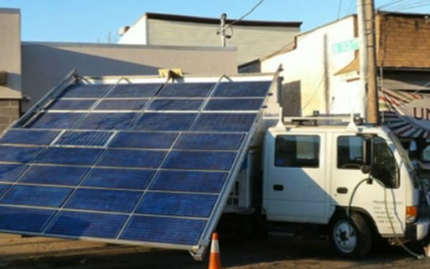

Greenpeace Provides Power to Sandy-Stricken Neighborhood with Solar Panel Truck
mashable.com
Called Rolling Sunlight, the solar-panel covered truck from Greenpeace has been providing power

Day 314: OLYMP-I-A for GREEN-LIVING (Year 2)- Action: I read about amazing new apps that help you monitor and regulate/reduce home and business energy usage from your smartphone.http://womenofgreen.com/2012/11/keep-warm-without-losing-your-cool-new-energy-saving-apps-are-here/

Keep warm without losing your cool. New Energy-saving Apps are here!
womenofgreen.com
It seems like we can do just about anything from our smartphones these days, and monitoring home energy usage is one of them. Although

Day 315: OLYMP-I-A for GREEN-LIVING (Year 2)- Action: I read about the Science Barge environmental education center in New York: http://www.groundworkhv.org/programs/science-barge/. It is a prototype sustainable urban farm with zero net carbon emissions, zero pesticides, and zero runoff. It operates completely "off the grid." Wonderful!!

Science Barge - Groundwork Hudson Valley
www.groundworkhv.org
The Science Barge is open for weekday educational programs and field trips for schools, camps, and other groups from mid-April through the beginning of November. Programs range from 1-3 hours and cost $125-$400. We

Day 316: OLYMP-I-A for GREEN-LIVING (Year 2)- Action: I read an article about elephants and the important work of the David Sheldrick Wildlife Trust: https://www.sheldrickwildlifetrust.org/updates/updates.asp?ID=469
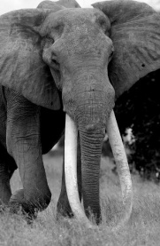
Timeline Photos
MUST READ: The Emperors of the Elephant World - By Dr. Dame Daphne Sheldrick https://www.sheldrickwildlifetrust.org/updates/updates.asp?ID=469
By: The David Sheldrick Wildlife Trust

Day 317: OLYMP-I-A for GREEN-LIVING (Year 2)- Action: I saw a Texas Disposal Systems (TDS) truck with pictures of wild animals displayed on the sides and back. The truck also displayed a website to learn more about the company's interest in animals. I looked up info on TDS online and read about how the company "create[s] a complete life cycle for thrown-away objects, gathering and reusing materials that would otherwise wind up in the landfill... [The company has a] carbon forestry initiative: carbon-absorbing, oxygen-releasing trees are grown in a nursery to help offset the carbon emissions generated by TDS’ fleet of trucks." Also, TDS operates an exotic animal ranch in a hunting-free sanctuary. http://www.forefrontaustin.com/feature/tds-making-austin-greener-one-trash-truck-and-gazelle-time

Making Austin Greener, One Trash Truck and a Gazelle at a Time | Forefront Austin
www.forefrontaustin.com
It's become practically second nature now: toss your cans, bottles, plastics, paper and cardboard into the recycling bin

Day 318: OLYMP-I-A for GREEN-LIVING (Year 2)- Action: I'm buying large containers of yogurt and using small, washable, reusable containers to take the yogurt in my lunch instead of purchasing and using the small, individual serving-size yogurts. Once the large yogurt containers are empty, I'm saving them to re-use for food storage, etc.

Day 319: OLYMP-I-A for GREEN-LIVING (Year 2)- Action: I learned about "Environment America" and the Environment America Fellow program: http://jobs.environmentamerica.org/programs/amr/become-environment-america-fellow. "Environment America works to advance ... clean energy, clean water, wilderness and wildlife protection, healthy food and sustainable agriculture..." Sounds like a wonderful program to engage college graduates.

Become an Environment America Fellow
jobs.environmentamerica.org
Work for a green future Each year, Environment America hires recent college graduates with the passion, the commitment and the talent it takes to stand up to polluters, organize public support and fi

Day 320: OLYMP-I-A for GREEN-LIVING (Year 2)- Action: I was at a store and purchased a lot of small items. I was offered plastic bags to carry my purchases to the car. I was soooo tempted to use the plastic bags, even though I had some cloth bags in the car. The plastic bags were handy and would have been quick and easy and I was tired. But, my green-living voice held firm and talked me out of it. So, I declined the bags, took the items out to the car and loaded them into the cloth bags. It really did not take that much more time or effort. Every little effort counts.

Day 321: OLYMP-I-A for GREEN-LIVING (Year 2)- Action: I found out about the Austin Sustainable Swap (http://www.austinsustainableswap.net/), a place to trade/exchange home-grown produce, crafts, educational workshops, ideas, etc. A wonderful concept that is growing!

Austin Sustainable Swap
www.austinsustainableswap.net
It's a meeting space where folks can gather and exchange home-grown produce, home-made crafts, as well as skills and services.

Day 322: OLYMP-I-A for GREEN-LIVING (Year 2)- Action: I found and explored a wonderful website: http://www.childrenandnature.org/. Great resources for families and teachers to engage children in nature! Awesome!
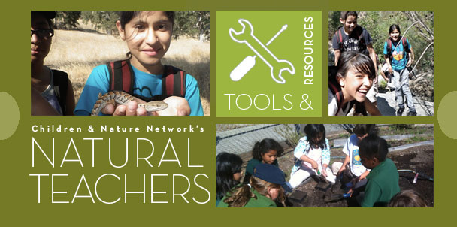

Children & Nature Network (C&NN)
www.childrenandnature.org
The Children & Nature Network (C&NN) is a national network of regional efforts. C&NN supports and accelerates the growth of a children and nature movement, some call it Leave No Child Inside, providing a forum for collaboration

Day 323: OLYMP-I-A for GREEN-LIVING (Year 2)- Action: I used a "Non-GMO Project Verified" canola oil in my baking today and read an article about 10 ways to help reduce GMOs in your diet:http://www.nongmoproject.org/2012/04/16/10-ways-to-spring-clean-gmos-out-of-your-home/
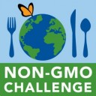

10 Ways to Spring Clean GMOs Out of Your Home
www.nongmoproject.org
You my already realize how critical a non-GMO diet is to the health of our planet—if so, good for you! Or you may be new to this issue and just starting to l

Day 324: OLYMP-I-A for GREEN-LIVING (Year 2)- Action: I saw a fabric gift cover in a grocery store and read more about fabric gift wrap options online: http://www.ecowrap.com/fabric-gift-wrap.html. A good idea for the holiday gift-giving... saves trees, reduces waste, and increases re-use.

Fabric Gift Wrap | Fabric Gift Wrapping | Reusable Fabric Gift Bags | Stylish Fabric Gift Bags
www.ecowrap.com
Fabric gift wrap: Use fabric gift wrapping ideas by EcoWrap

Day 325: OLYMP-I-A for GREEN-LIVING (Year 2)- Action: I read about the Amu Ranch and the David Sheldrick Wildlife Trust's work to help save this wildlife habitat. http://www.sheldrickwildlifetrust.org/updates/updates.asp?ID=471.
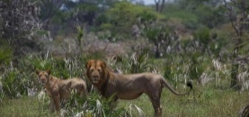
Timeline Photos
Step into Amu, a project that forms part of our 'Saving Habitats' initiative, fo...See More
By: The David Sheldrick Wildlife Trust

Day 326: OLYMP-I-A for GREEN-LIVING (Year 2)- Action: I signed the petition to speak out against the killing of elephants for ivory. http://www.iworry.org/
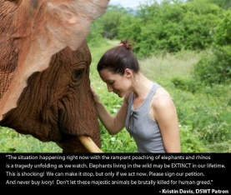
Timeline Photos
DSWT Patron Kristin Davis speaks up about the need for us all to act now to stop...See More
By: The David Sheldrick Wildlife Trust

Day 327: OLYMP-I-A for GREEN-LIVING (Year 2)- Action: Enjoyed eating leftovers. A simple and delicious way to prevent waste :)).

Day 328: OLYMP-I-A for GREEN-LIVING (Year 2)- Action: I learned about the Happy Planet Index, a global measure of sustainable well-being: http://www.happyplanetindex.org/

Happy Planet Index
www.happyplanetindex.org
The Happy Planet Index (HPI) is the leading global measure of sustainable well-being. The HPI measures what matters: the extent to which countries deliver long, happy, sustainable lives for the people that live in them.

Day 329: OLYMP-I-A for GREEN-LIVING (Year 2)- Action: I had a wonderful morning jogging along the river. Nature displayed a beautiful parade of colors- reds, yellows, greens, and bright sky-blue. It was spectacular to run through swirling, falling leaves... nature's confetti, celebrating autumn!

Day 330: OLYMP-I-A for GREEN-LIVING (Year 2)- Action: I seem to have a companion butterfly in my backyard. Several times in the past 2 weeks, when I've gone outside, the butterfly finds me and flies close by and sometimes even lands on me. So, in honor of my butterfly friend, I read an article about the best ways to create a garden habitat that attracts butterflies: http://www.nwf.org/Get-Outside/Outdoor-Activities/Garden-for-Wildlife/Gardening-Tips/How-to-Attract-Butterflies-to-Your-Garden.aspx
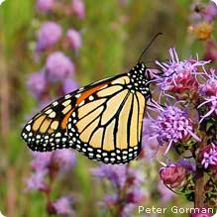

Attracting Butterflies - National Wildlife Federation
www.nwf.org
Learn to attract butterflies to your habitat. Gardening for wildlife means you'll get to see beautiful butterflies and birds, as well as have a vibrant yard filled with native

Day 331: OLYMP-I-A for GREEN-LIVING (Year 2)- Action: I read an article about a controversial de-tusking method being used to try to save elephants from poaching. Such desperate measures emphasize the critical condition of elephant preservation in the face of the lucrative ivory trade. http://blog.nature.org/2012/11/detusking-mountain-bull/?src=s.fb
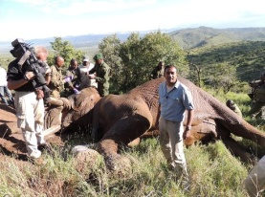
Timeline Photos
Our lead scientist Sanjayan poses in front of a snoozing Mountain Bull. Some Afr...See More
By: The Nature Conservancy

Day 332: OLYMP-I-A for GREEN-LIVING (Year 2)- Action: I was shopping at a local toy store and while shopping I overheard some of the staff complaining that soon stores would not be able to offer plastic bags for customers. They did not seem in favor of the change, saying how hard it would be for customers to be able to carry out large items, etc. When I checked out, I had bought some larger items. I asked them to wait a minute while I went to get my cloth bag from the car. I have one bag that is extra-large. The staff person was pleased to see that all the items fit in the cloth bag. Though I never brought up the subject of plastic vs. cloth bags, I think the simple action of using the cloth bag helped the staff experience how non-threatening the change can be.

Day 333: OLYMP-I-A for GREEN-LIVING (Year 2)- Action: I read an article about the work of the Nature Conservancy to secure and protect a 50 mile corridor of land in the Tehachapi Mountains. The land protects many rare species and their ability to freely migrate within a habitat that connects the California coastal range, the Sierra Nevada and southern California mountains. Awesome! http://www.conserveca.org/blog_multimedia/conserving-tehachapi-wildlife-corridor.xml?src=s.fblocal
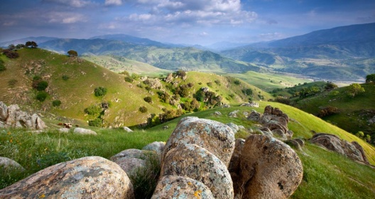

Conserving Tehachapi Wildlife Corridor | The Nature Conservancy
www.conserveca.org
Scenic views of the rolling green hills and oak trees of the Tollhouse Ranch located in the heart of the corridor. The Nature Conservancy's purchase of the Tollhouse Ranch

Day 334: OLYMP-I-A for GREEN-LIVING (Year 2)- Action: I saw this beautiful photo of Blue Morpho butterflies. I read more about them online at http://www.rainforest-alliance.org/kids/species-profiles/blue-butterfly. "Blue morphos are severely threatened by deforestation of tropical forests and habitat fragmentation. Humans provide a direct threat to this spectacular creature because their beauty attracts artists and collectors from all over the globe who wish to capture and display them."
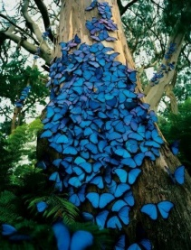
Messenger Photos
The Blue Morpho Butterfly is one of the many flying beauties of the Amazon.
We ...See More
By: Zola Acai

Day 335: OLYMP-I-A for GREEN-LIVING (Year 2)- Action: I found a great tip for a way to create recycled gift packaging. Cool idea!
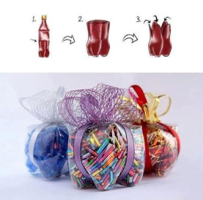
Tumblr Finds
Tumblr find of the day: Recycled packaging for your eco-friendly gifts via Creaz...See More
Inspiring posts from people Thinking Outside the Bin -http://earth911.tumblr.com/
By: Earth911

Day 336: OLYMP-I-A for GREEN-LIVING (Year 2)- Action: I visited Dell Children's Hospital. There is a sign in the hallway about the hospital's environment-friendly lighting system. The architecture creates an abundance of natural light. Sensors detect natural lighting levels and turn off artificial lighting when not needed. "*In 2009, Dell Children's was certified as the world's first LEED® Platinum hospital by the U. S. Green Building Council. LEED® (Leadership in Energy and Environmental Design) is the internationally-recognized benchmark for the design, construction and operation of high performance green buildings."http://www.goodhealth.com/articles/2009/01/14/dell_childrens_recognized_as_world_class_green_hospital
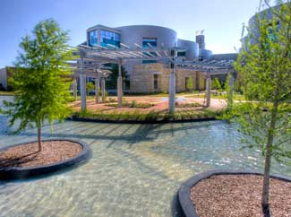

Dell Children's Recognized as World Class Green Hospital
www.goodhealth.com
The first hospital in the world to receive the LEED (Leadership in Energy & Environmental Design) Platinum designation, given by the U.S. Green Building Council.

Day 337: OLYMP-I-A for GREEN-LIVING (Year 2)- Action: I wrapped a holiday gift in a decorative holiday hand towel instead of wrapping paper. A gift in a gift-wrap!

Day 338: OLYMP-I-A for GREEN-LIVING (Year 2)- Action: I reviewed an interesting infographic on carbon dioxide emissions (total and per capita) by country: https://www.facebook.com/photo.php?fbid=514316051920993&set=a.476694139016518.111777.384118004940799&type=1&relevant_count=1&ref=nf
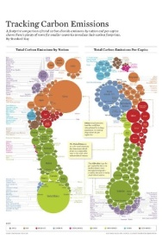
Timeline Photos
Two ways to track carbon footprints (by nation & per capita)
…all in a beautiful...See More
By: EcoSocial

Day 339: OLYMP-I-A for GREEN-LIVING (Year 2)- Action: Instead of throwing out used batteries, I save them in a labeled container. When I get a fair number of them, I take them to the local library which is a battery recycling location.

Day 340: OLYMP-I-A for GREEN-LIVING (Year 2)- Action: I read that the recycling service for our neighborhood will be picking up aluminum/tin foil now! Wonderful!!

Day 341: OLYMP-I-A for GREEN-LIVING (Year 2)- Action: I wrapped a holiday gift in a colorful, reusable grocery/shopping bag. A fun and sustainable way to wrap presents :)).

Day 342: OLYMP-I-A for GREEN-LIVING (Year 2)- Action: We went to a grocery store and when we bought our groceries we did not use any of the store's bags to carry them out. The store gave us a "bag discount" for not using bags. How awesome is that!

Day 343: OLYMP-I-A for GREEN-LIVING (Year 2)- Action: I watched an amazing video shared with me by a friend. The video tells the story of the "Landfillharmonic," an orchestra with instruments made from recycled parts found in a landfill. So incredibly awesome!!https://www.facebook.com/photo.php?v=10151279562307432&set=vb.759907431&type=2&theater
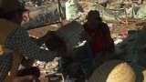

Dec 4, 2012 9:55pm

Amazing!
Length: 3:43

Day 344: OLYMP-I-A for GREEN-LIVING (Year 2)- Action: I watched a video about urban farming: http://vimeo.com/15997939#t=90. A wonderful way to transform and build urban community!
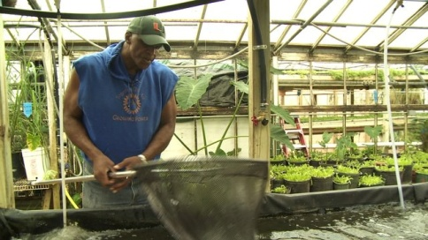

Will Allen: The Urban Farmer
vimeo.com
Transforming urban food production - www.spark.poptech.org

Day 345: OLYMP-I-A for GREEN-LIVING (Year 2)- Action: I enjoyed a brisk, cool walk, immersed in nature with my dog. I love how she explores the path with such gusto. Every smell, sight, and sound has meaning. Her appreciation is absolute.

Day 346: OLYMP-I-A for GREEN-LIVING (Year 2)- Action: I read an informative article about pesticides and their presence in our foods and in us: http://opinionator.blogs.nytimes.com/2012/12/11/pesticides-now-more-than-ever/. The Environmental Working Group’s guide to pesticides in produce (http://www.ewg.org/foodnews/summary/) lists a “Dirty Dozen,” those fruits and vegetables with highest pesticide residues and a “Clean Fifteen,” those with the lowest.

Pesticides: Now More Than Ever
opinionator.blogs.nytimes.com
A half century after 'Silent Spring,' the use of chemicals in agriculture has actually risen.

Day 347: OLYMP-I-A for GREEN-LIVING (Year 2)- Action: I am using the US Postal Services "Go Green" stamps. Each stamp has a simple step people can take to help the environment. So awesome!http://about.usps.com/what-we-are-doing/green/gogreenstamps.htm.
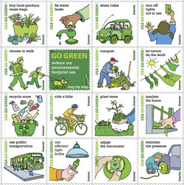

USPS Sustainability - Go Green stamps
about.usps.com
Sixteen stamps showing little things each of us can do to conserve resources and help the environment.

Day 348: OLYMP-I-A for GREEN-LIVING (Year 2)- Action: I had a discussion today with friends and learned more about "peak oil," the impact of oil production on our environment, and climate change. I looked up more info online at: http://www.peakoil.net/. The Association for the Study of Peak Oil and Gas (ASPO) "is a network of scientists, affiliated with institutions and universities, having an interest in determining the date and impact of the peak and decline of the world's production of oil and gas, due to resource constraints."

ASPO International | The Association for the Study of Peak Oil and Gas
www.peakoil.net
"The term Peak Oil refers to the maximum rate of the production of oil in any area under consideration, recognising that it is a finite natural resource, subject to depletion."

Day 349: OLYMP-I-A for GREEN-LIVING (Year 2)- Action: When I bought some "Go Green" stamps the other day, I read that the US Postal Service meets the eco-friendly "Cradle to Cradle Certification" standards. So, I looked up more info about this certification program online: http://www.c2ccertified.org/. The "Cradle to Cradle Certification" program uses rigorous scientific criteria to evaluate how well a business conserves natural resources. "The materials and manufacturing practices of each product are assessed in five categories: Material Health, Material Reutilization, Renewable Energy Use, Water Stewardship, and Social Responsibility." Awesome!
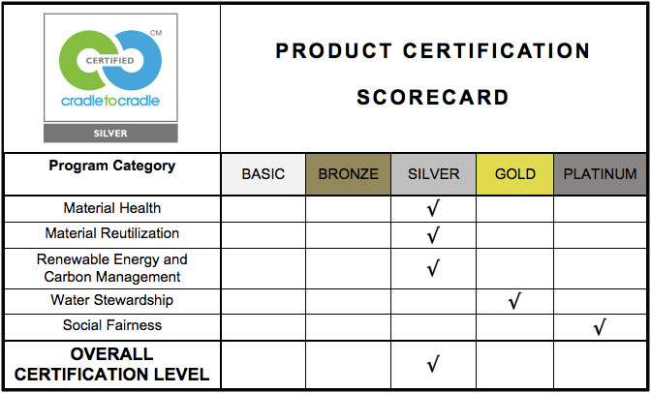

Cradle To Cradle Products Innovation Institute
www.c2ccertified.org
The Cradle to Cradle Products Innovation Institute is a non-profit organization created to bring about a large scale transformation in the way we make the things we make

Day 350: OLYMP-I-A for GREEN-LIVING (Year 2)- Action: I watched the movie "Born Free." I had not seen it in a long time. It is a wonderful film which emphasizes the importance of animals being allowed to live free in the wild. I found out that, interestingly, the two leading actors in the movie became animal activists after making the film.http://www.pbs.org/wnet/nature/episodes/elsas-legacy-the-born-free-story/introduction/6139/

Elsa’s Legacy: The Born Free Story ~ Introduction | Nature | PBS
www.pbs.org
Born Free was a game changer.

Day 351: OLYMP-I-A for GREEN-LIVING (Year 2)- Action: I was outside in the early morning and a unique "honking" sound caught my attention. My dog seemed intrigued as well. At first I could not locate the sound. Then, I looked up and spotted geese flying across the sky. It was a special, transfixing moment, the quiet beauty of the morning, the geese flying overhead in the light of dawn. How beautiful our world is.www.panhala.net/archive/wild_geese.html
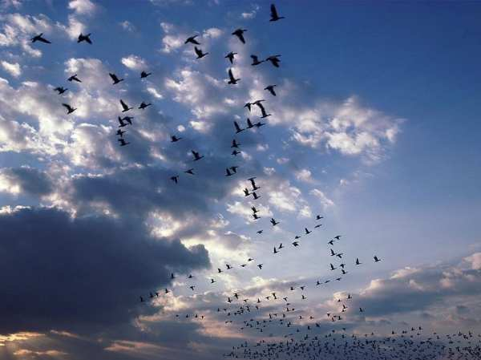

Wild Geese -- Mary Oliver
www.panhala.net

Day 352: OLYMP-I-A for GREEN-LIVING (Year 2)- Action: I recycled printer cartridges today. I realize that making spaces (or setting aside bags or boxes) in the house and car for things that I recycle on a regular basis, helps remind me to recycle and makes the process convenient and more efficient.

Day 353: OLYMP-I-A for GREEN-LIVING (Year 2)- Action: I read about "PACT," a business that is out to make the world a better place. Their socks and underwear are made with organic cotton and some products are made in factories powered with wind energy. When you buy one of their products, the company helps contribute to good causes. http://www.wearpact.com/good-source/

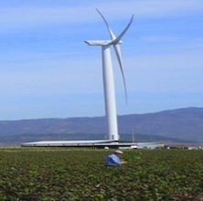

Good Source PACT Apparel Fair-Trade Organic Cotton Underwear, Socks and Tees
www.wearpact.com
PACT's Good Fabric. Good Design. Good Cause., mantra helps create a catalyst for positive change in basics like underwear, socks and tees.

Day 354: OLYMP-I-A for GREEN-LIVING (Year 2)- Action: I was on a walk and noticed birds fluttering in the bushes. It made me think about the cold, freezing weather approaching and I wondered how birds shelter themselves and survive in the winter. I found an interesting post about tips for feeding birds in the winter: http://www.sussexwildlifetrust.org.uk/blog/2011/12/seven-tips-for-feeding-birds-this-winter/

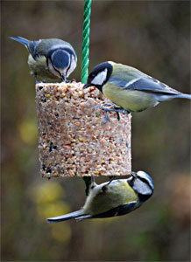
Seven Tips For Feeding Birds This Winter | Wild Comment
www.sussexwildlifetrust.org.uk
Sussex Wildlife Trust - Taking Care of Sussex

Day 355: OLYMP-I-A for GREEN-LIVING (Year 2)- Action: I read an article about compassionately raised meats and poultry:http://www.thedailygreen.com/living-green/definitions/Compassionately-Raised-Meats-Poultry. "The nonprofit watchdog group Consumers Union so far has examined only the "certified humane" label, which it deemed a "highly meaningful label that indicates that meat, dairy and egg products came from animals that were treated humanely," according to its eco-oriented web site, Eco-labels.org. The "certified humane" label has several requirements. Among examples: Livestock must have access to clean and sufficient food and water; they must have sufficient room to move naturally; and their environment must not endanger their health."
Read more: http://www.thedailygreen.com/living-green/definitions/Compassionately-Raised-Meats-Poultry#ixzz2FpigJ8s3
Compassionately Raised Meats and Poultry
www.thedailygreen.com
Wouldn't it be great if farm animals were raised compassionately? Well, some people are way ahead of you on that.

Day 356: OLYMP-I-A for GREEN-LIVING (Year 2)- Action: I went to a 3D movie. I was happy to see that theater emphasized the importance of recycling the 3D glasses and made the recycling convenient by having a special recycle bin outside the exit of the theater. I read an article about the carbon footprint of 3D glasses and the pros and cons of recycling vs. using newly developed biodegradable glasses:http://www.treehugger.com/culture/billions-and-billions-of-3d-glasses-will-biodegradable-frames-discourage-reuse.html.
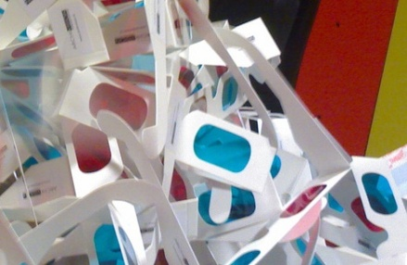

Billions and Billions of 3D Glasses: Will Biodegradable Frames Discourage Reuse?
www.treehugger.com
It is estimated that if the 42.1 million pairs of 3D glasses used at theaters to watch Avatar were laid end-to-end, they would stretch more than 3,987 miles. Avatar and Alice in

Day 357: OLYMP-I-A for GREEN-LIVING (Year 2)- Action: I went to a cafe to get a quick breakfast. I noticed they had bagels. When I asked about them, they said they got them from a local baker and emphasized that they try to serve local food products whenever possible. It is good to hear more and more people making a point of buying local produce and products. I read an article on the benefits of thinking and buying "local:" http://sustainableconnections.org/thinklocal/why

Why Buy Locally Owned? — Sustainable Connections
sustainableconnections.org
There are many well-documented benefits to our communities and to each of us to choosing local, independently owned businesses. We realize it is not always possible to buy what you need locally and so merely ask you to Think Local FIRST!

Day 358: OLYMP-I-A for GREEN-LIVING (Year 2)- Action: Sharing a beautiful wish for the world!
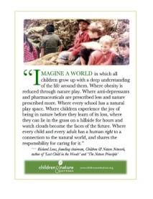
Timeline Photos
Wish for the season, and 2013.
By: Richard Louv

Day 359: OLYMP-I-A for GREEN-LIVING (Year 2)- Action: Along with stuffing the turkey, we remembered to stuff the recycle bin. Blessings for all, including the Earth.

Day 360: OLYMP-I-A for GREEN-LIVING (Year 2)- Idea: I thought about the importance of seeking simplicity in our lives in order to ensure the natural abundance of the Earth. Less can definitely be more!

Day 361: OLYMP-I-A for GREEN-LIVING (Year 2)- Action: I enjoyed getting some e-cards from friends for the holidays... one way to save paper.

Day 362: OLYMP-I-A for GREEN-LIVING (Year 2)- Action: I read about different eco-volunteering opportunities in the book "Volunteer Vacations." There are numerous wildlife and conservation volunteer opportunities in the U.S. and worldwide. I found an online article which highlights some of the vacations described in the book as well as a few others: http://www.thedailygreen.com/environmental-news/latest/eco-travel-volunteer-vacations-50022309
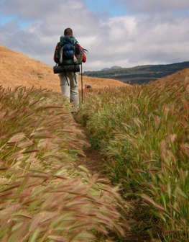

15 Volunteer Vacations
www.thedailygreen.com
See beautiful scenery, visit exotic places and help the environment!<br />Find more great <a href="http://www.thedailygreen.com/living-green/ecotourism-national-parks-vacations " target="_blank">ecotourism vacation ideas</a>.

Day 363: OLYMP-I-A for GREEN-LIVING (Year 2)- Action: I read more about the efforts of "Vegan Outreach," a "501(c)(3) nonprofit organization dedicated to reducing the suffering of farmed animals by promoting informed, ethical eating." http://whyveganoutreach.blogspot.com/2012/12/choosing-for-maximum-impact.html
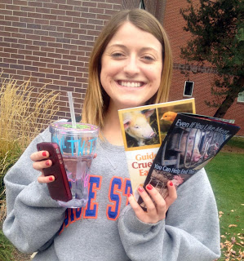

Your Daily Dose of Vegan Outreach!: Choosing for Maximum Impact
whyveganoutreach.blogspot.com
We're dedicated to reducing suffering as much as possible. Care more about results than words? Want a vegan world,

Day 364: OLYMP-I-A for GREEN-LIVING (Year 2)- Action: I went for a long run this morning. Nature was at its best: a gorgeous red-flaming sunrise mirrored in a glass lake, a duck taking off from the water with webbed feet tap dancing on the surface, geese flying overhead in V formation, a cardinal's bright red shining like a sparkling ruby in the brown, leaf-barren bushes, and the graceful swans gliding with the current. How wonderful to be able to enjoy the beautiful gifts of our green planet!

Day 365: OLYMP-I-A for GREEN-LIVING (Year 2)- Action: I read an article about how taking positive steps for green-living can put money in your pocketbook. Some good ideas for the New Year!http://earth911.com/news/2012/03/07/7-ways-to-make-money-by-going-green/

7 Ways to Make Money by Going Green - Earth911.com
earth911.com
Guide to local resources including recycling centers, how to recycle, pollution prevention and how help protect the environment.

